DoBu Martial Art

 |

Submmative assignment

Kyaw Kyaw Soe

2023



**STUDENT ASSESSMENT SUBMISSION AND DECLARATION**

When submitting evidence for assessment, each student must sign a declaration confirming that the work is their own.

|  |  |  |  |
| --- | --- | --- | --- |
| Student Name:  Kyaw Kyaw Soe | | Assessor name: | |
| Issue date:  18 Feb, 2023 | Submission date:  21 Feb,2023 | | Submitted on:  21 Feb,2023 |
| Programme: BTEC Level 5 Higher National Diploma in Computing – Application development RQF | | | |
| Unit: 2 Front End Development | | | |
| Assignment number and title: ABC Learning Center | | | |

**Plagiarism**

Plagiarism is a particular form if cheating. Plagiarism must be avoided at all costs and students who break the rules, however innocently, may be penalized. It is your responsibility to ensure that you understand correct referencing practices. As a university level student, you are expected to use appropriate references throughout and keep carefully detailed notes of all your sources of materials for material you have used in your work, including any material downloaded from the Internet. Please consult the relevant unit lecturer or your course tutor if you need any further advice.

**Student Declaration**

|  |
| --- |
| **Student declaration**  I certify that the assignment submission is entirely my own work and I fully understand the consequences of plagiarism. I understand that making a false declaration is a form of malpractice.  Student signature:  Date:, 21 Feb, 2023 |



Pearson Education 2018

Higher Education Qualifications

Contents

Domain Name System (DNS) 4

DNS recursive resolver 4

Root name server 4

TLD name server 4

Authoritative server 4

DNS record 5

How domain names are managed and organized 5

Relationship between communication protocols, server hardware, operating system and web server software with regard to designing, publishing and accessing a website 5

Communication Protocols 5

Server hardware 6

Operating system 6

Web server software 6

Software 7

Capabilities and relationship between Front-end and Back-end website technologies and how they are related to presentation and application layer 7

Front-end website technology 7

Back-end website technology 7

Capabilities and relationship between front-end and back-end website technologies 8

How front-end and back-end relate to presentation and application layers 8

Differences between online website creation tools and custom-built sites with regard to design flexibility, performance, functionality, User Experience (UX) and User Interface (UI) 9

Online website creation tools 9

Custom-built website 9

Comparison between online website creation tools and custom-built website 10

Project Background 10

Business requirement 10

Functional requirement 10

Non-Functional requirement 12

Environmental requirement 12

Information architecture 13

Characteristic of information architecture 13

Advantages of information architecture 13

Information architecture for Dobu Martial Art 13

Wireframe 14

Characteristics of wireframe 14

Advantages of wireframe 15

Wireframe of DoBu Martial Art 15

Common Content 15

Home 16

Class 17

Membership 17

Special Course 18

Schedule 18

Instructors 19

About us 19

Contact 20

Privacy policy 20

Sitemap 21

Registration Form 22

Storyboard 22

Characteristics of storyboard 22

Advantages of storyboard 22

Storyboard of DoBu Martial Art 23

Connections from header 23

Connections from footer 23

Connections other than header and footer 24

Implementation of branded, multi-page website for DoBu Martial Art supported with realistic content 24

Home page, index.html 24

classes.html 29

membership.html 36

specialcourse.html 44

schedule.html 52

instructors.html 57

aboutUs.html 64

contact.html 70

sitemap.html 76

privacy.html 81

reguistrationForm.html 87

user.html, admin pages 92

Testing 99

Test plan for DoBu Martial Art 100

Usability test cases for Dobu Martial Art 100

Functional text case for DoBu Martial Art 101

Compatibility test case for DoBu martial Art 102

Responsive test case for DoBu Martial Art 103

Performance test case for DoBu Martial Art 104

# Domain Name System (DNS)

Domain name system is essential for internet connected resources. It maintains a list of domain names, resources and IP address of a website. It was used to translate the readable domain name that the user entered into IP address which support the web browser to load the resources. There are 4 types of DNS Servers. They are DNS recursive resolver, Root name server, TLD name server and Authoritative server.

## DNS recursive resolver

DNS recursive resolver is designed to deliver the client DNS query to DNS nameserver. It will either responds the request by itself with cached data or sent the client request to root nameserver, TLD nameserver and authoritative server in order. Then, responds the requested IP address back to the client.

## Root name server

Root nameserver is to convert the readable host names into IP addresses.

## TLD name server

Top-level Domain Name Server (TLD) maintains the information about domain name and host its extensions such as com, net that come after the URL.

## Authoritative server

Authoritative server maintains the information specific to domain name and provide the IP address of the requested host name from DNS record, back to the DNS recursive resolver.

## DNS record

DNS record locates within authoritative DNS servers and maintains the information about domains with its IP addresses and ways to handles the request for the domain. There are some common types of DNS records. They are A record, CNAME record, MX record, TXT record, NS record, SOA record, PRT record and so on.

## How domain names are managed and organized

Domain names are managed by a global network of server, Domain Name System (DNS) that interprets the human readable domain into IP address the only machines can understand and organized within a specialized database which are parts of the world-wide system of domain registrars. Then, provides the right to manage the domain names to respective domain owners.

Firstly, the browser will send a DNS query to the recursive resolver to request the OIP address of the URL and web address that user type. The recursive resolver will responds the request by itself with cached data or pass the query to the root server. The root server will translate the domain name to IP address. Then TLD server response to and pass the query to the authoritative server for the domain. At last, recursive resolver responses the user’s request back to the web browser when the IP address of the domain is found.

Domain registrars are authorized by Internet Corporation for Assigned Names and Numbers (ICANN) to allows the customer to make a purchase, register the domain names that consists of assigning registered information to relevant authoritative name server and provide means to manage for updating contact information and DNS setting to respective domain owners.

# Relationship between communication protocols, server hardware, operating system and web server software with regard to designing, publishing and accessing a website

The relationship between the communication protocols, server hardware, operating system and web server are essential for great and qualified website performance. The server hardware, operating system and web server software need to in sync with each other to process the hardware's resources and memory, provide common services and platform to computer’s programs and software applications. Moreover, communication protocols also need to be compatible with other chosen server hardware, operating system and web server software to handle website load performance and mange and allow user to access website’s content.

## Communication Protocols

Protocols are set of rules and guidelines for formatting and transmitting data. They are designed to clarify the correct process and procedures to be followed through many situations. They are needed in many fields like Data Commination, networking, science and technology, media, society, etc. In communication protocols, they are designed to allow different devices to communicate with each other. There are some essential protocols for networking and data communication.

* **HTTP** (Hyper Text Transfer Protocol) is for transferring data and information between devices. Nowadays, HTTP becomes essential basic foundation for internet and world wide web.
* **HTTPS** (Hyper Text Transfer Protocol Secure) is to provide more security for the encrypted HTML from cyber-attacks by altering readable message and text to ciphertext.
* **FTP** (File Transfer Protocol) is a communication protocols that connect between client and server and transfer computer files on network.
* **IP** (Internet protocol) is used to deliver the data packets to right place. IP information attached on packets support the router to send packets to correct destination.
* **SMPT** (Simple mail Transfer Protocol) is also an internet communication protocol for electronic mail transfer. It was used to send and receive mails and messages.

## Server hardware

Server hardware are physical equipment that are designed to host and deliver services and website’s resources. This includes server, storage devices and other familiar hardware component such as CPU, memory, power supply, Network interface card, motherboard and etc. Moreover, quality and performance of these server hardware can determine the reliability and speed of the website.

## Operating system

Operating system is software program that runs on the server hardware and acts as the interface between hardware and software application. OS manages the computer’s hardware like processing resources, managing memory and providing user interface. Then, provide common services for computer programs and platform to run applications. **Microsoft Window**, **Linux**, **macOS**, **IOS** and **Android** are most common examples for Operating system.

## Web server software

Web server software runs on operating system like Linux and Microsoft Window. Its job is to response the clients’ request by delivering web pages or contents back to the clients. When the browser requested a file hosted on web server, it fetch the required content from appropriate web server software and then deliver it back to the user by using relevant communication protocols. There are many well-known web server software like

* **Apache HTTP Server** which is a widely used open-source server,
* Lightweight and high-performance servers like **Nginx** and **Lighttpd**
* **Google web server** to support google web pages and
* **Microsoft IIS** to use on window operating system.

## Software

Software applications are computer programs which are designed to fulfil the specific requirements of the user and organizations. There are many applications for various purposes such as email clients, social media platforms, gaming and entertainment applications, designing and editing tools and so on. Therefore,

* Software like **Diagram** and **Balsamiq** to design the web page layout and structure,
* IDE software like **Visual Studio Code, Notepad++** and **Sublime text** are used for implement code for web page and
* **Microsoft Word and PowerPoint** are used for documentation and presentation purposes.

# Capabilities and relationship between Front-end and Back-end website technologies and how they are related to presentation and application layer

## Front-end website technology

Front-end website technology is used to interact with the user by creating graphical user interface of the website or web application using client-side scripts and frameworks. Popular front-end web technologies include

* **HTML** (Hypertext Markup Language) to determine the structure of the web pages.
* **CSS** (Cascading Style Sheet) to maintain the displayed html elements and layouts on the screen
* **JavaScript** to create dynamic web pages
* **Bootstrap** is a CSS framework which is used to create responsive web pages
* **jQuery** is a JavaScript library to improve the code efficiency of JavaScript used within the website

## Back-end website technology

Back-end website technology is a server-side script that are used to handle the unseen parts of the website such as, focusing on architecture, back-end logic, database, handling client-side requests, process data and generate the required content back to the client-side. Developer used programming languages, frameworks, servers and databases to develop and manage the back-end of the website. There are some popular of back-end website technology like

* **Java, Python, PHP** and **C#** are popular programming languages among the developers
* **MySQL, SQL Server, Oracle** and **MongoDB** are good examples for database
* Servers like **Apache, Tomcat** and **Nginx** are used for back-end and
* Popular examples of frameworks are **Django** (Python)**, Spring** (java)**, Express** (JavaScript) and **Laravel** (PHP)

## Capabilities and relationship between front-end and back-end website technologies

In order to develop an fully function website or web application, both front-end and back-end technologies are essential components. Front-end is used to communicate with the user through user interface while the back-end support the website by providing necessary information, processing and storing data. They are connected with Application programming Interface (API) which allows to transfer data and information between them.

Front-end technology is used to deliver responsive and user-friendly user interface of the website. The capabilities of the front-end technologies include,

* Designing and developing user interface by using HTML, CSS and JavaScript
* Developing responsive websites and application that can be used at different screen platform and devices
* Adding animation to improve user experiences with JavaScript and jQuery
* Integration with back-end technologies such as database and server to create an interactive and dynamic websites of web application
* Allow to develop websites and applications that can be able adapt at multiple browsers so that the user can access them from various browsers which they are using

Back-end technology is to handle request from client-side, database management, server-side logic and generate response back to client-side of the website or application.

* Proficient in various programming languages like java, python, PHP and Ruby to meet the specific requirement of the project
* Providing database management to manage and process data and information from client-side
* Support API integration to allow accessing other services like cloud services and social medias
* Provide security from many threats
* Support various pre-build and structured server-side frameworks like Django, Spring and Express to improve data managing and request handling.

## How front-end and back-end relate to presentation and application layers

Presentation layer and application layer are from Open System Interconnection (OSI) which is the model framework for computer network operation. Front-end technology includes user interface that is relate to presentation layer of the system, while back-end technology is relate to application layer that manage data and information of the website.

Presentation layer contains components that are relate to client-side, front-end web technologies such as HTML, CSS and JavaScript. This layer display user interface that contains data, animation, images, videos and allow user to interface with the system.

On the other hand, application layer is related to server side, back-end technologies that process data and focus on the logic of server-side logic. This layer includes database, web server, programming languages and APIs.

# Differences between online website creation tools and custom-built sites with regard to design flexibility, performance, functionality, User Experience (UX) and User Interface (UI)

## Online website creation tools

Online website creation tools provide the customer with platform and services in order to develop and publish a website with a clean and user-friendly interface. The developer can create such user interface design by these tools with their provided pre-designed and structured templates, drag and drop functions and customization options. They are very effective against less budget, time consuming and simple projects. Webpage design may not be flexible as custom-built but maintenances and updates will be less.

There are some popular online website creation tools such as

* **Wix** which provides cloud base platform and wide range of functions with drug and drop function
* **WordPress** is a hosting service that offers many templates and plugin
* **Shopify** is an e-commerce platform with various templates and customization options
* **Squarespace** also provide many attractive visual templates and also support for e-commerce platform
* **Adobe Dreamweaver** can provide code hints to built responsive website with real-time preview and various appealing templates

## Custom-built website

Custom-built websites are designed and developed according to the specific requirements of customer. They are built by using various programming languages, frameworks and other tools. It can be more expensive and time consuming than using online website creation tools but they can offer more customized and unique user interface design.

## Comparison between online website creation tools and custom-built website

|  |  |  |
| --- | --- | --- |
|  | Online website creation tools | Custom-built website |
| Design flexibility | Provide with many attractive pre-designed and structured templates but design flexibility is limited | Developer can fully control and customize the design according to customers’ will |
| Performance | Performance may be limited due to its limited server resources and code | Can be maintain the performance and speed by choosing appropriate coding and hosting server |
| Functionality | Functions and other features may be limited but can purchase many advanced features by paying additional fess | Functionality can be customized and adjust according to specific requirement but sometime it can be complex for the developers |
| User experience (UX) | Even thought, it may be limited by its pre-structured templates but it can still be improved by some editing and testing | Developers can fully manage and customized the user experience by it may takes many works to do |
| User interface (UI) | it may be limited by its pre-structured templates but it can still be improved by some editing and testing | Developers can design and customized the unique user interface according to specific requirement |

# Project Background

This is junior web developer, Kyaw Kyaw Soe from Webspace, independent web-developing company. Our company, Webspace is well known for its innovate, clean and user-friendly custom-build website for clients’ unique requirement. We take many projects and operations from large industries to small local companies.

Dobu Martial Art offers project to build a website for its future business operations.

## Business requirement

Dobu Martial Art is a gym that offers martial art courses, self-defense courses and fitness training. They need innovative, clear and user-friendly website to promote the gym, advertising martial art courses with its respective prices, managing customers’ membership account and provide information about gym facilities and services. Therefore, this website is essential for DoBu martial art gym’s future business operations.

## Functional requirement

These are the requirement and information provided by DoBu Martial Art. There are 6 membership options, 1 self-defense course and public and personal fitness training along with their respective prices. Following screen capture is for membership options, special course and fitness training information about their number of martial arts taught, session counts and monthly fee.

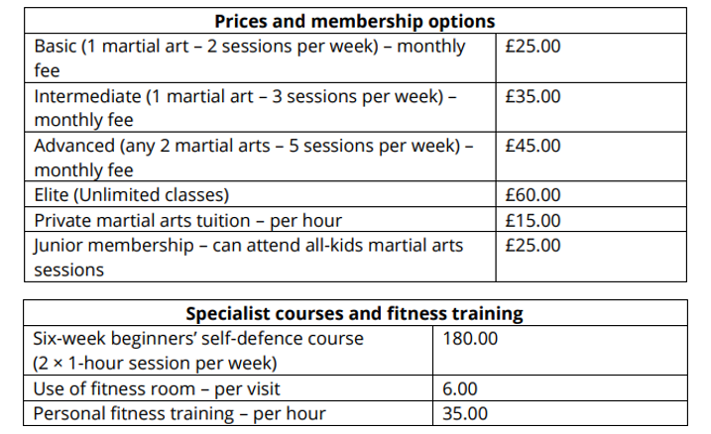

There are 4 main types of martial art are taught at DuBo Martial Art Gym. They are karate, jiu-jitsu, judo and muay thai. Moreover, there will also be martial arts set for kids and junior membership. Trainees can also practice martial art at the open mat. Following screen capture is the weekly schedule time table for DuBo martial Art.

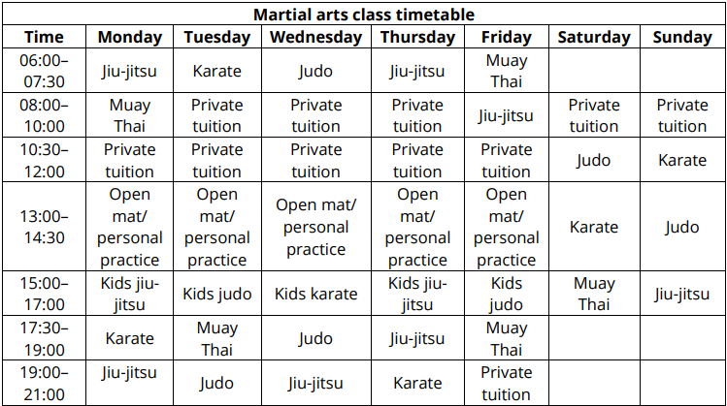

DuBo martial Art also provides information about the instructors along with their names, job positions and martial art titles. There are six instructors at DuBo Martial Art Gym. This is the detail information about instructors provided from DuBo Martial Art.

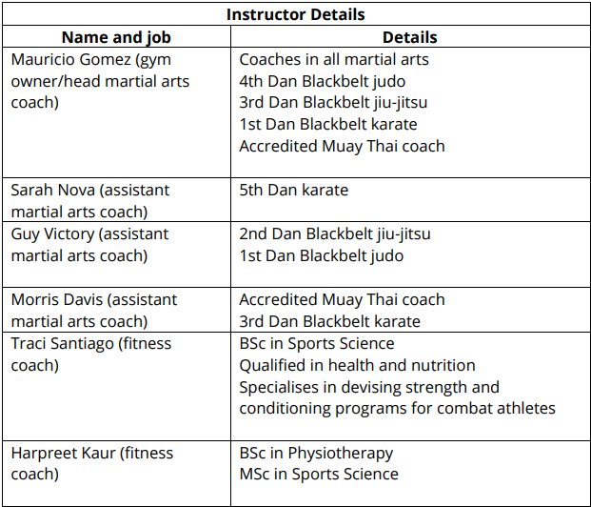

## Non-Functional requirement

There are non-functional requirements that need to be follow to be deliver a qualified website to the client. We need to improve the performance of the website and other technical aspects like capacity, traffic, graphic, audio and video. Then maintain the connection between server, client-side-scripting and operation systems, database and application servers.

## Environmental requirement

**Environment and tools for front end development of Dobu Martial Art**

|  |  |  |
| --- | --- | --- |
| Hardware | CPU | 11th gen, Intel core i7 |
| Memory | 8 GB |
| Storage | 195 GB |
| Operating system | Microsoft | Window10 |
| Software | Documentation | Microsoft word |
| Presentation | Microsoft power point |
| Information architecture | Diagram.net |
| Wireframe | Balsamiq.cloud |
| Story board | paint |
| Web design | Visual study code |
| Skill | Programming language | HTML, CSS, JavaScript |
| Library | Bootstrap, jQuery |
| Web server | XAMM | Apache, Tom cat |
| Stakeholders | Client | DoBu Martial Art Gym |
| Company | Webspace  Kyaw Kyaw Soe (Junior Web Developer) |

# Information architecture

Information architecture is a blueprint of the project that identify the features and hierarchy of the project. It includes the structured, organized and determined content, flow, functions and behaviors of the website or applications. This can help the user to navigate and understand the flow of the website or application.

## Characteristic of information architecture

In order to create a well-designed information architecture there are some characteristics to follow. They are providing critical information of the website, focusing on structure of the website, Keeping the clear and simple and providing connections between information.

## Advantages of information architecture

Advantages of well-designed information architecture are ease to maintain and organize information necessary to the website, achieving reliable foundation for the website, providing easier navigation for the website, improve user experience.

## Information architecture for Dobu Martial Art

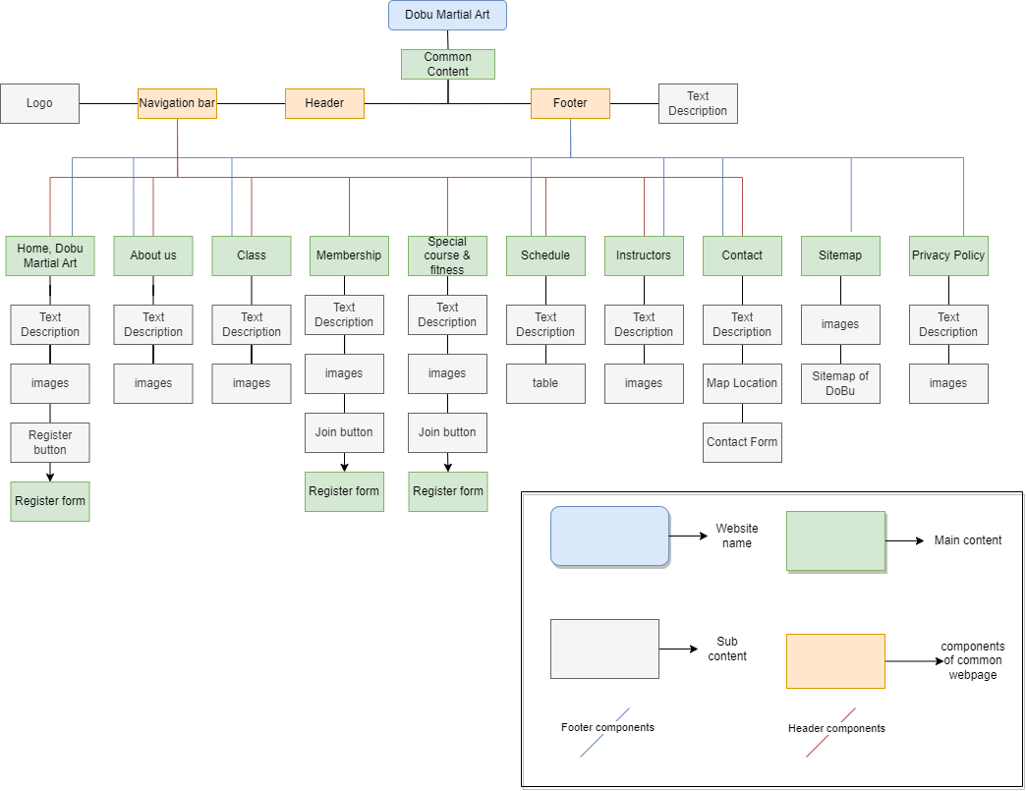

# Wireframe

Wireframe is an illustration of the website layout that contains contents, space allocations and functions of web page. Wireframes are used to design the basic structure of the website during early development process. Wireframe acts like a blueprint and helps the developers understand the design structure of the website that can be reliable at implementing visual design.

## Characteristics of wireframe

In order to design the wireframe efficiently, we need to understand the characteristic of wireframe. They are

* Meeting required content structure
* Display clear action for user
* Using navigation efficiently
* Control number of necessary components in main navigation
* Place the page order efficiently
* Determine what user most want to see

## Advantages of wireframe

There are many good points that developers and website designers like about wireframes. They are

* Simple to construct the website structure
* Provide structural blueprint for visual design
* Provide better decision-making experience
* Maintain risks
* Ease to determine that the ideas work or fail
* Less consuming of time, cost and computer memory

## Wireframe of DoBu Martial Art

### Common Content

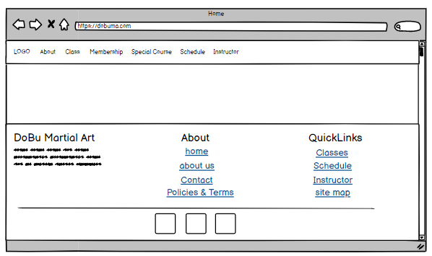

### Home

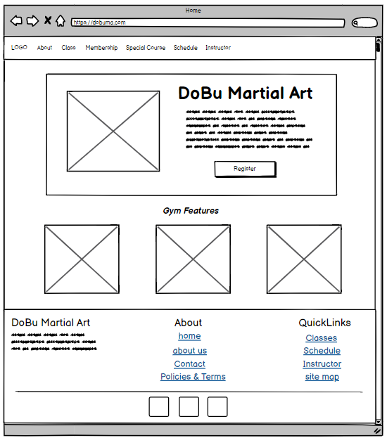

### Class

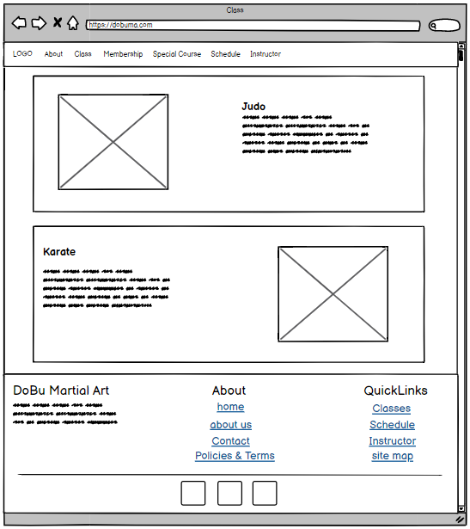

### Membership

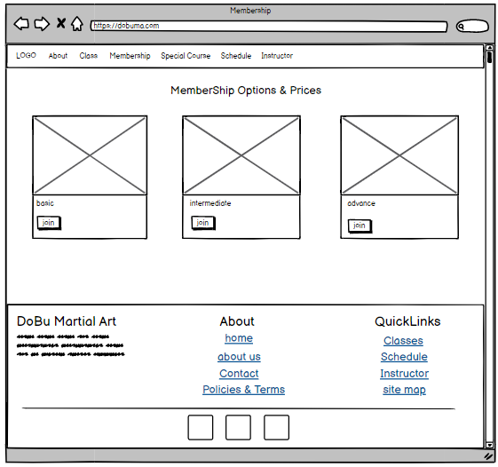

### Special Course

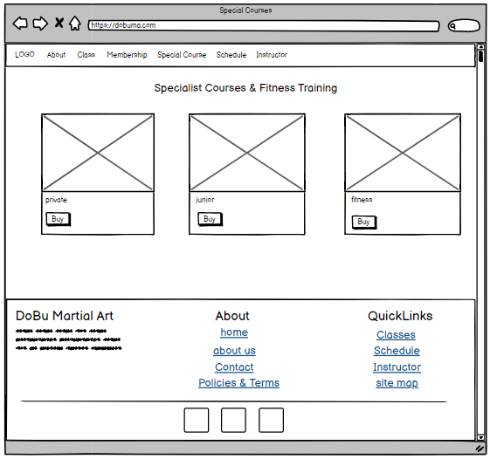

### Schedule

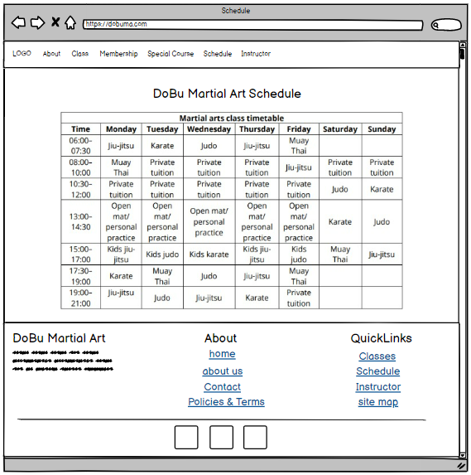

### Instructors

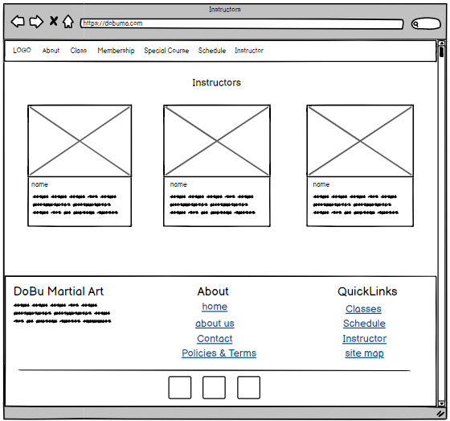

### About us

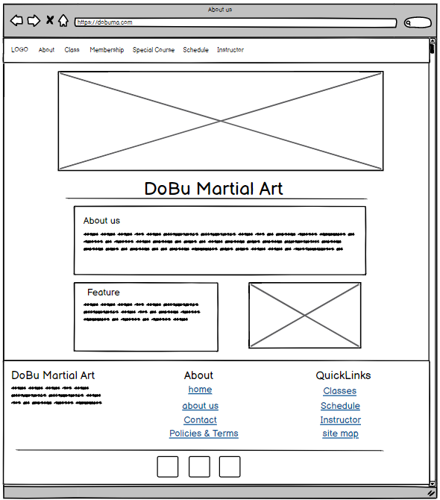

### Contact

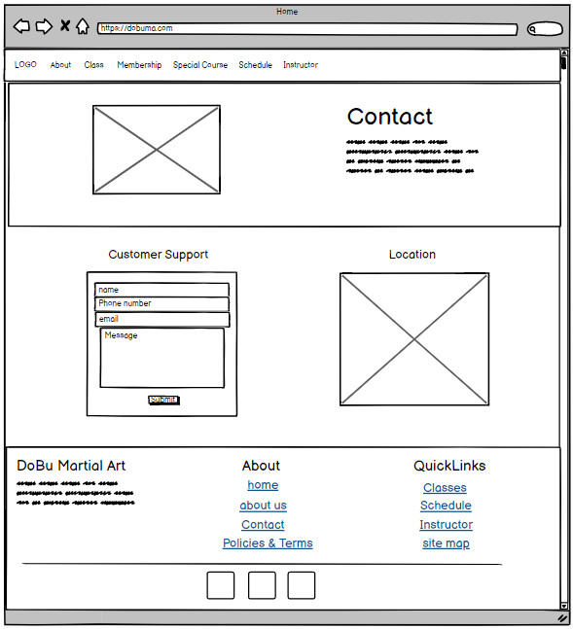

### Privacy policy

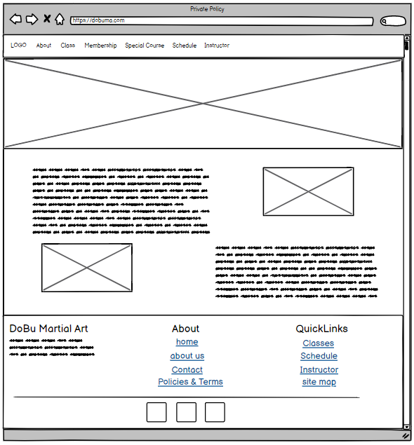

### Sitemap

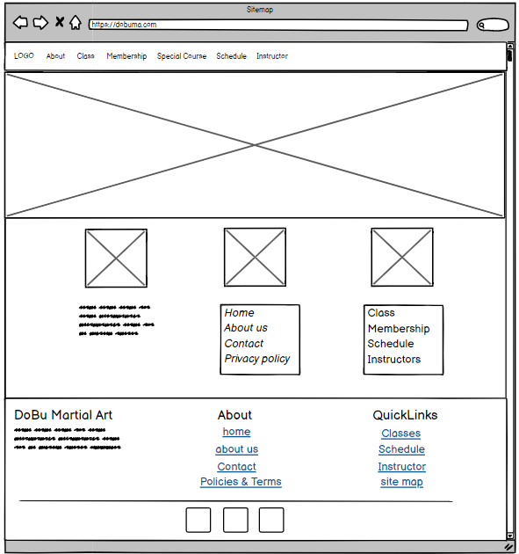

### Registration Form

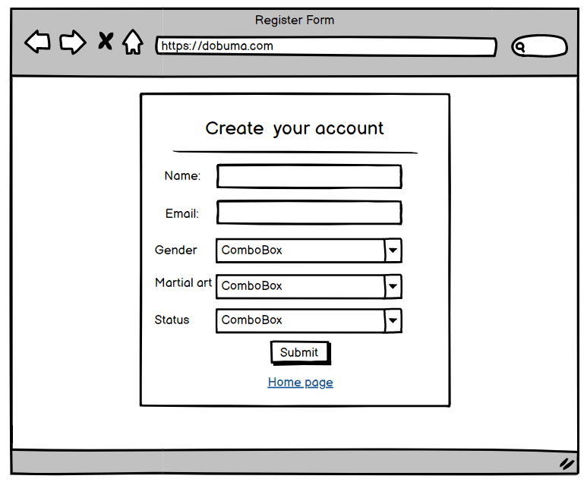

### Admin

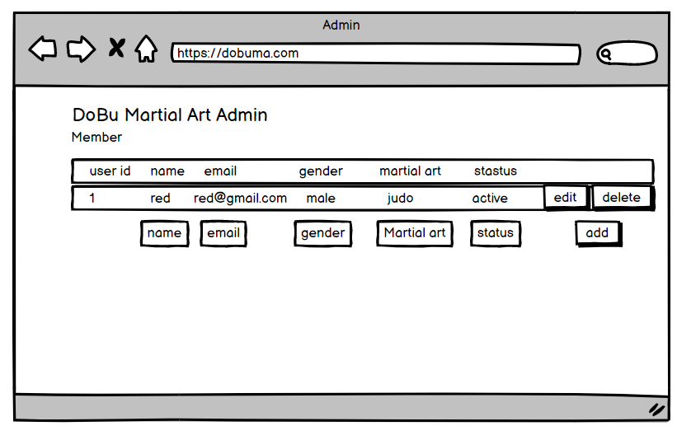

# Storyboard

Storyboard provides the order of the components within the web page, grids and structure of the web page and connections between the web page. This helps the developers and designers to analyze the final result of the web project.

## Characteristics of storyboard

* Determine clear goal and ideas for each web page
* Draw contents on each page to visualize the final result
* Provide connection between web pages
* Consider things that need to test before the project is delivered

## Advantages of storyboard

* Ease for team collaboration and brainstorming
* Help to visualize the final result
* Provide connections between web pages
* Ease to identify weakness and bugs of web design
* Less consume budget and time

## Storyboard of DoBu Martial Art

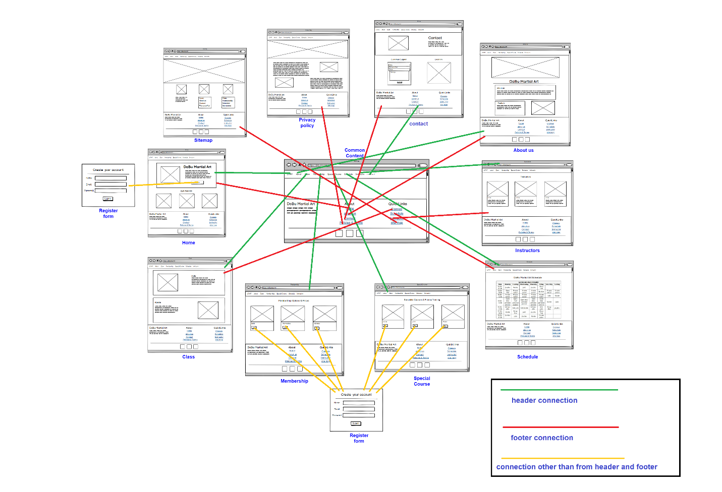

### Connections from header

|  |  |
| --- | --- |
| Items from header, navigation bar | Connected webpages |
| 1. Home, DoBu Martial Art | index.html |
| 1. Classes | classes.html |
| 1. Membership | membership.html |
| 1. Special course | specialCourse.html |
| 1. Schedule | schedule.html |
| 1. Instructors | instructors.html |
| 1. About us | aboutUs.html |
| 1. Contact | contact.html |

### Connections from footer

|  |  |
| --- | --- |
| Items from footer | Connected webpages |
| 1. Home, DoBu Martial Art | index.html |
| 1. Classes | classes.html |
| 1. Schedule | schedule.html |
| 1. Instructors | instructors.html |
| 1. About us | aboutUs.html |
| 1. Contact | contact.html |
| 1. Privacy Policy | privacy.html |
| 1. Sitemap | sitemap.html |

### Connections other than header and footer

|  |  |  |
| --- | --- | --- |
| Web page | Items | Connected webpage |
| Home, DoBu Martial Art | 1. register button | 1. registrationForm.html |
| Course | 1. join | 1. registratuionForm.html |

# Implementation of branded, multi-page website for DoBu Martial Art supported with realistic content

## Implementation of .html and .css files

|  |  |  |
| --- | --- | --- |
| Files type | Name | Reason |
| HTML | 1. index.html 2. classes.html 3. membership.html 4. specialCourse.html 5. schedule.html 6. instructors.html 7. aboutUs.html 8. contact.html 9. privacy.html 10. sitemap.html 11. registrationForm.html 12. user.html | 1. for home, DoBu Martial Art page 2. for classes page 3. for membership page, 4. for special course page 5. for schedule page 6. for instructor page 7. for about us page 8. for contact page 9. for privacy policy page 10. for sitemap page 11. for registration form page 12. admin page |
| CSS | 1. index.css 2. classes.css 3. membership.css 4. specialCourse.css 5. schedule.css 6. instructors.css 7. aboutUs.css 8. contact.css 9. privacy.css 10. sitemap.css | To embed style for nav bar, footer, margin, layout, body, color, images, container, jumbotron for each page |
| JS | 1. classes.js 2. instructors.js 3. sitemap.js 4. registrationForm.js | 1. for intro, history and video tabs 2. to hide and show titles 3. for menu list 4. for input validation and store data at local storage |

## Home page, index.html

Home page for DoBu Martial Art include index.html and index.css. Home page design is built with bootstrap nav bar, footer, jumbotron, grids system, cards image overlay and other html elements. Screen capture of home page and coding of index.html are provided.

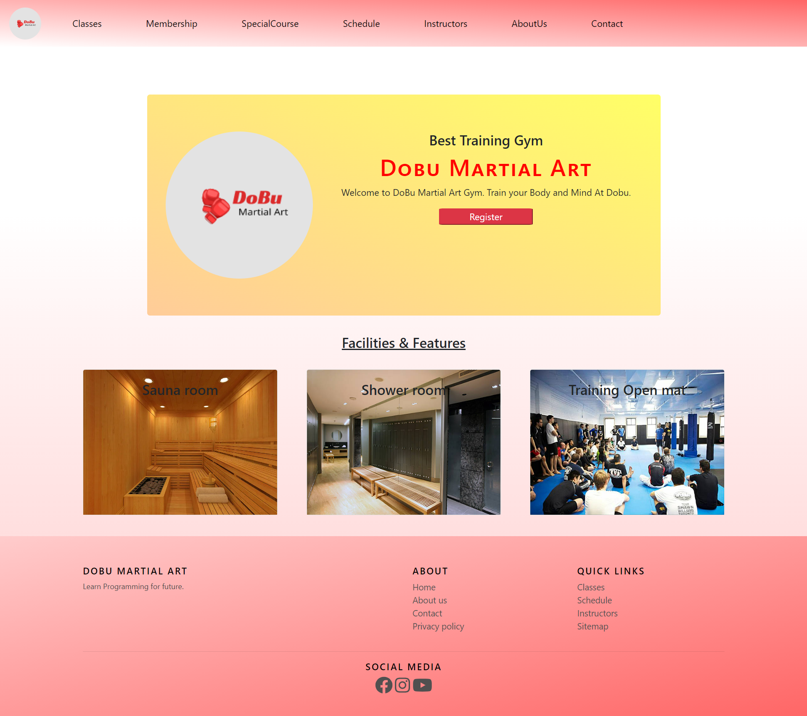

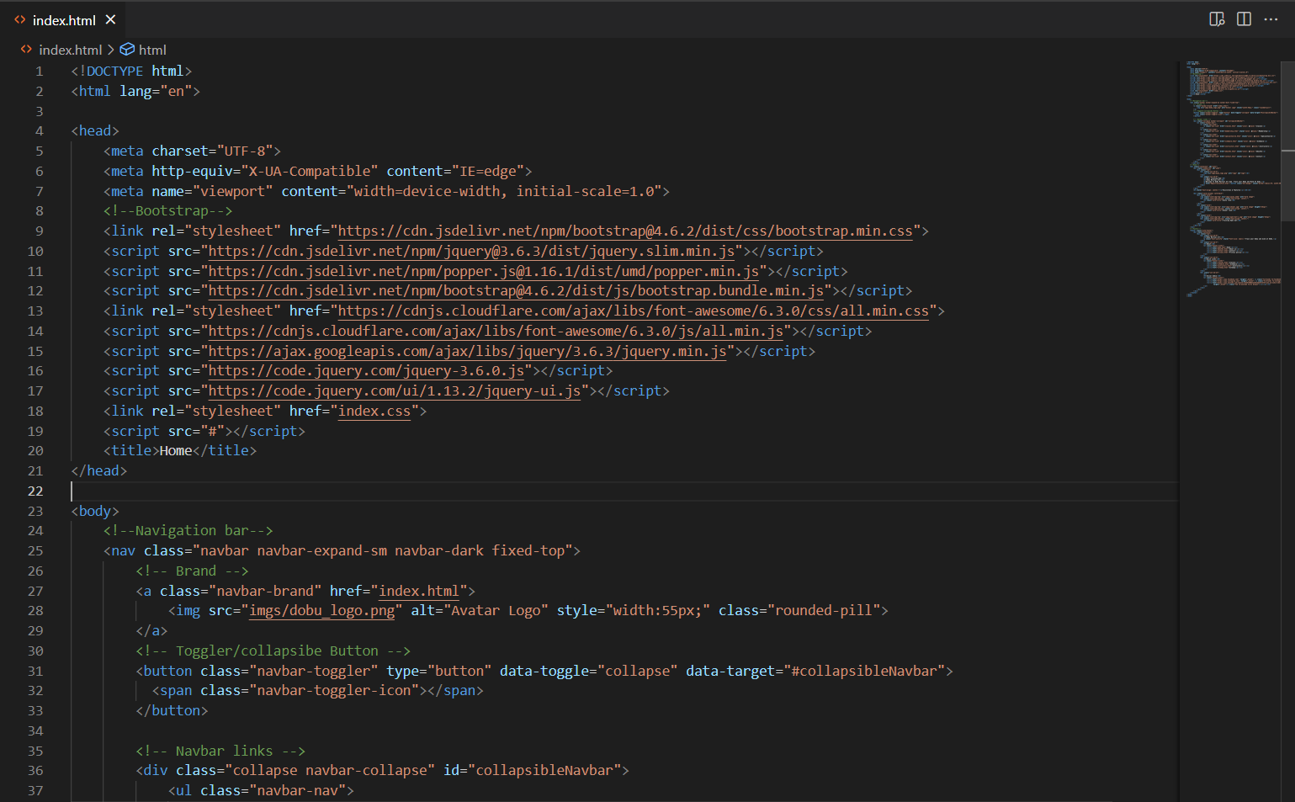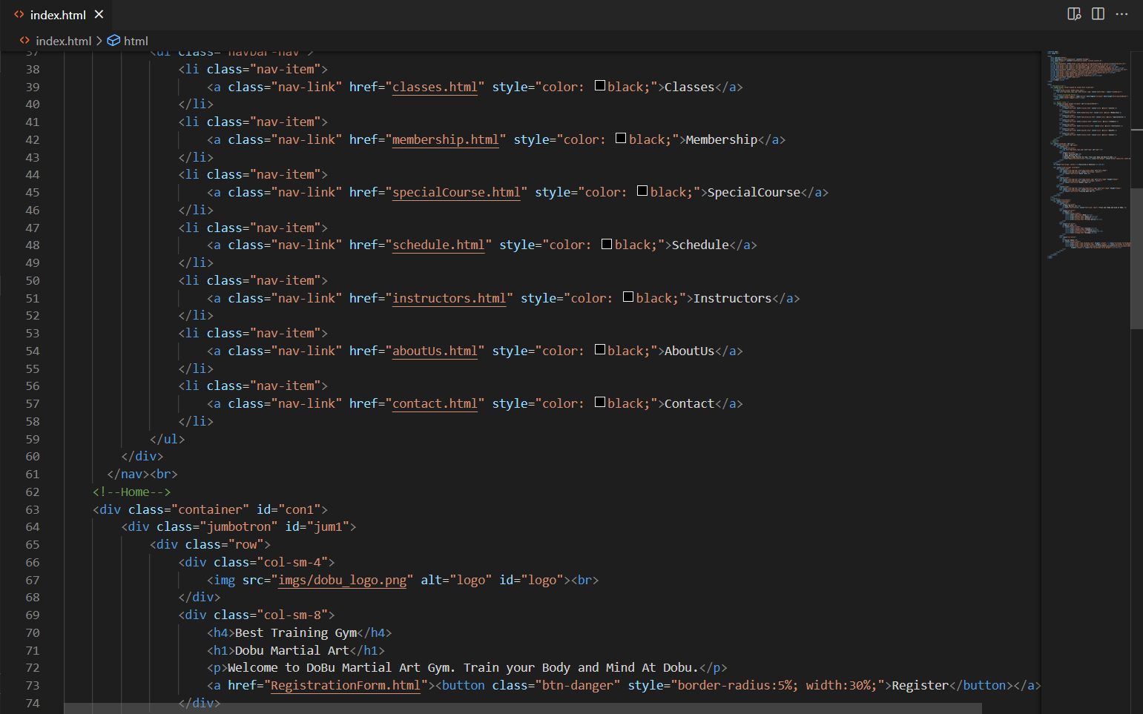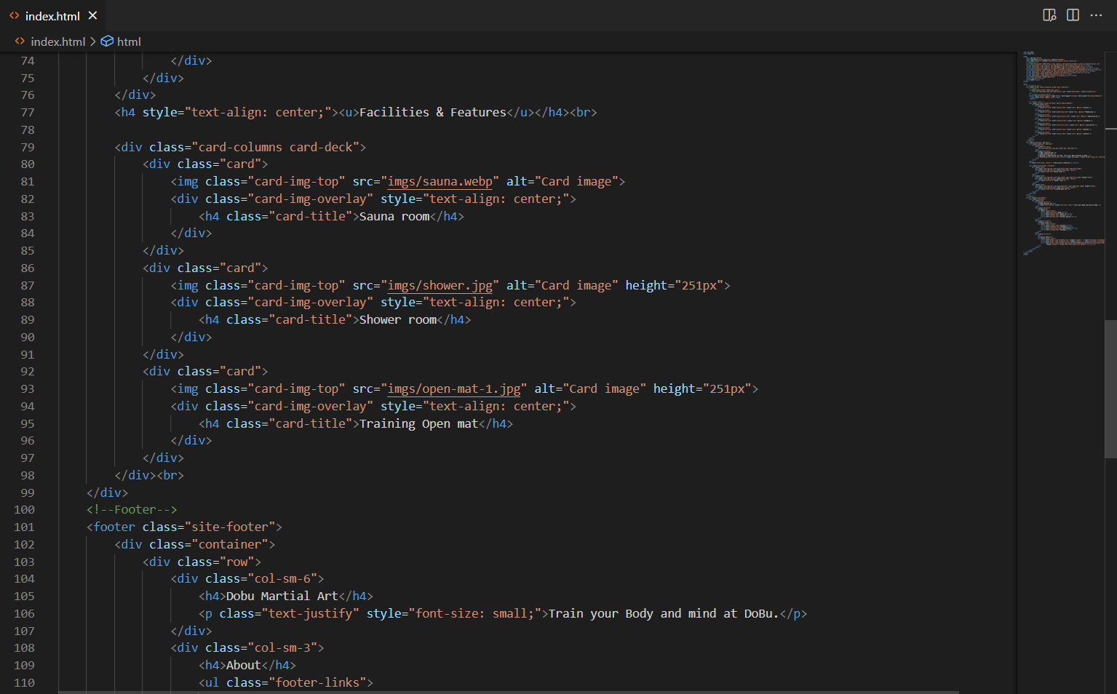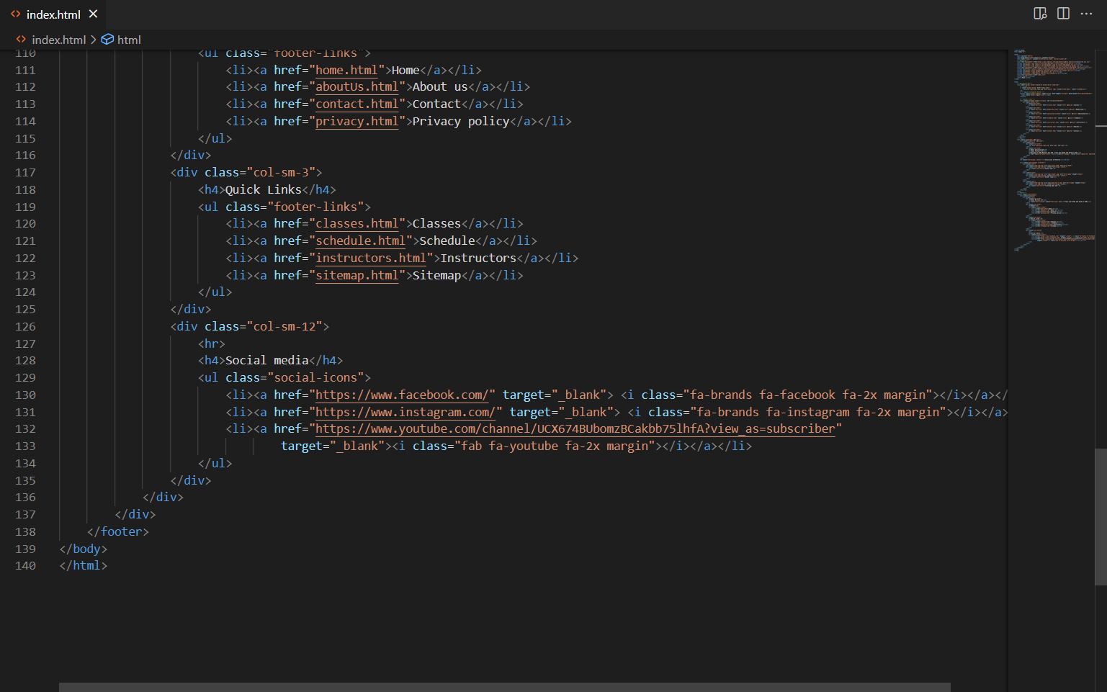

## classes.html

Classes page is built with classes.html, classes.css and classes.js. Within classes.html navbar, footer, bootstrap grids system, jumbotron and other html elements are used. Classes.css contains design implementation for navbar, footer and other layouts. Classes.js includes jQuery tabs for intro, history, video and text implementation for tabs. The output result for classes pages and coding of classes.html are provided.

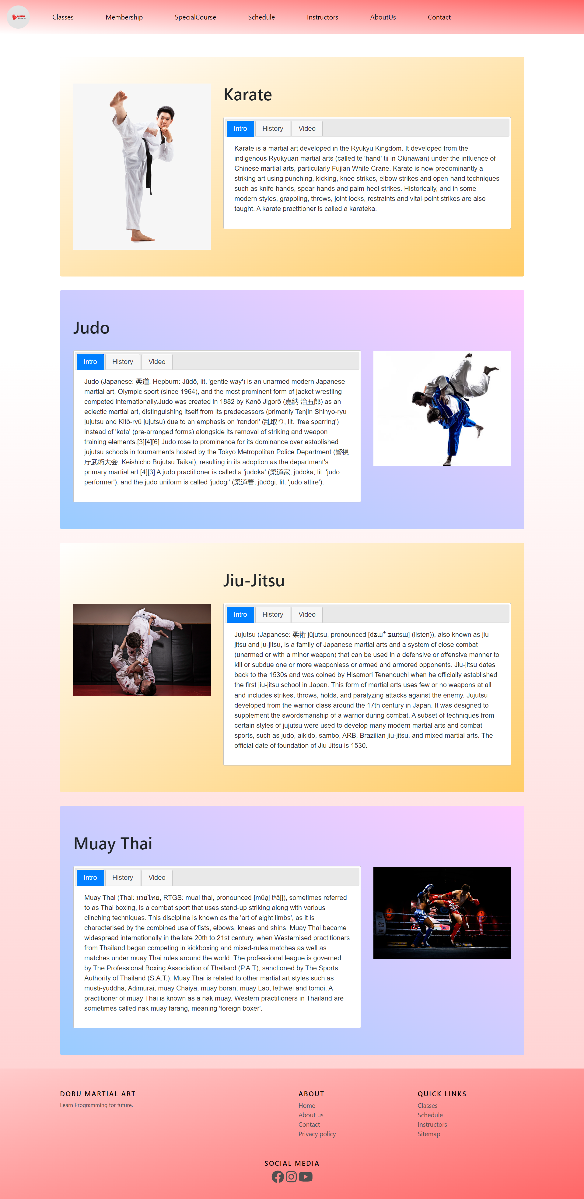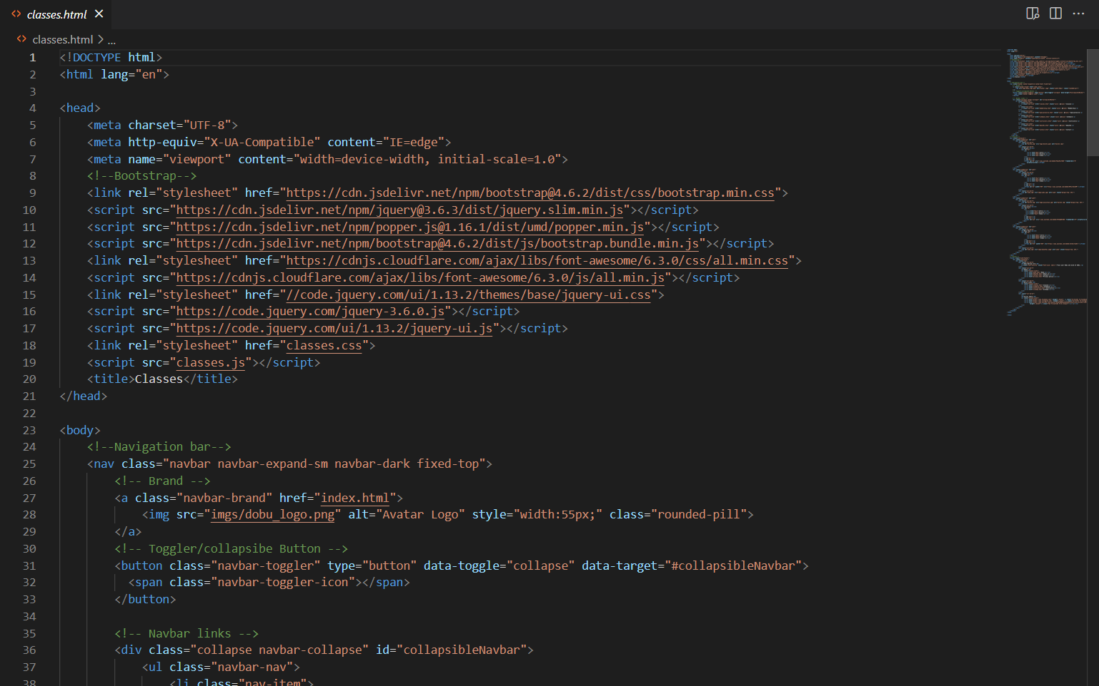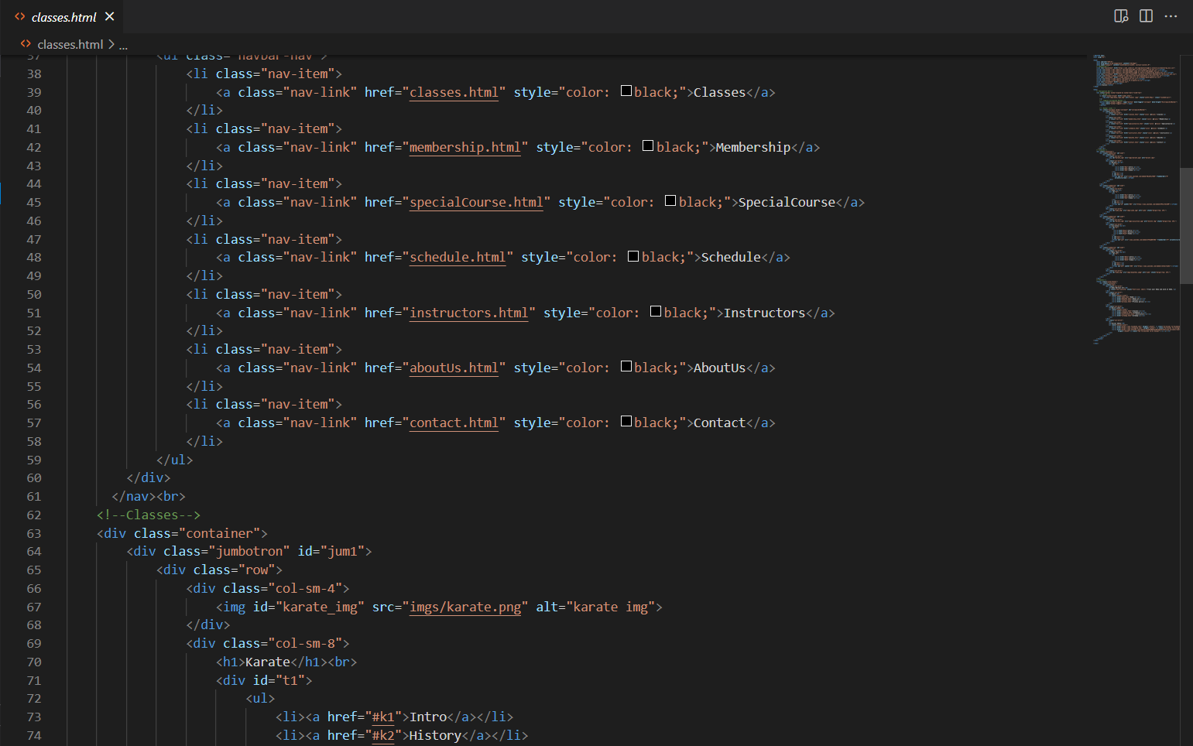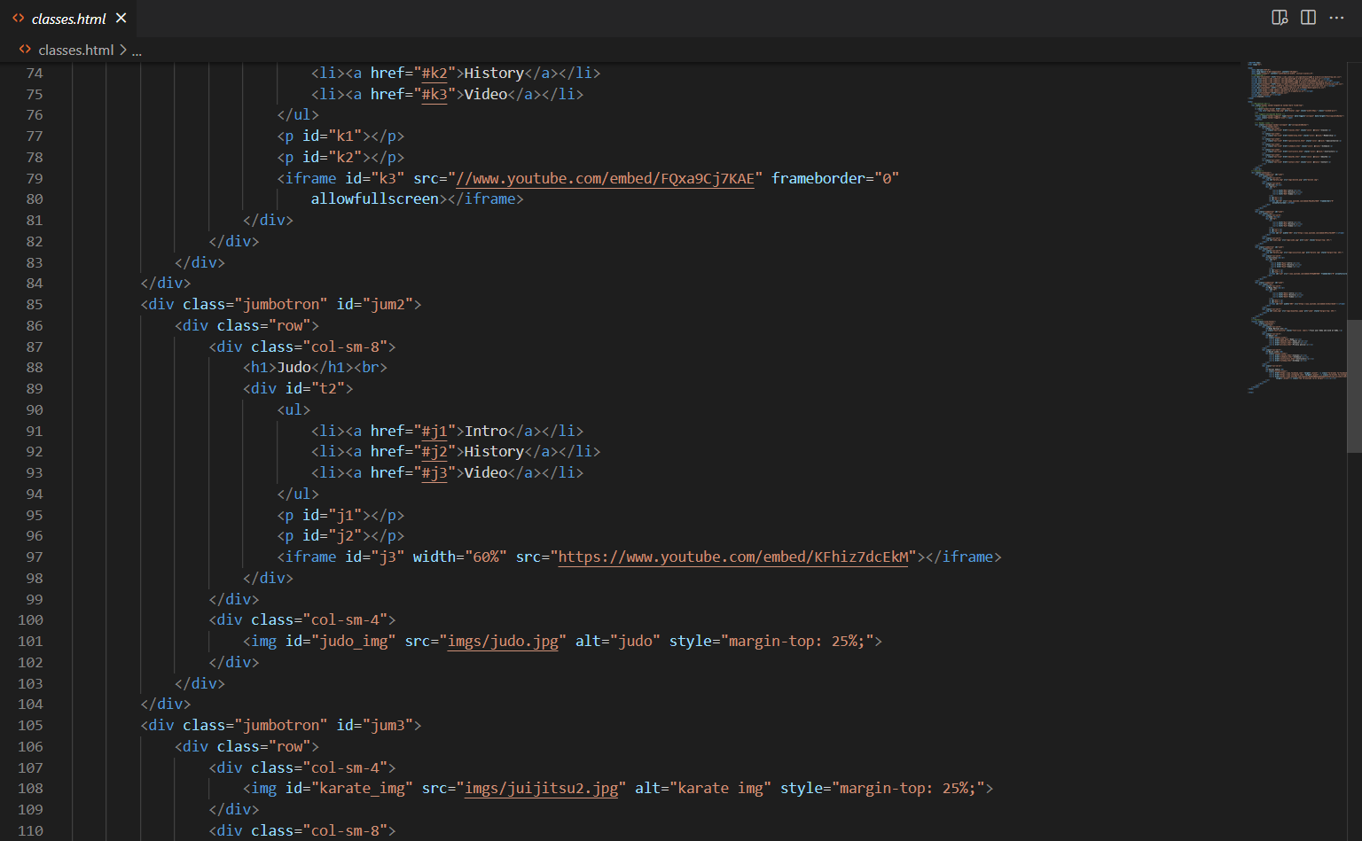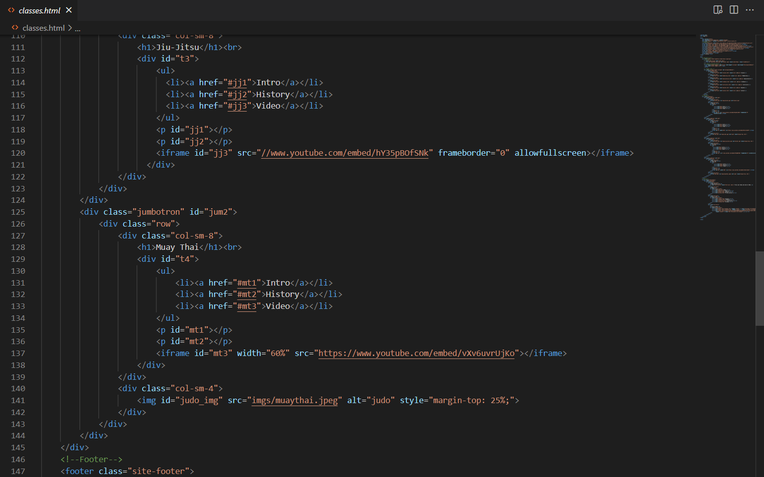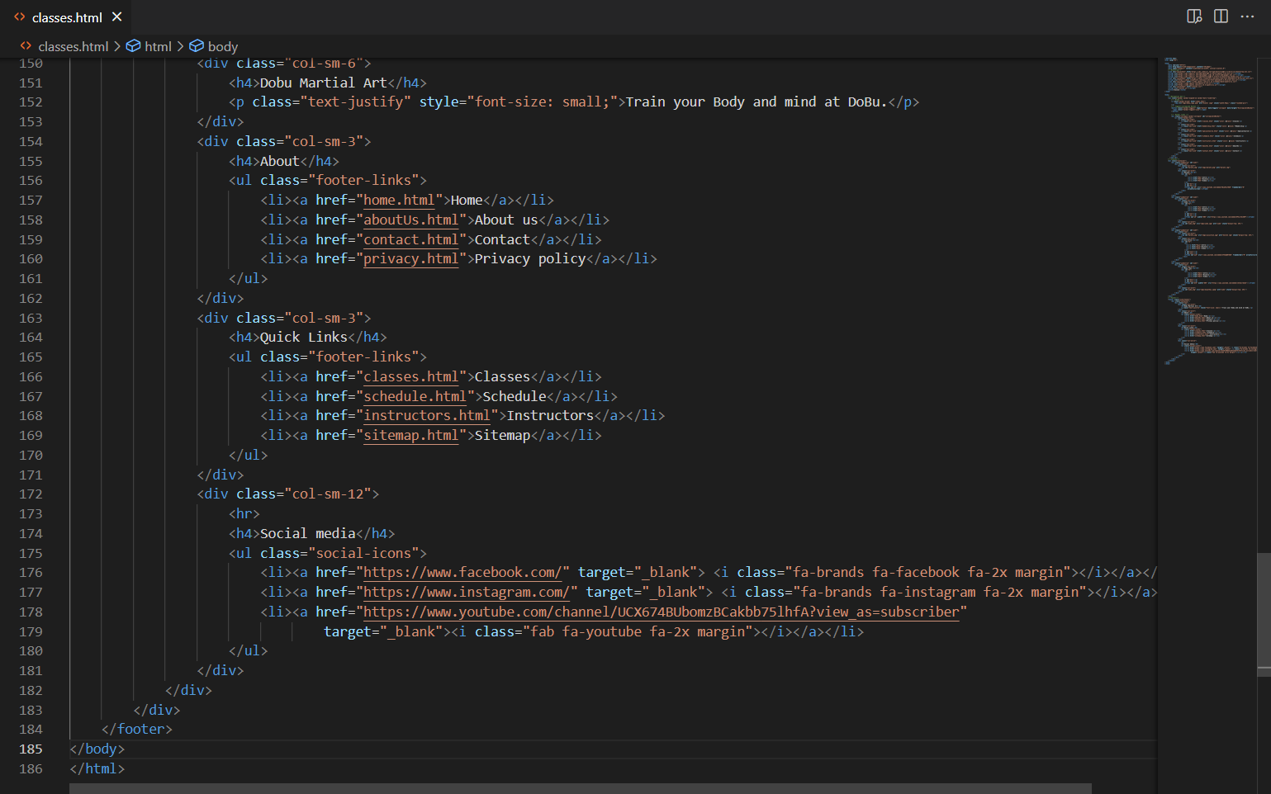

## membership.html

Membership page include membership.html and membership.css. Membership.html contains html elements, navbar, footer, bootstrap grids system, cards, tables. Membership.css contains CSS code for navbar, footer. The following are screen capture of membership page and membership.html.

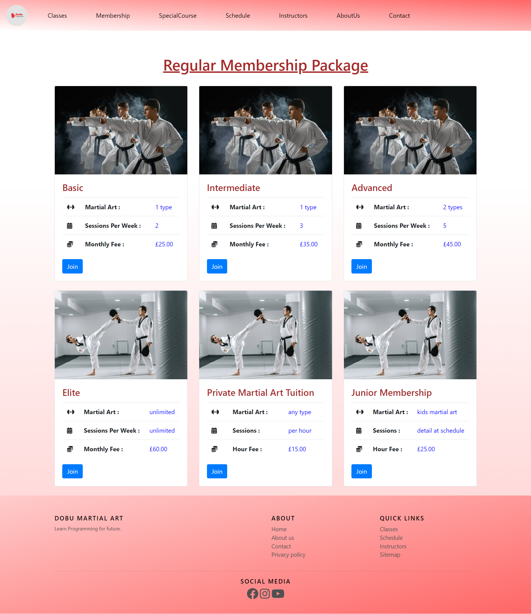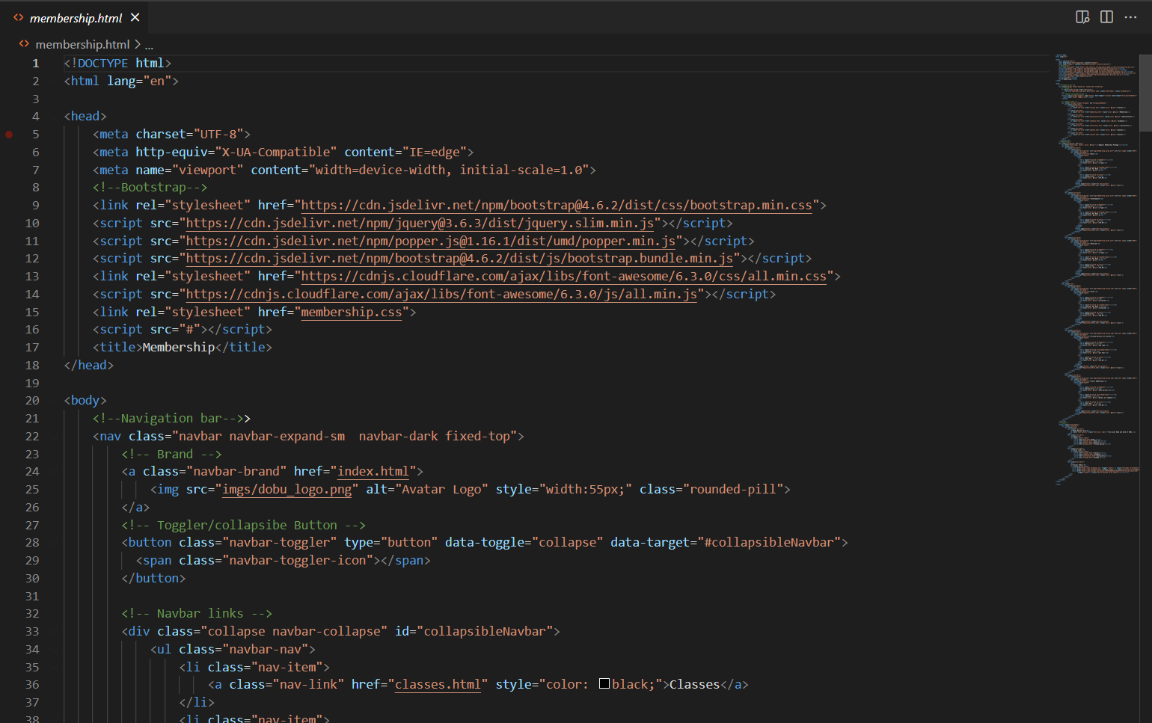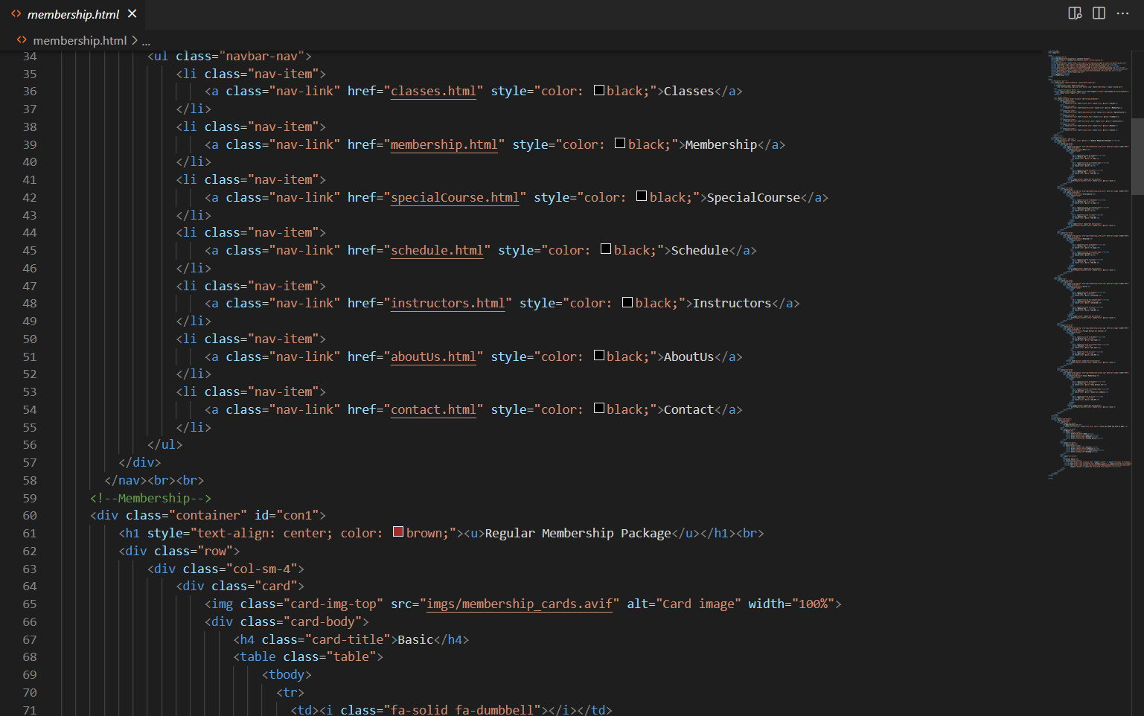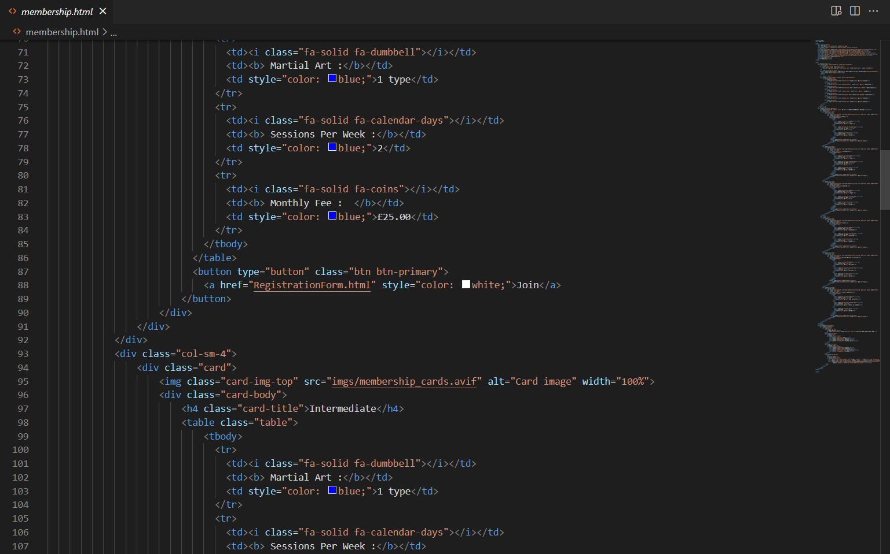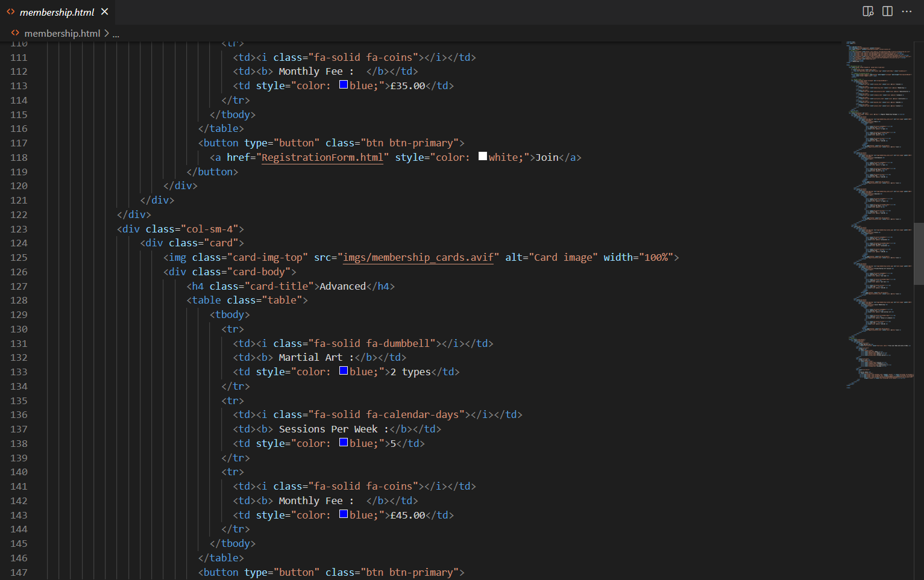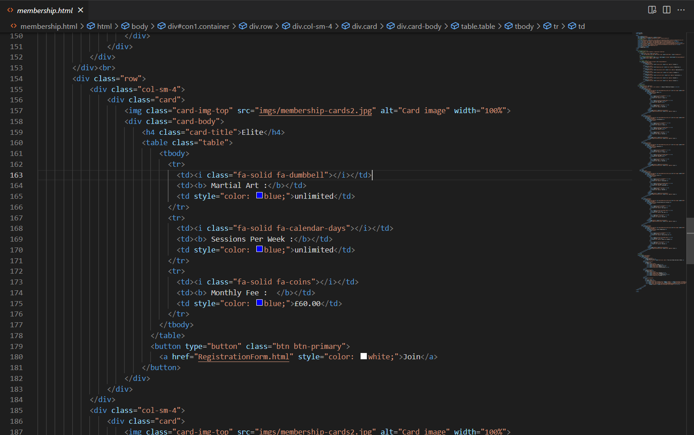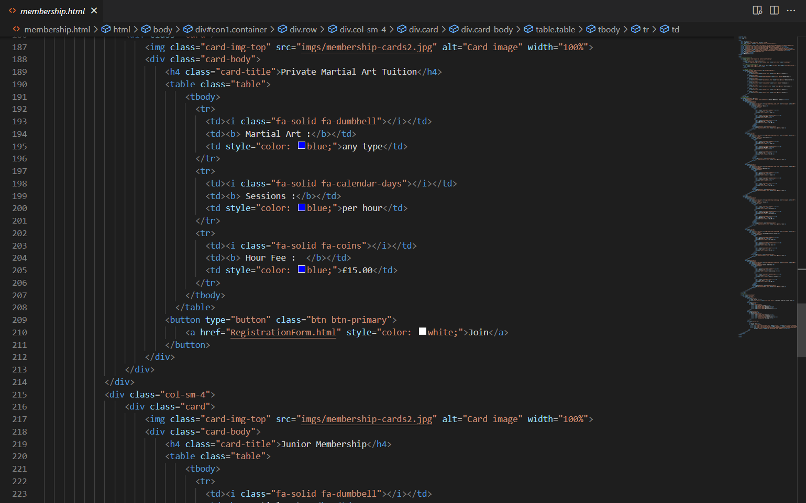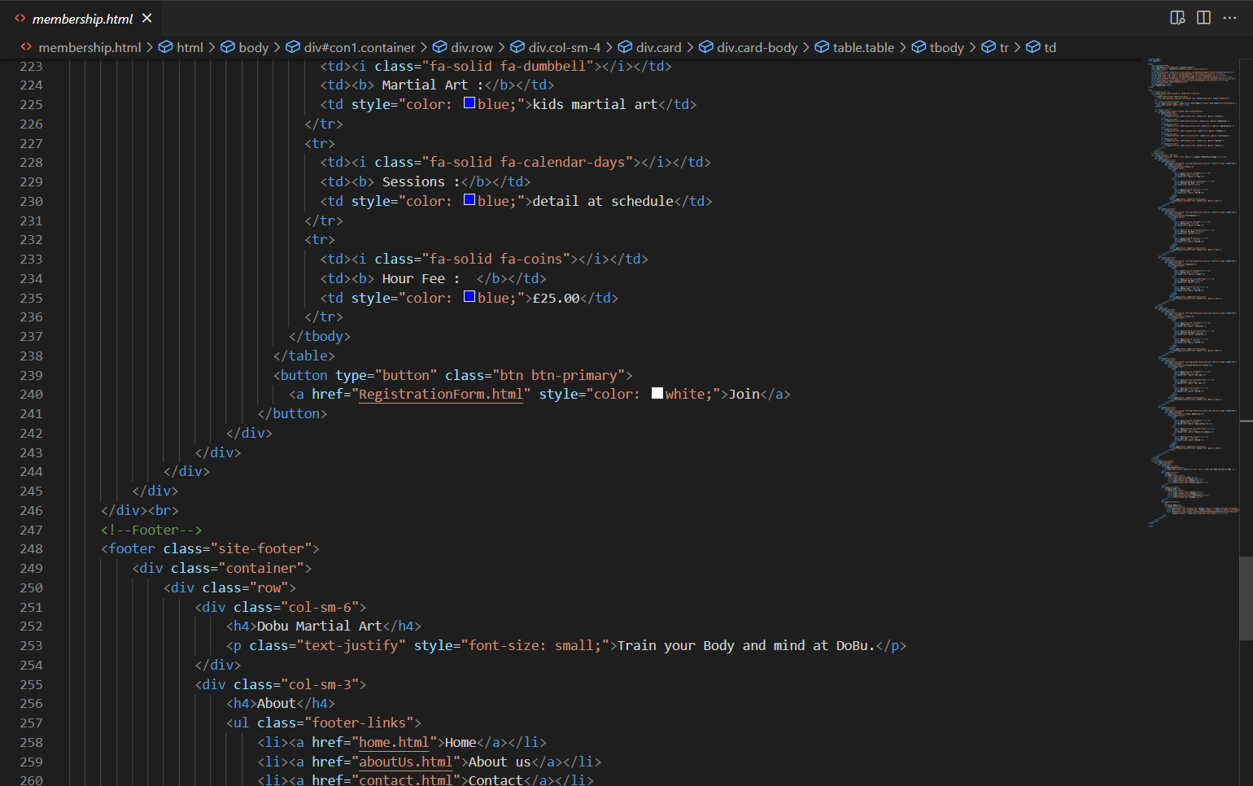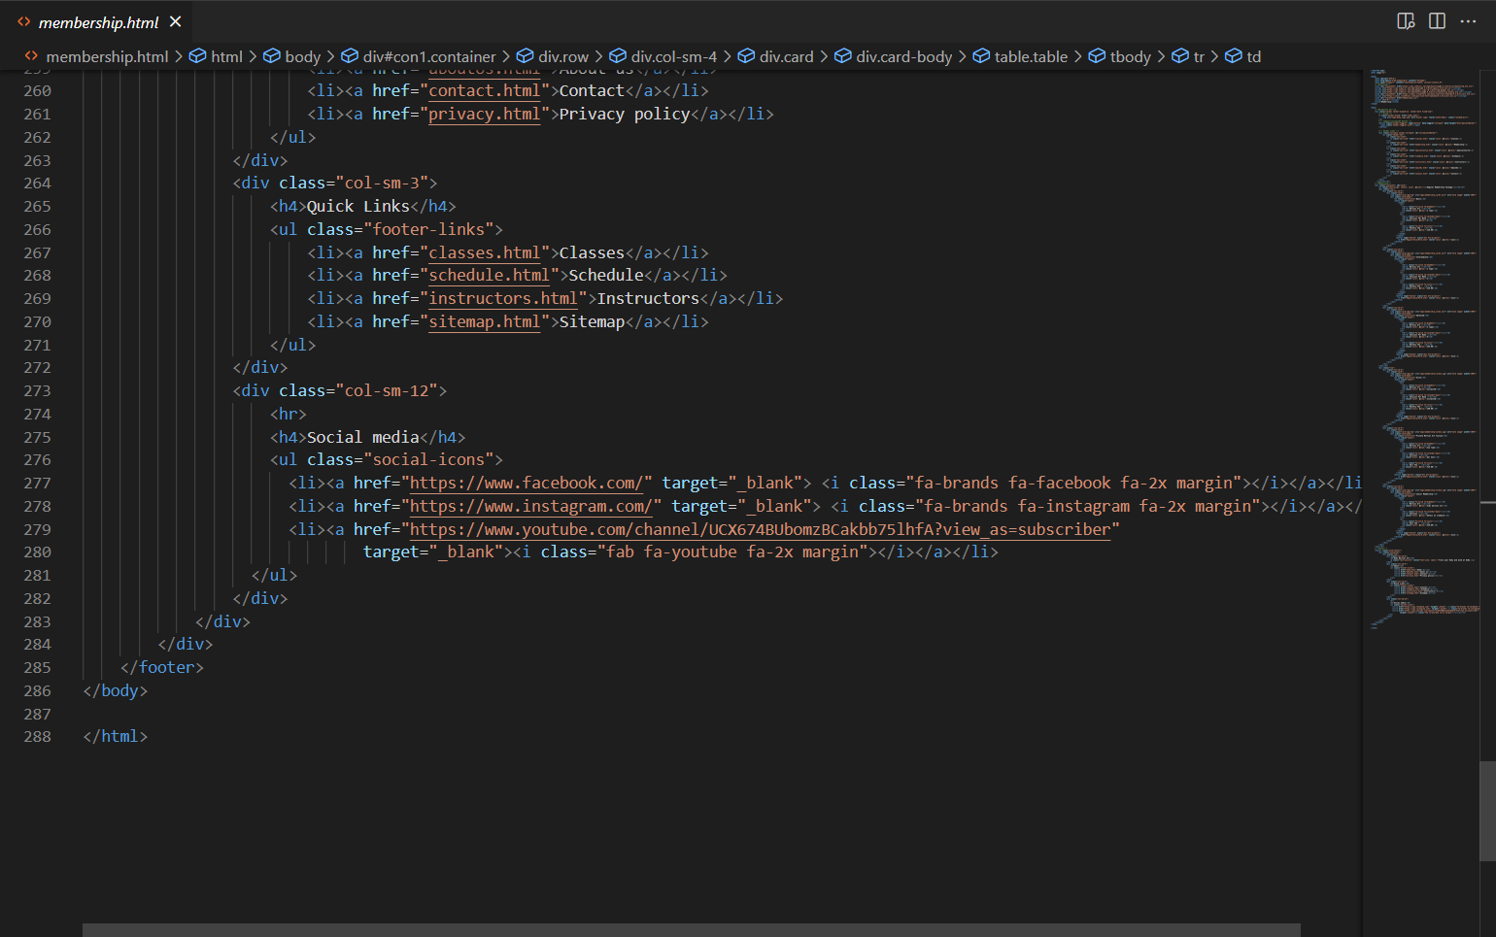

## specialcourse.html

Special Course page is built with specialCourse.html and specialCourse.css. specialCourse.html contains html elements, navbar, footer, bootstrap grids system, cards, tables. specialCourse.css contains CSS code for navbar, footer. The following are screen capture of special course page and specialCourse.html.

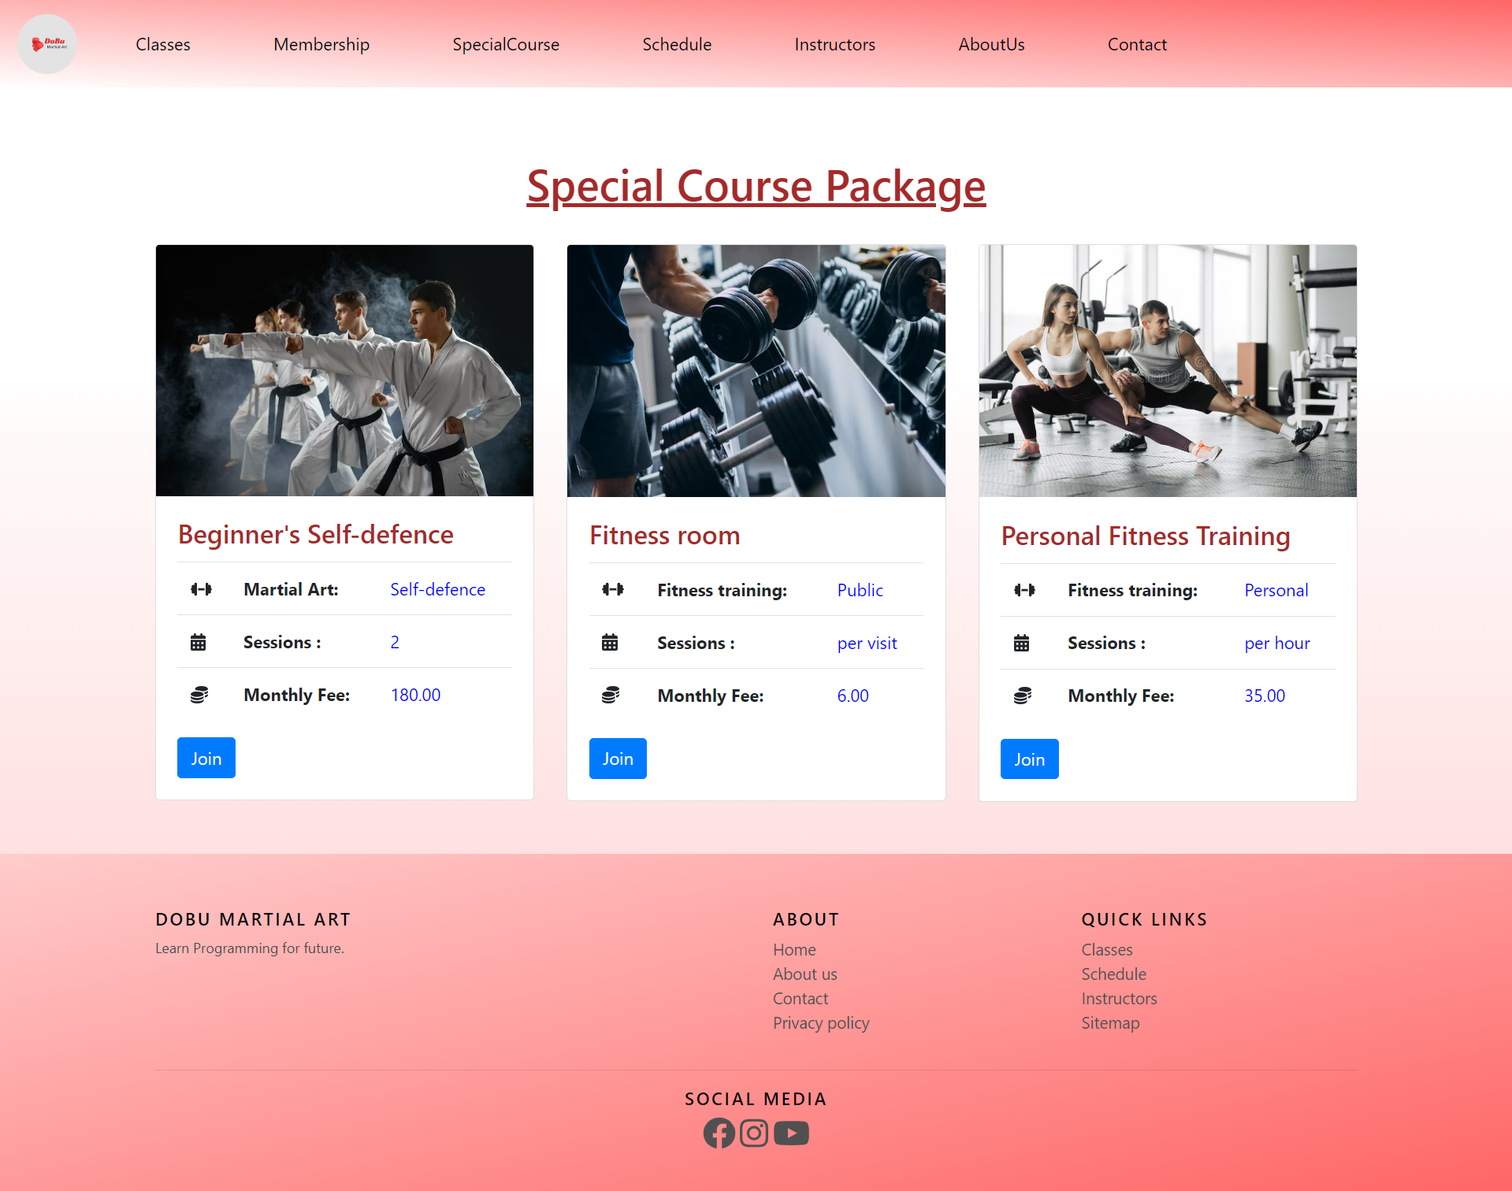

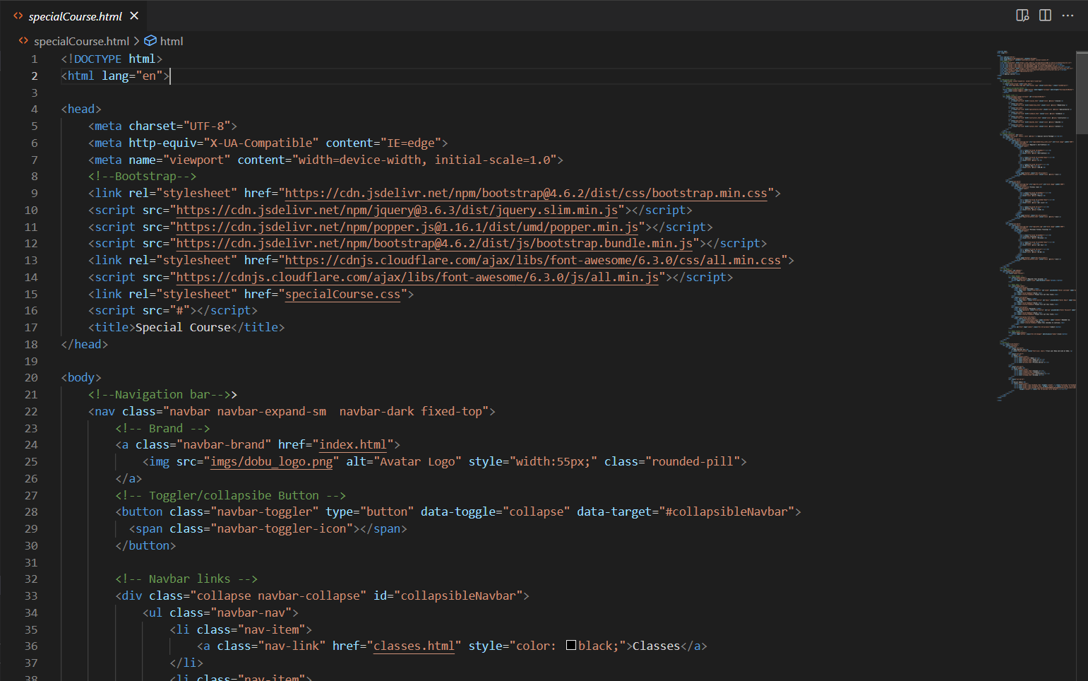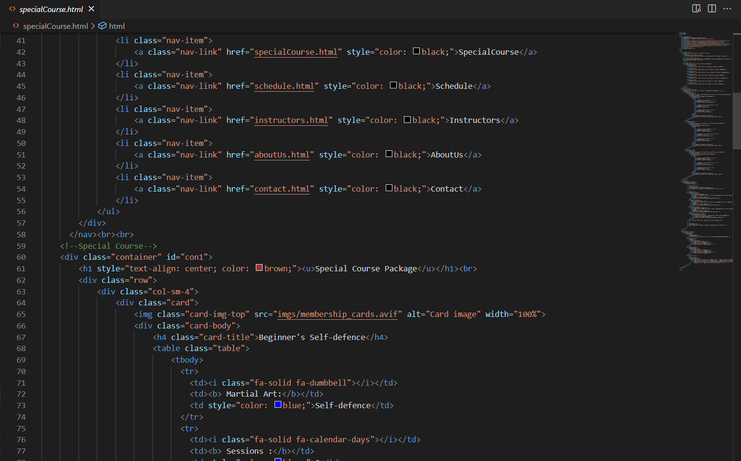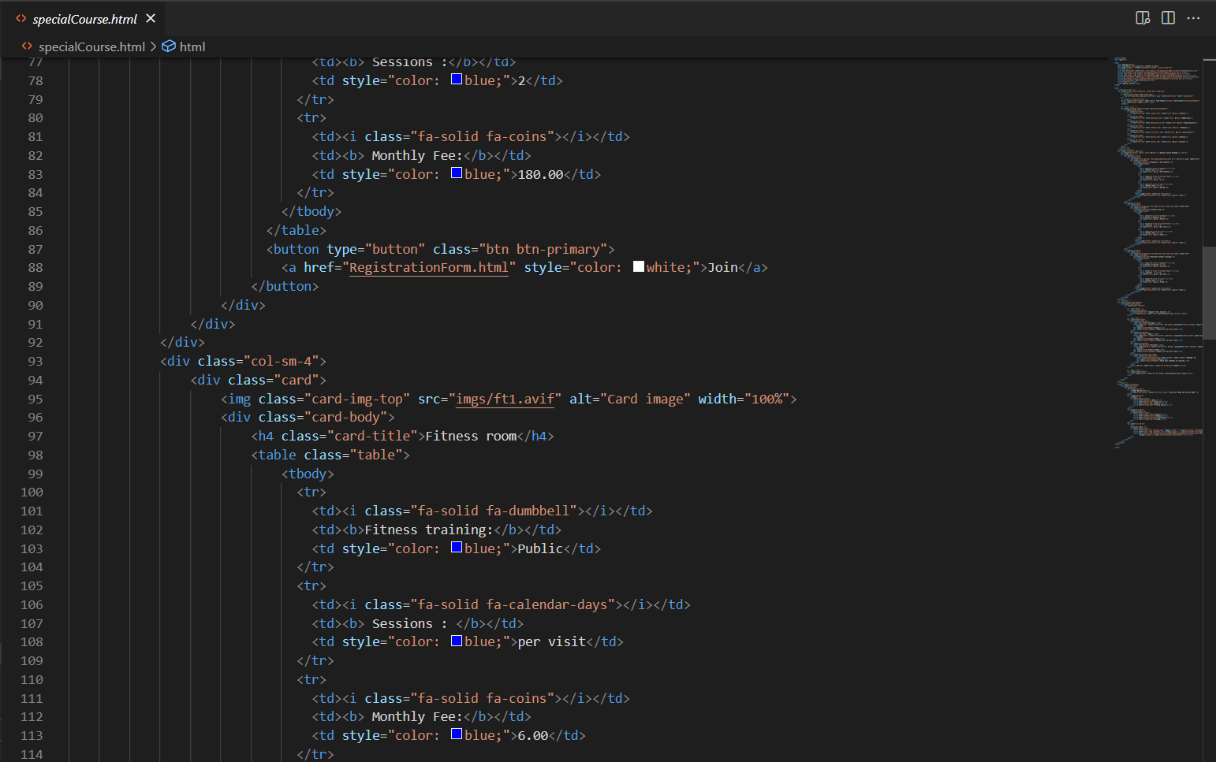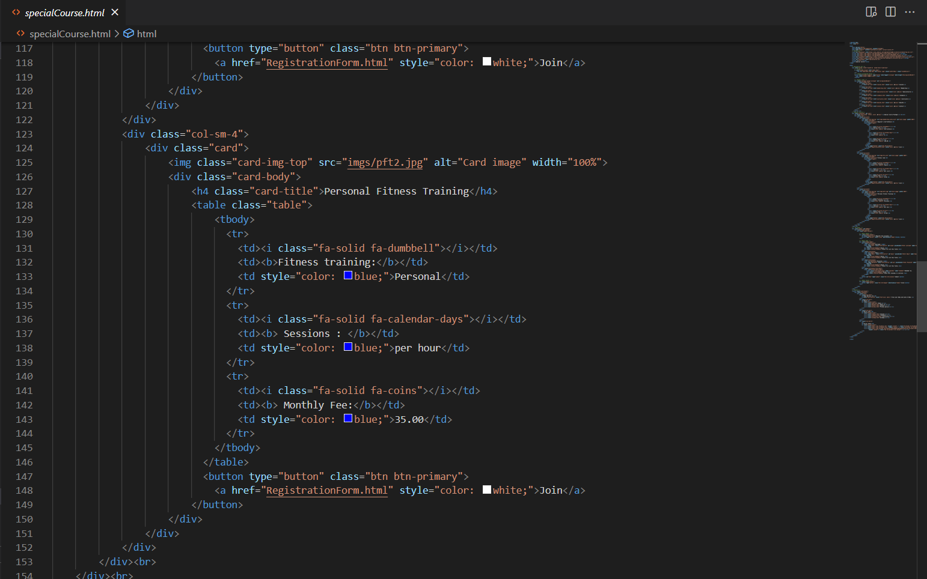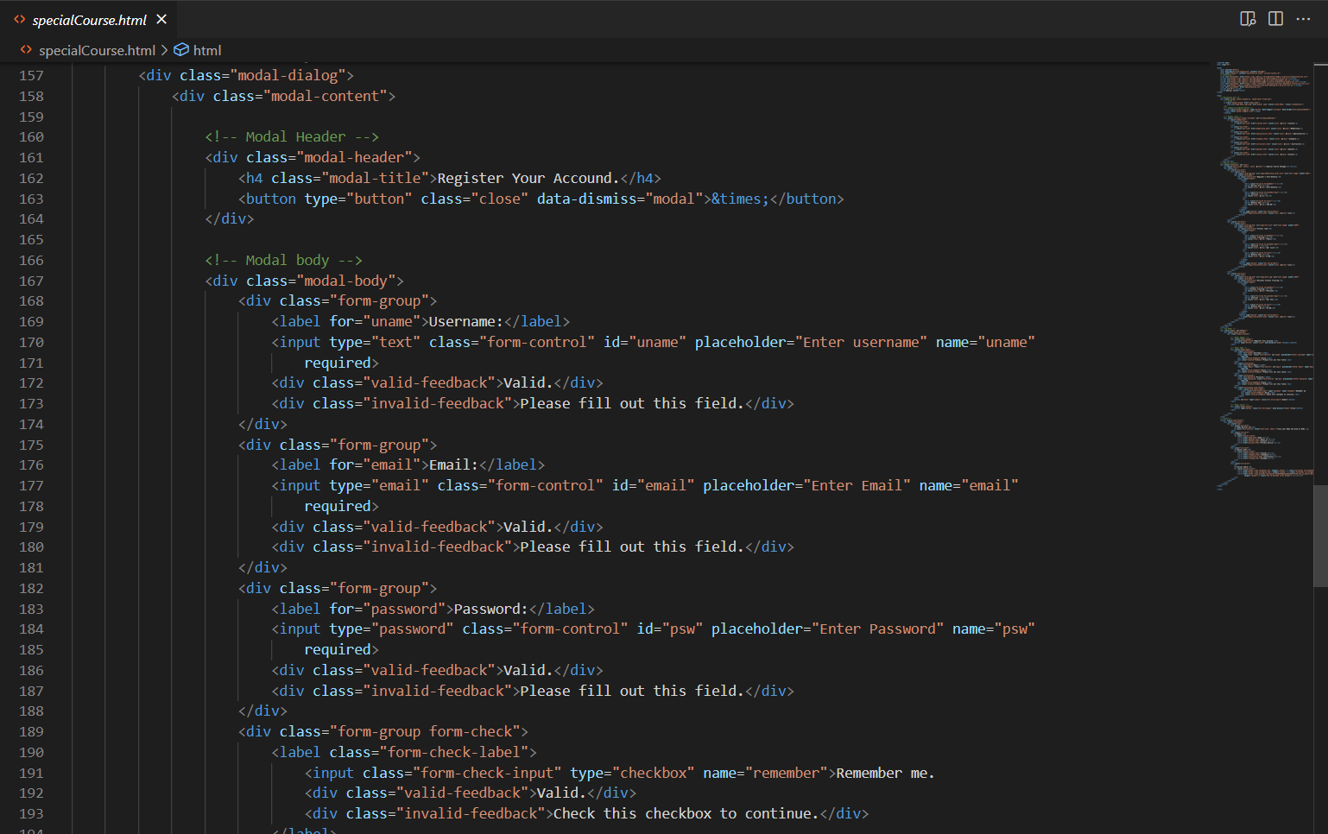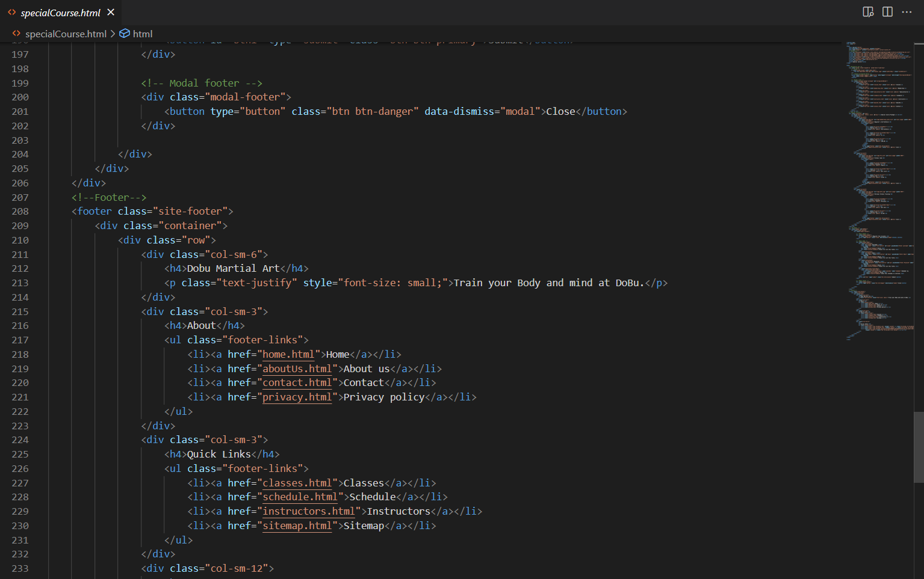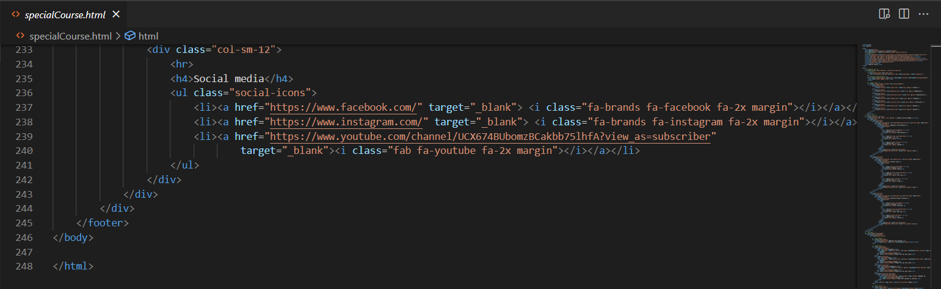

## schedule.html

Schedule course is built with schedule.html and schedule.css. Schedule.html contains html elements like heading and bootstrap table. Schedule.css includes css code for header and footer.

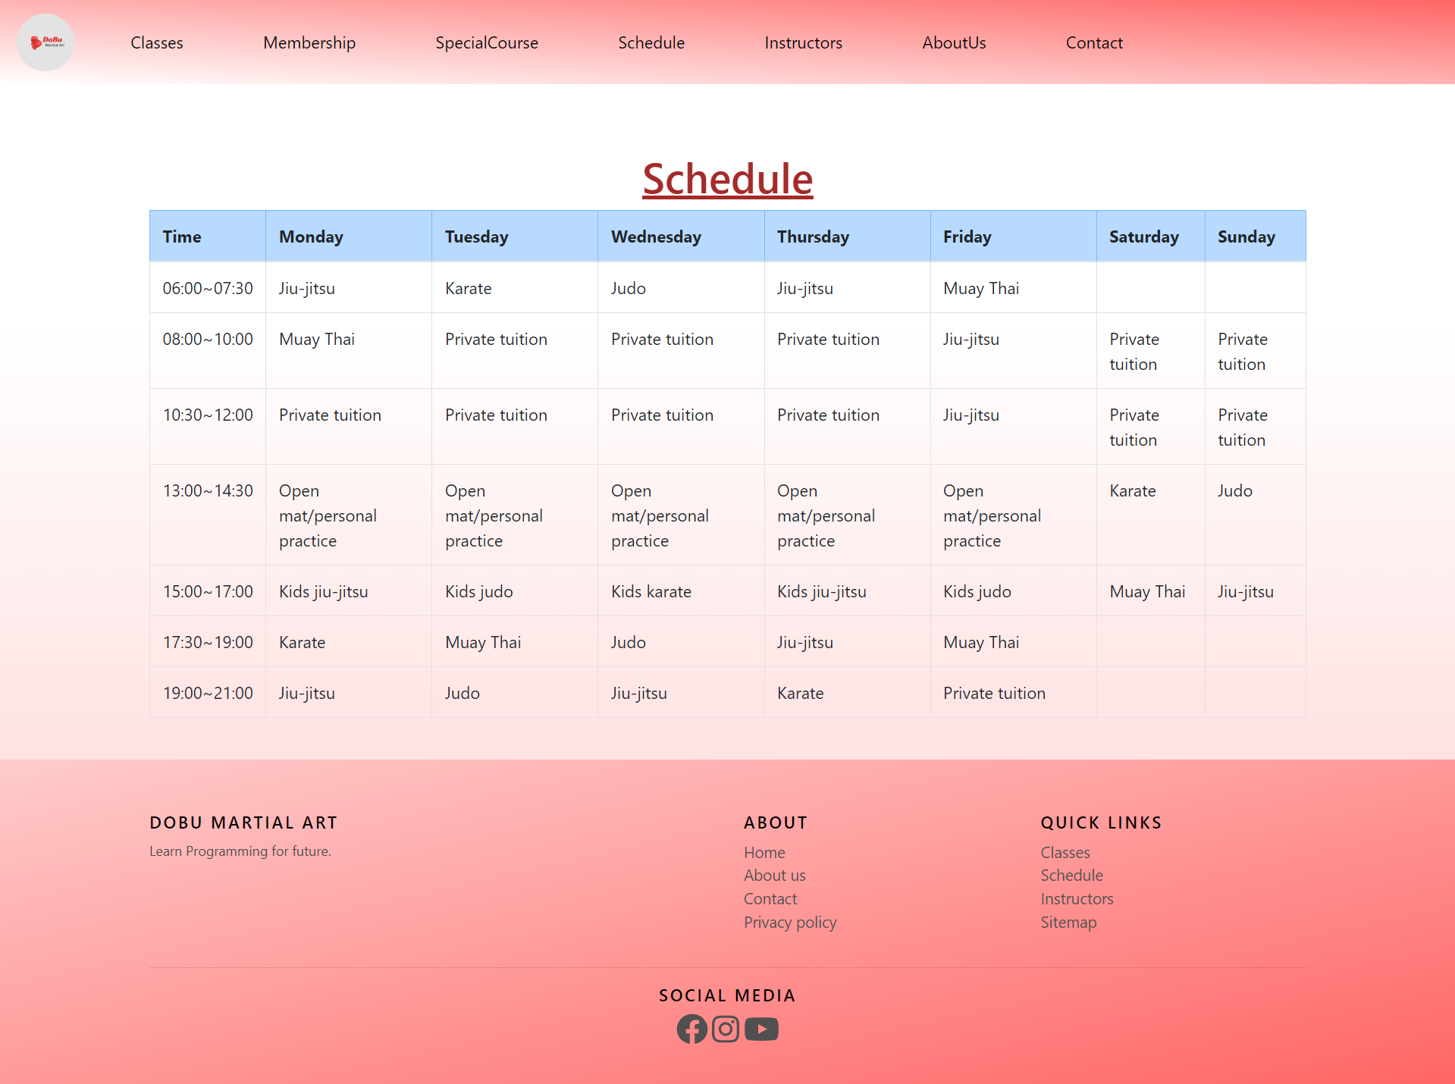

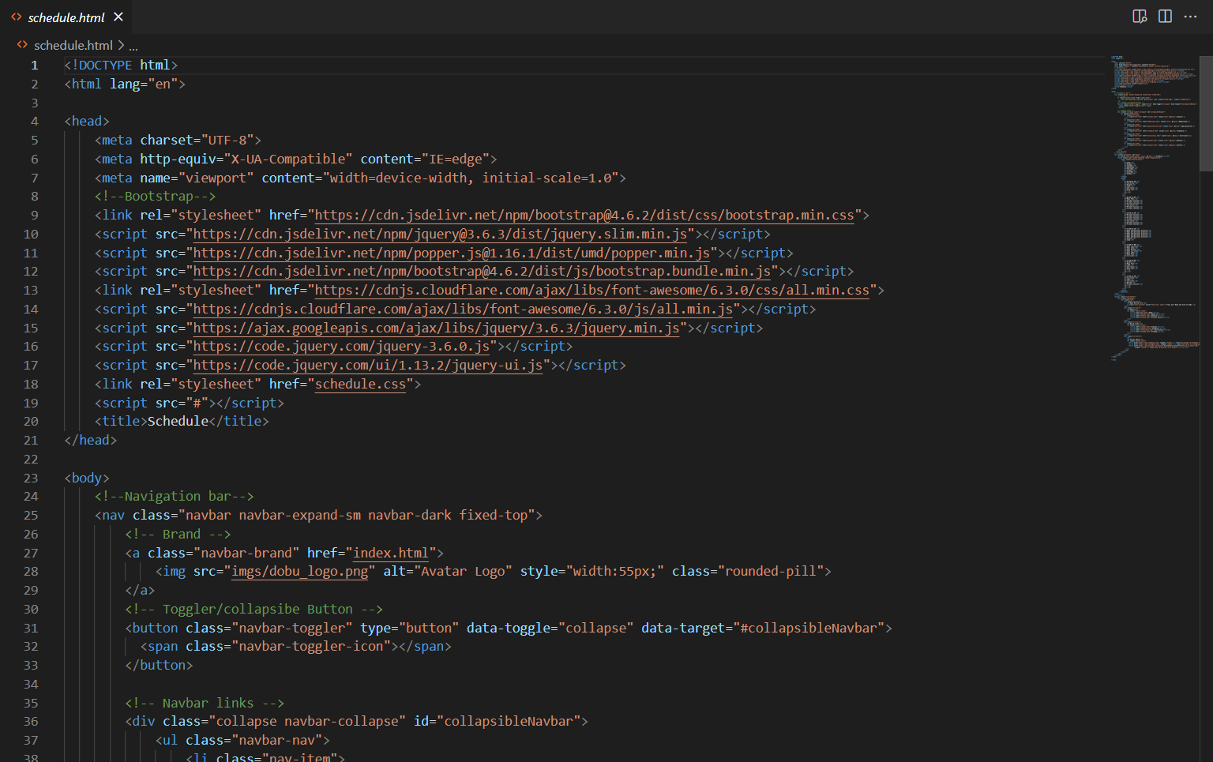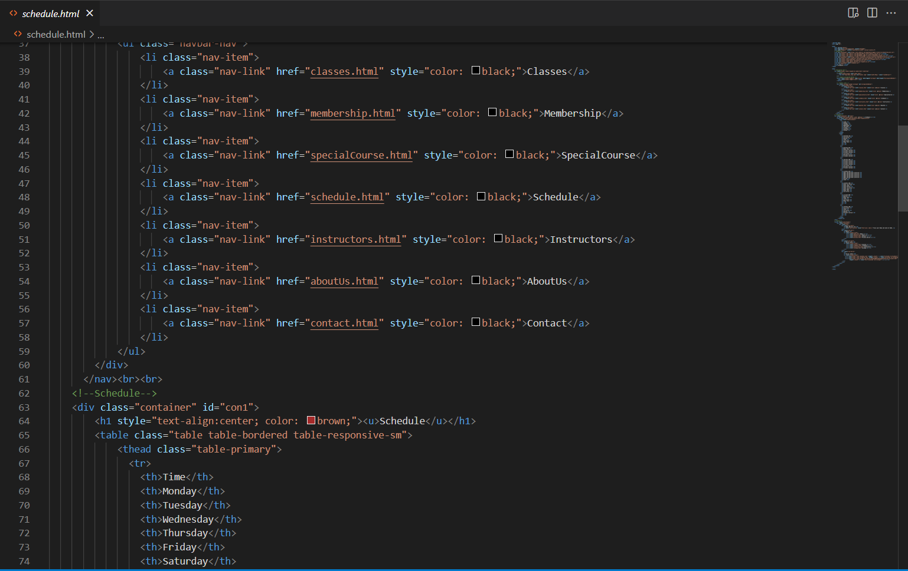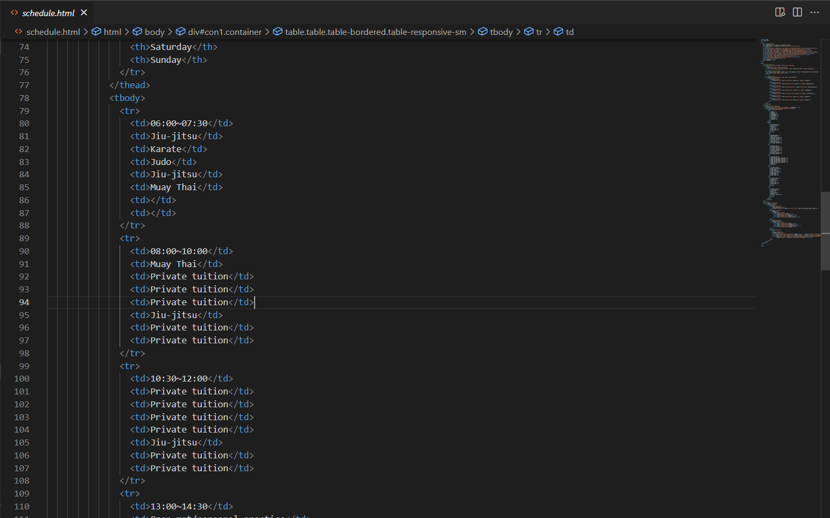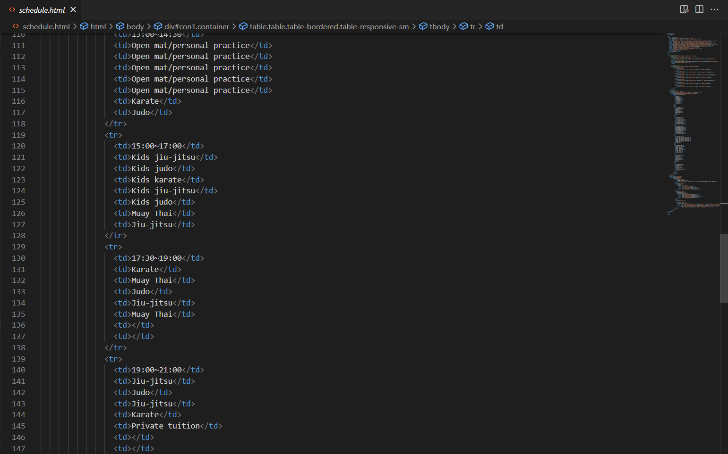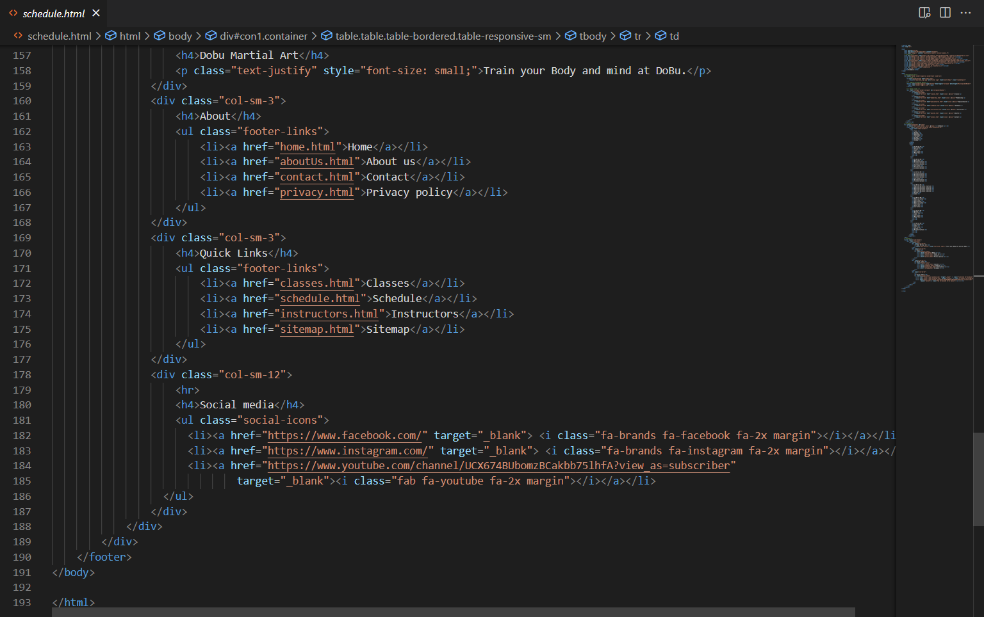

## instructors.html

Instructors page includes instructors.html, instructors.css and instructors.js. instructors.html contains navbar, footer, bootstrap cards and other html elements. Instructors.css contains css code for navbar and footer. Instructors.js contains jQuery code to hide and show the instructors’ titles.

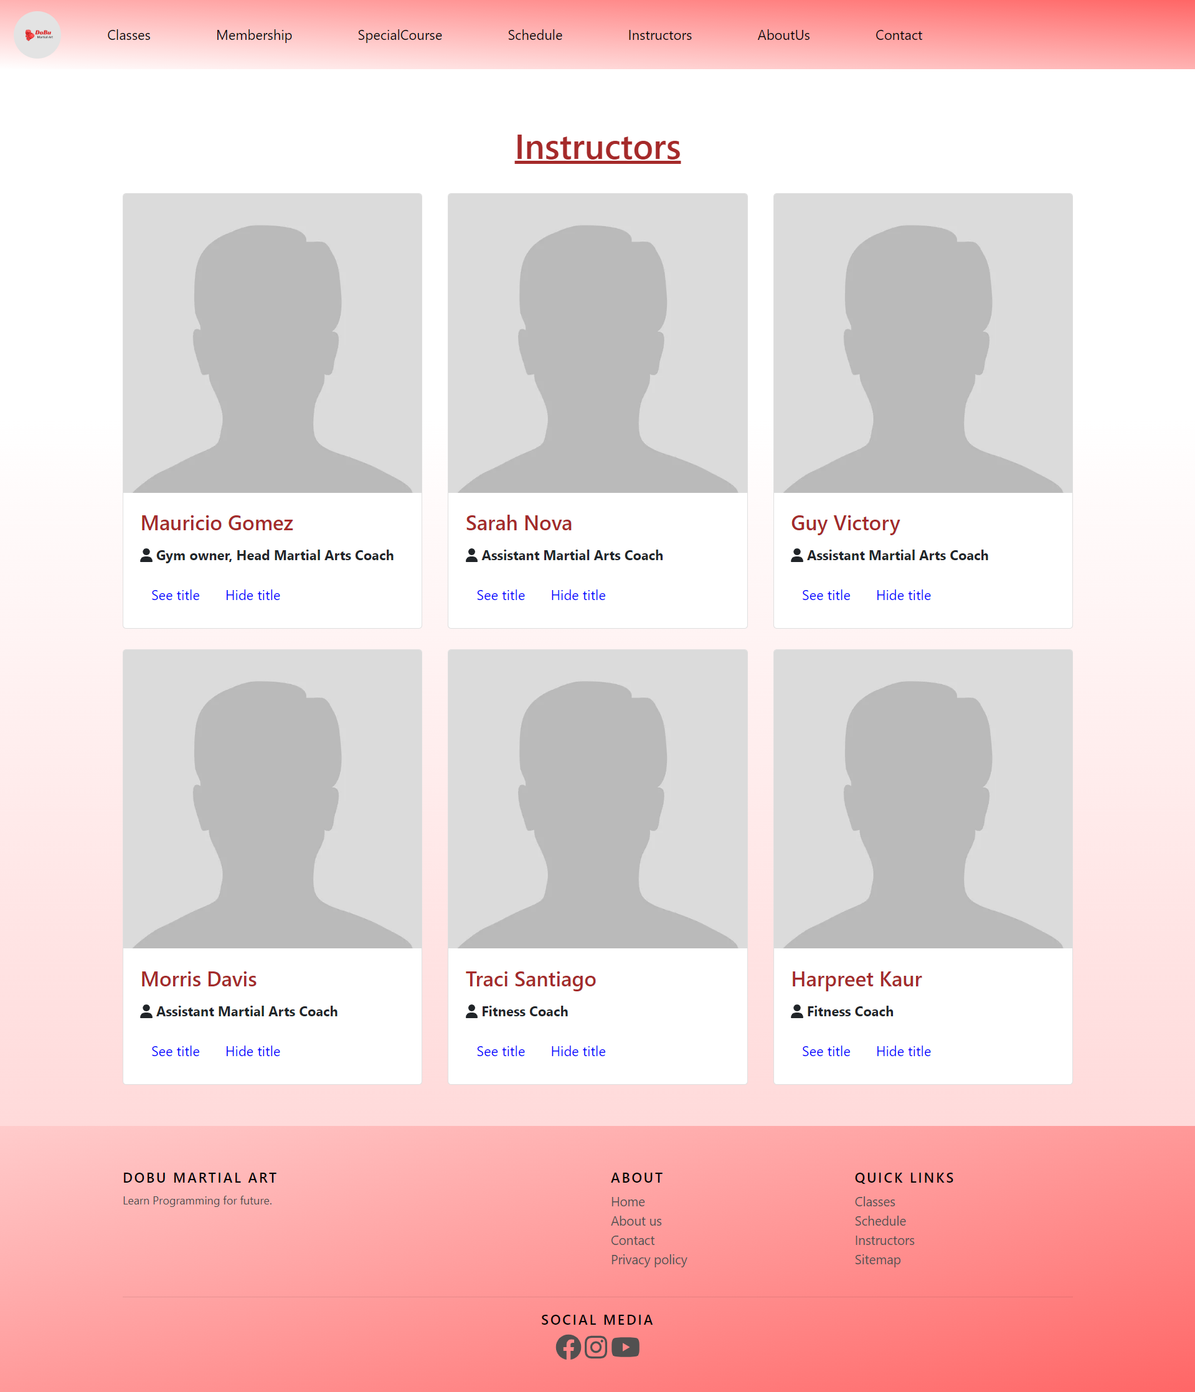

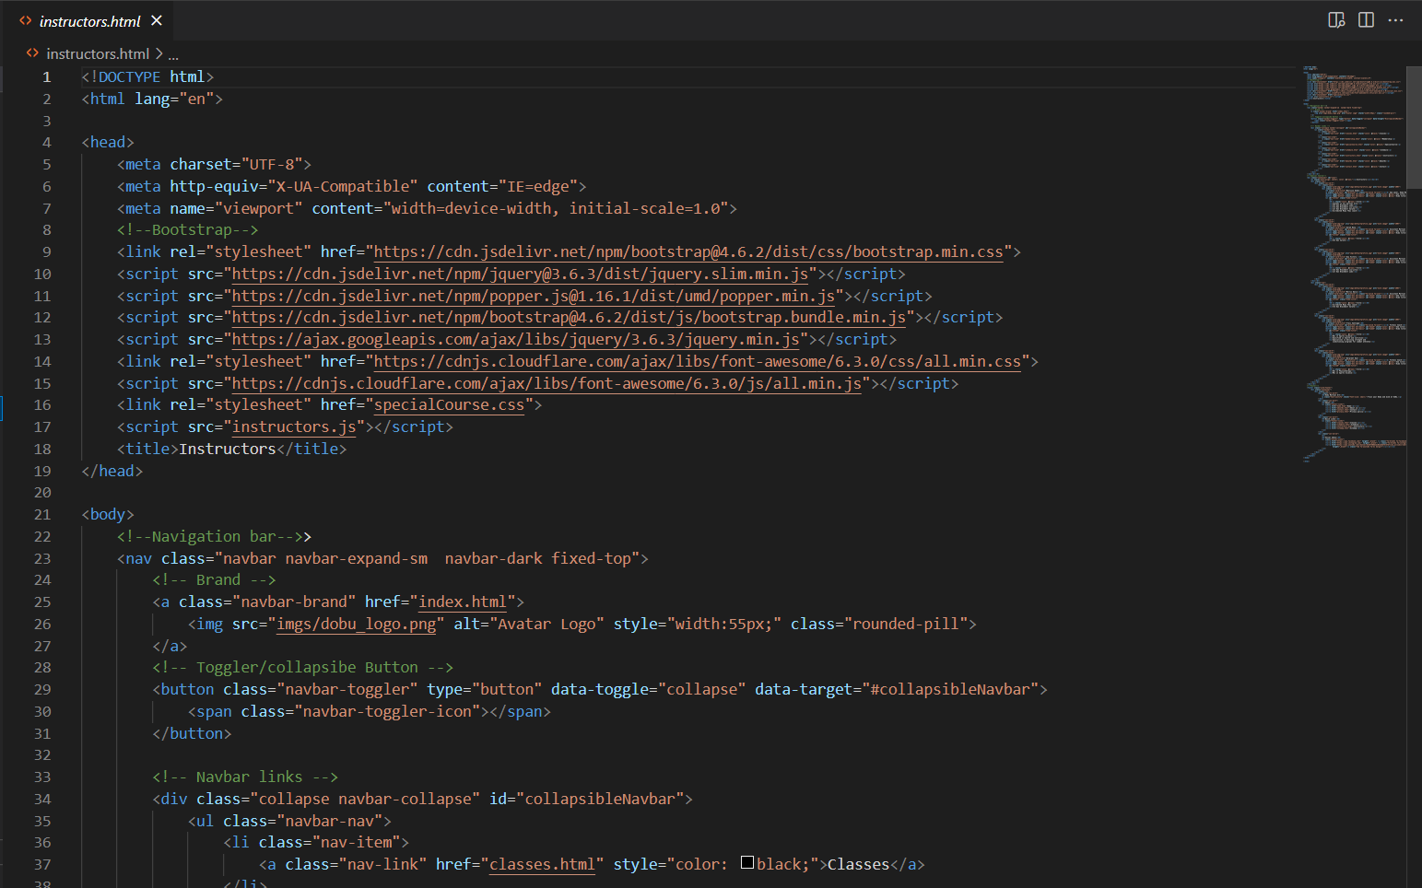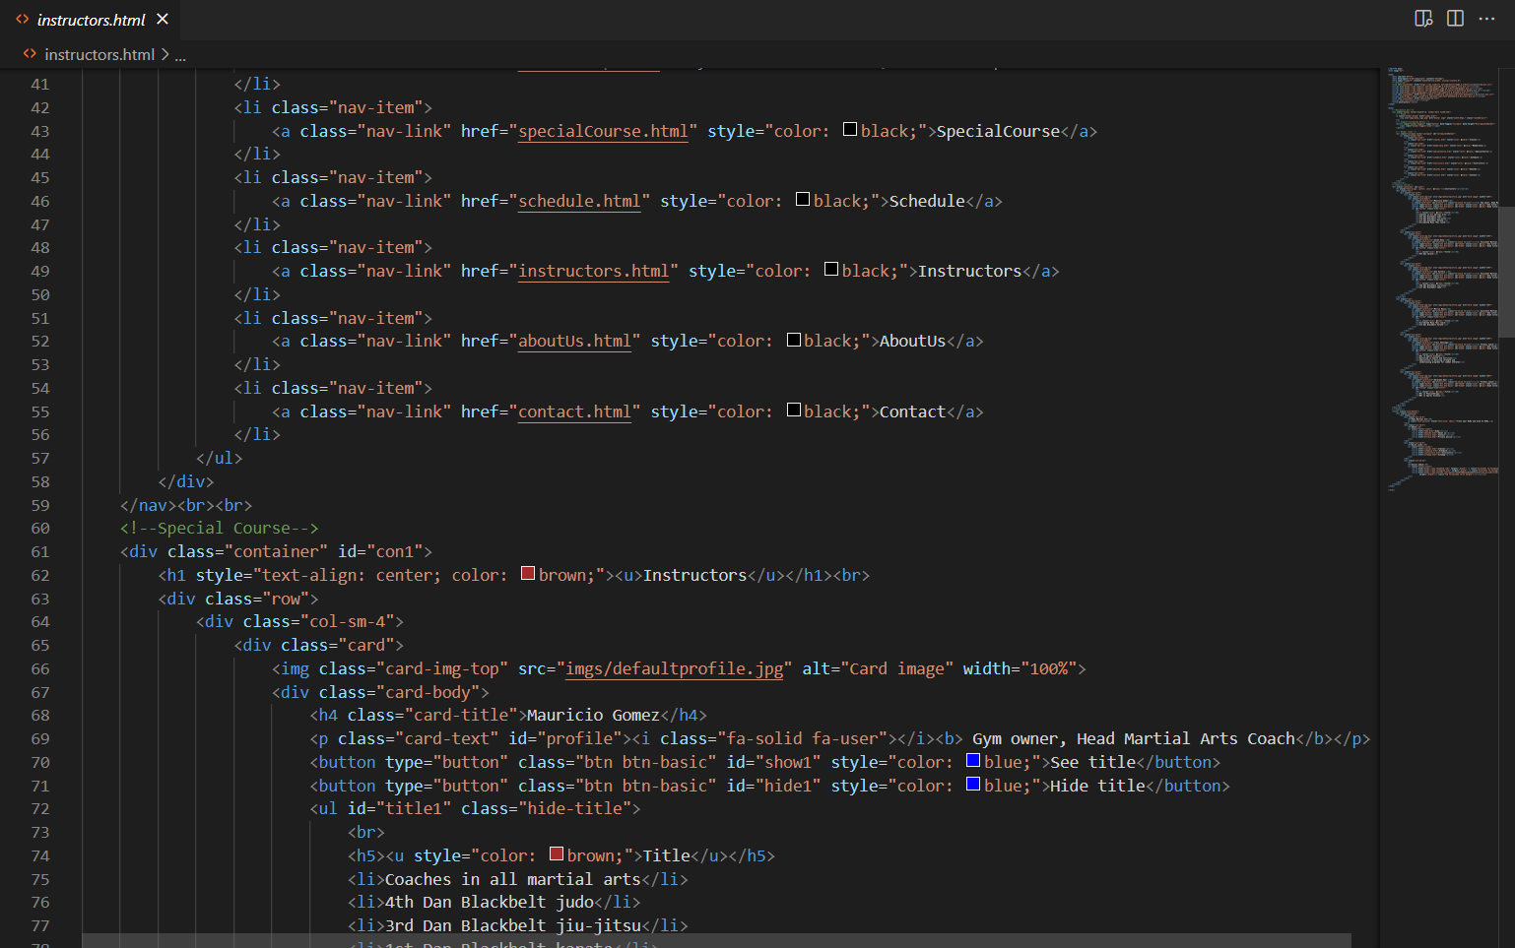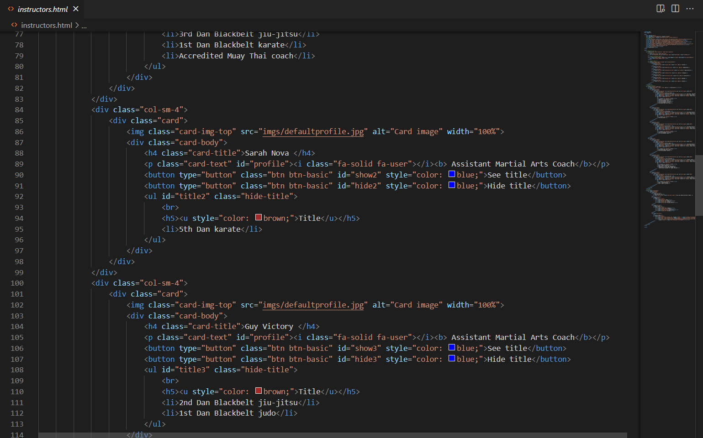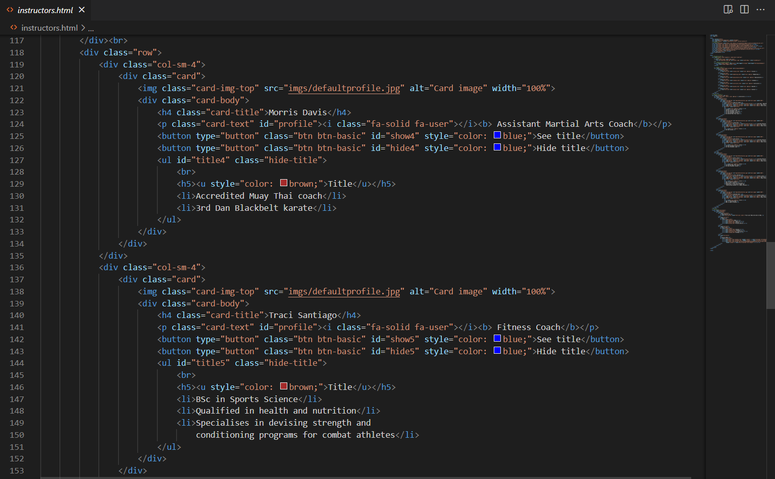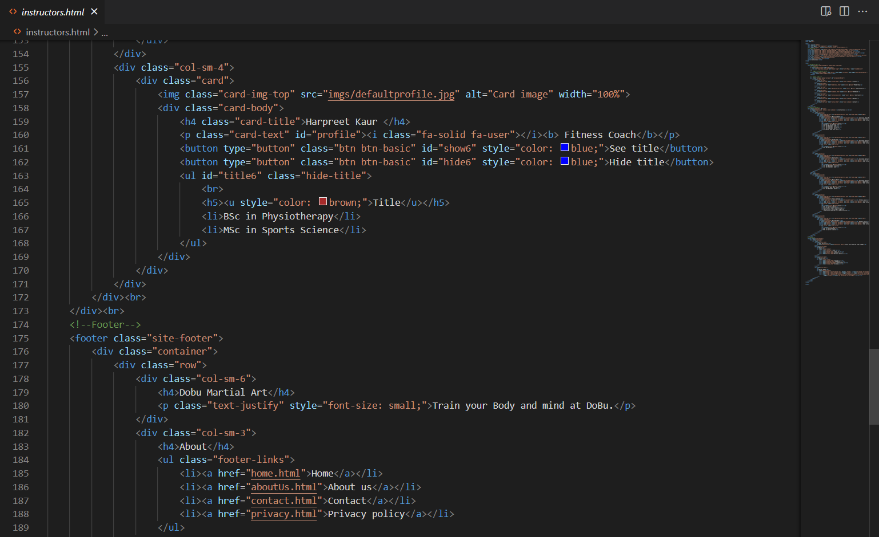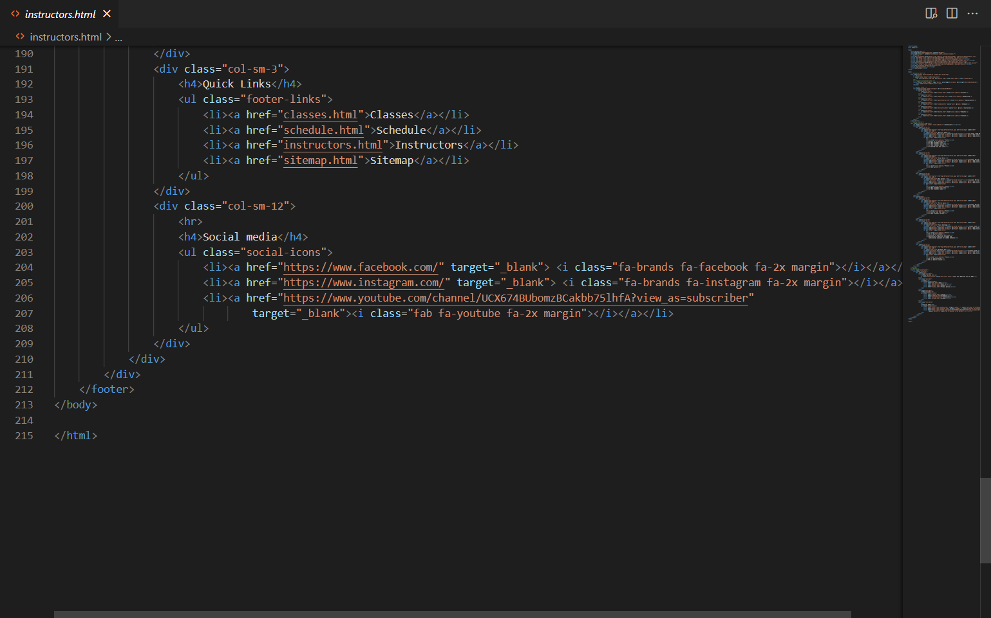

## aboutUs.html

About us page contain aboutUs.html and AboutUs.css. aboutUs.html contains navbar, footer, bootstraps carousel, jumbotron and other html elements. aboutUs.css contains cs codes for navbar, footer and layout. Page screen capture and coding for aboutUS.html are provided.

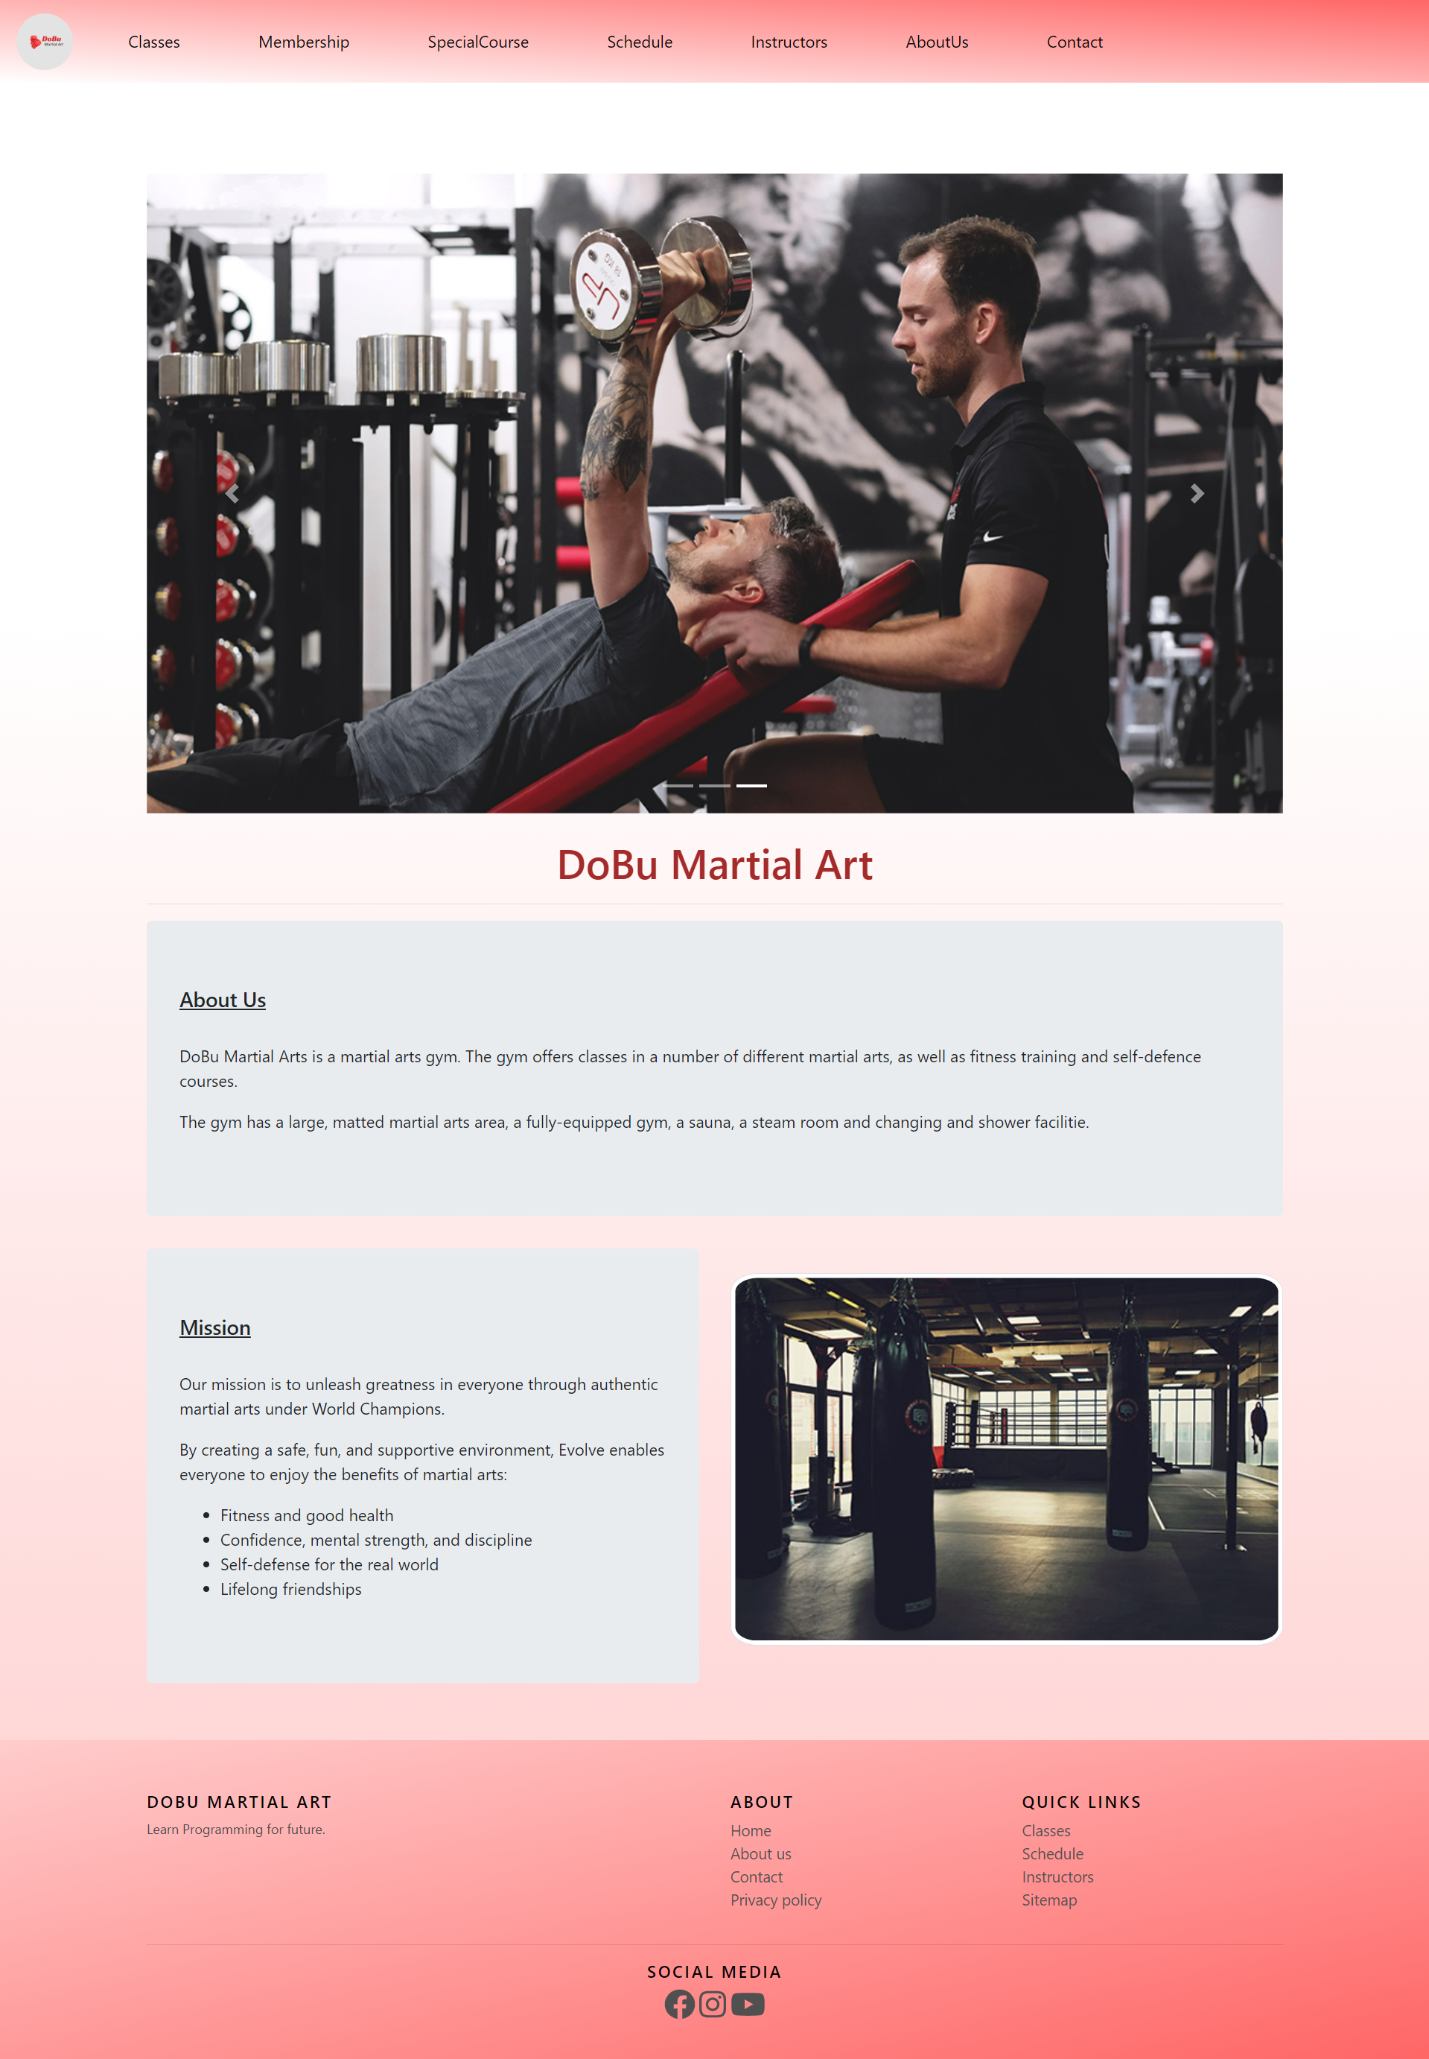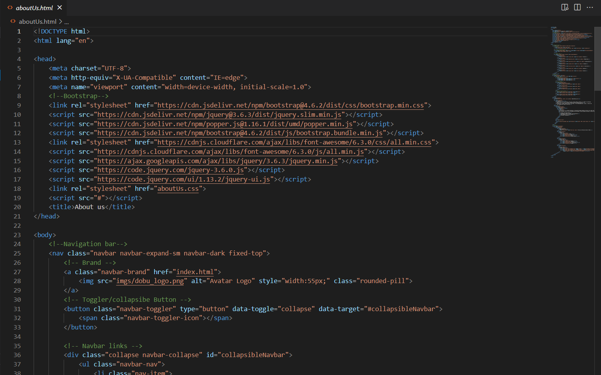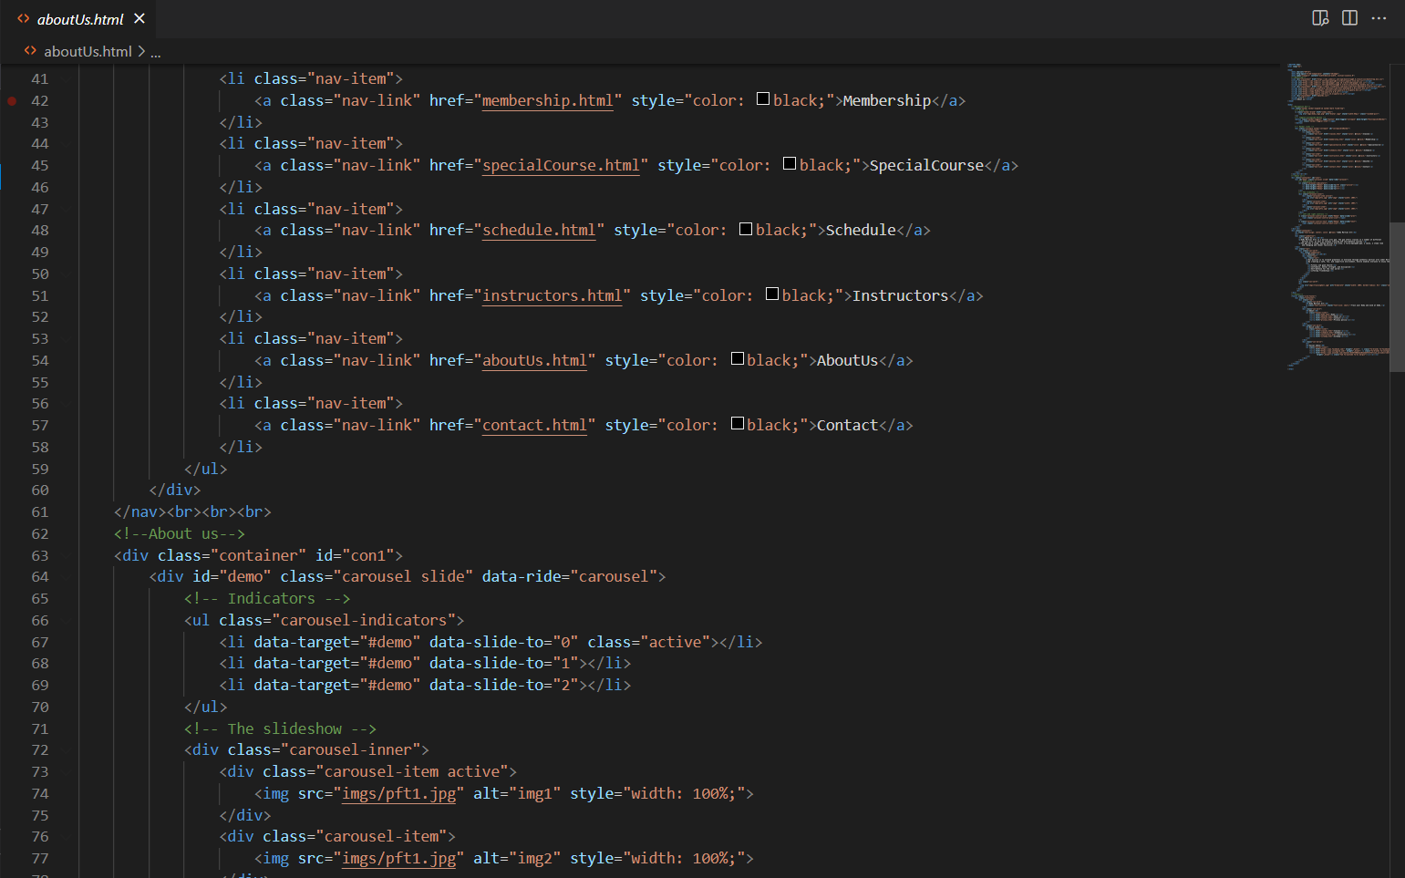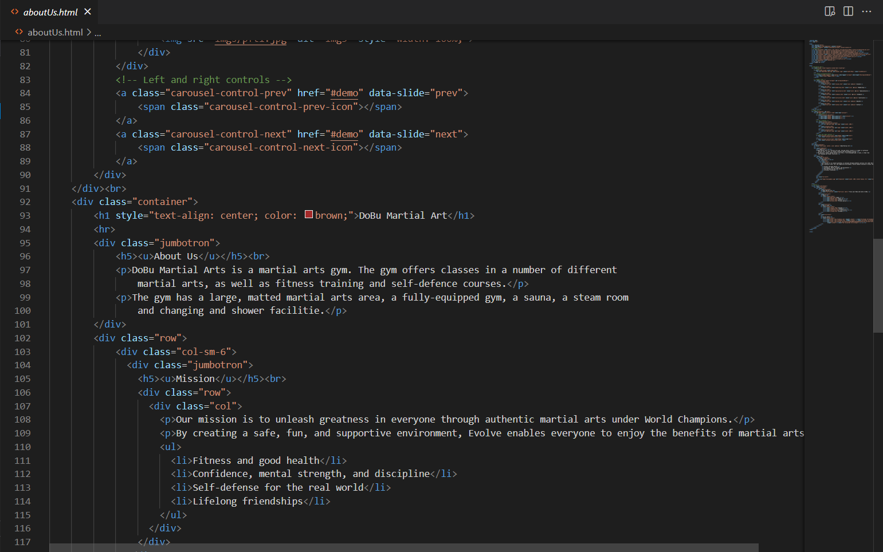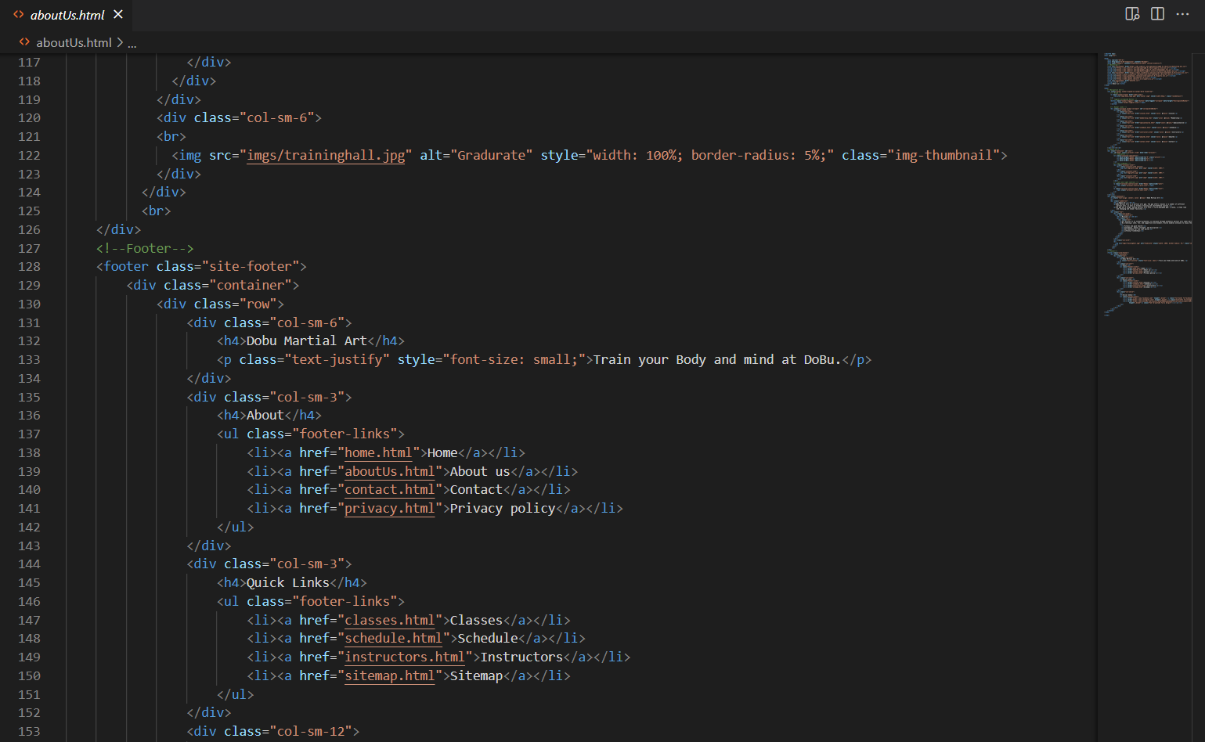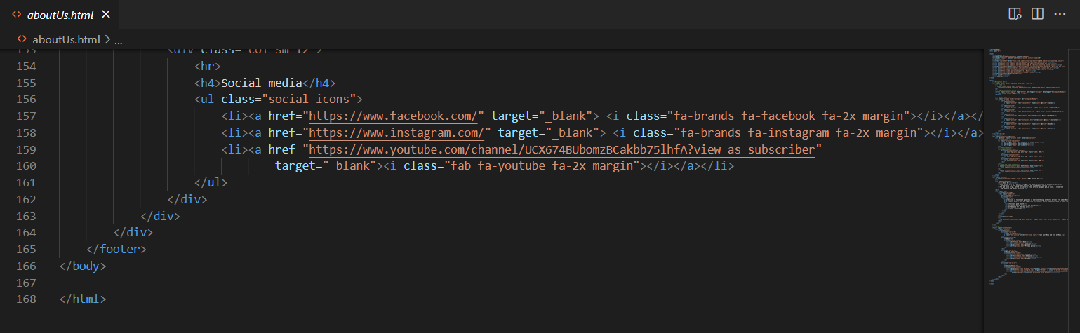

## sitemap.html

Sitemap page includes sitemap.html, sitemap.css and sitemap.js. within sitemap.html, there are html code for navbar, footer, images, bootstraps grids system and jumbotron. Contact.css contains css codes for navbar, footer, background and trans box. Contact.js contains jQuery for menu lists for about and quick links. The following are sitemap page output and coding for contact.html.

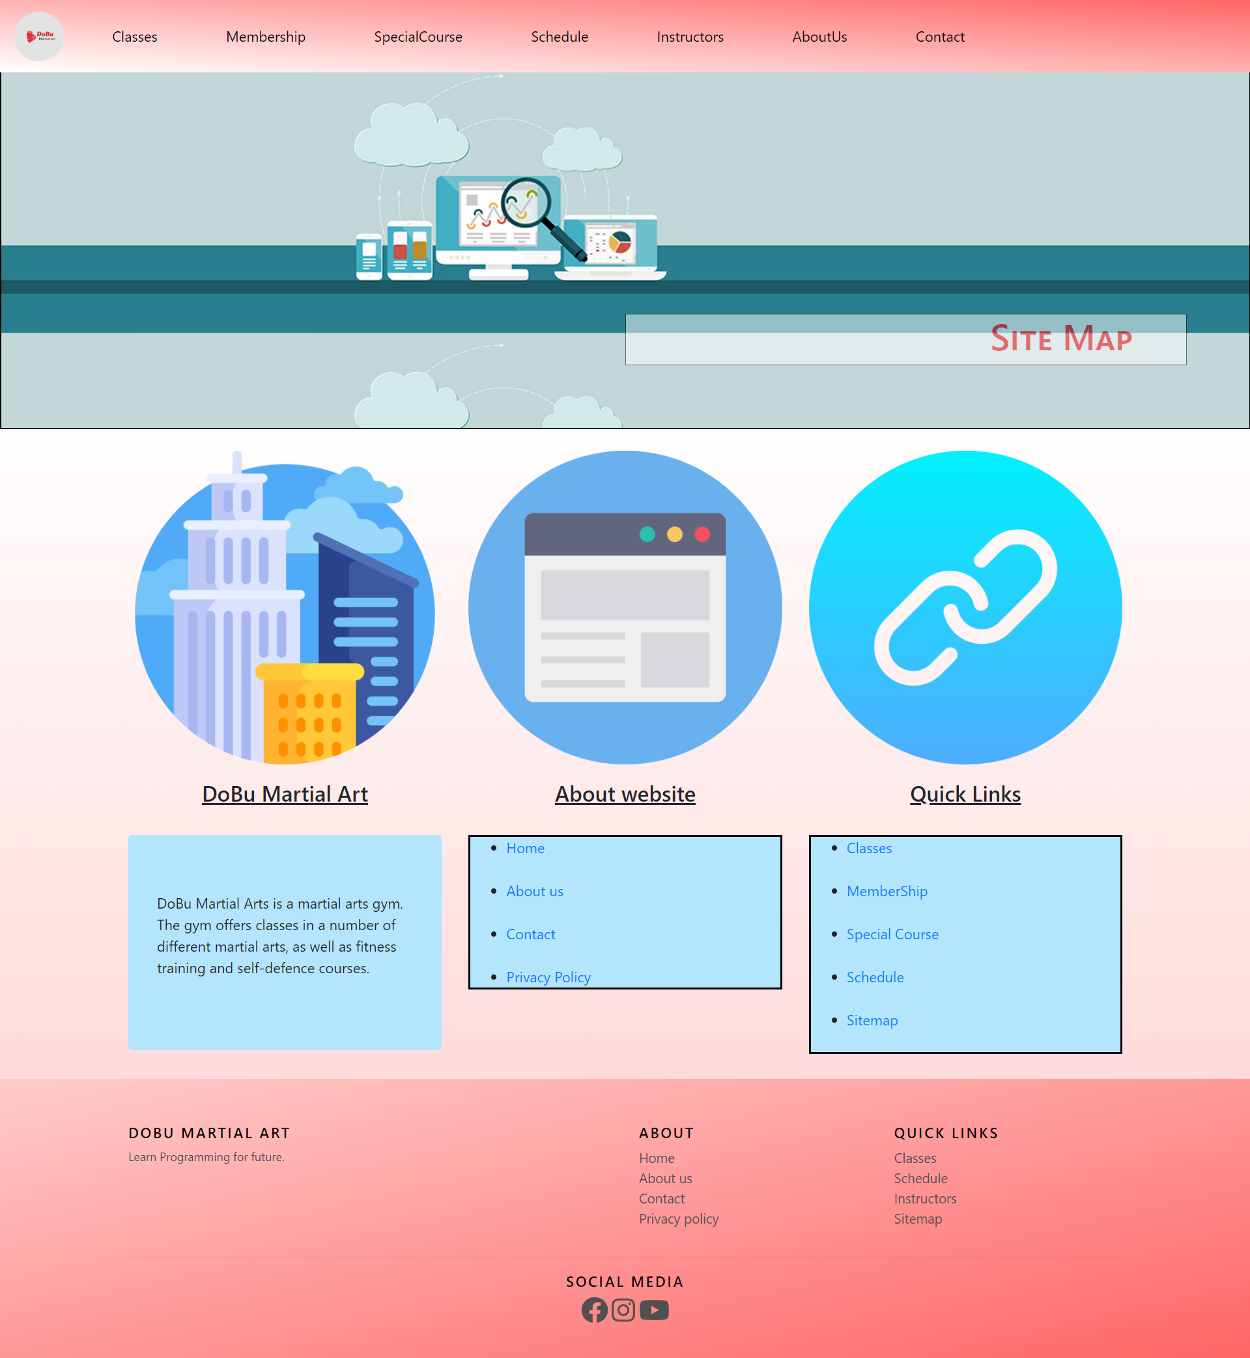 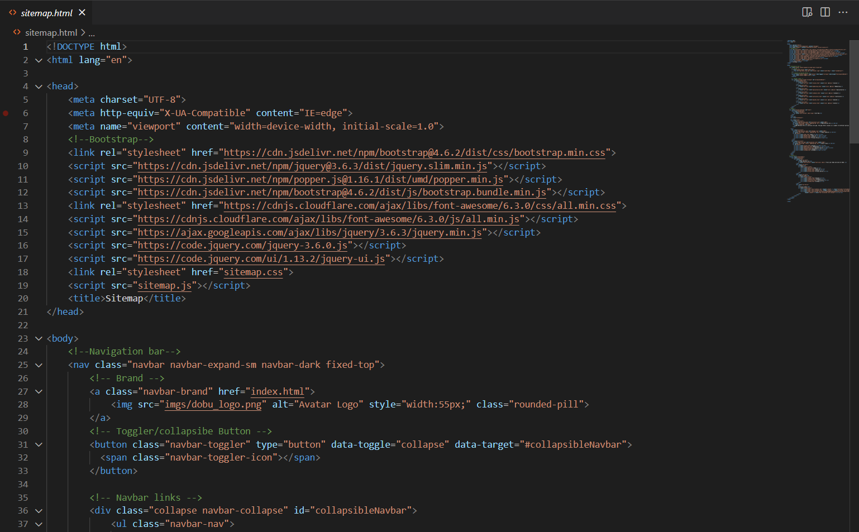 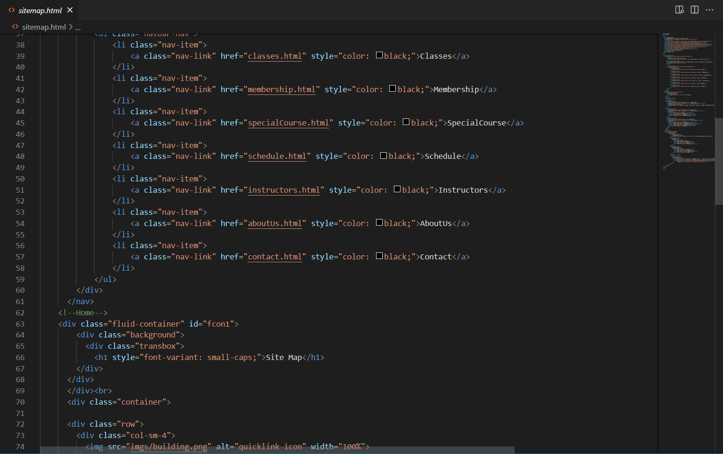 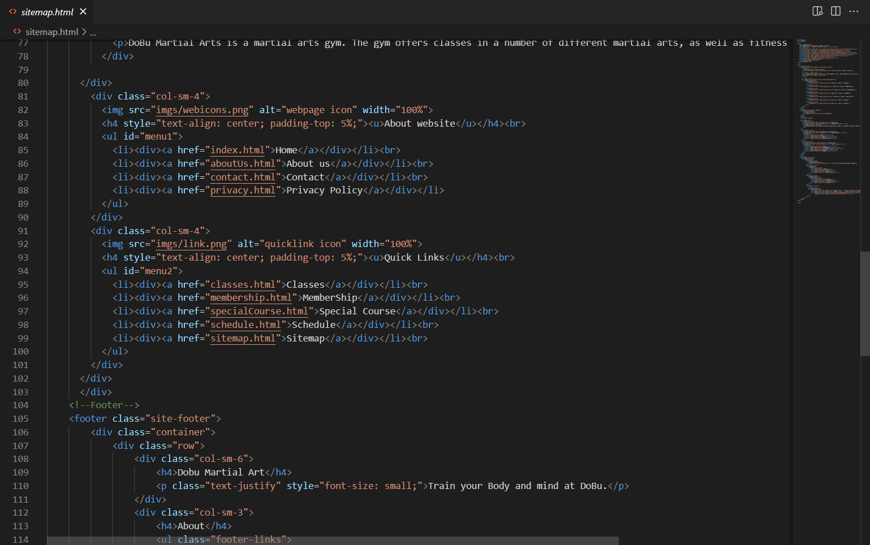 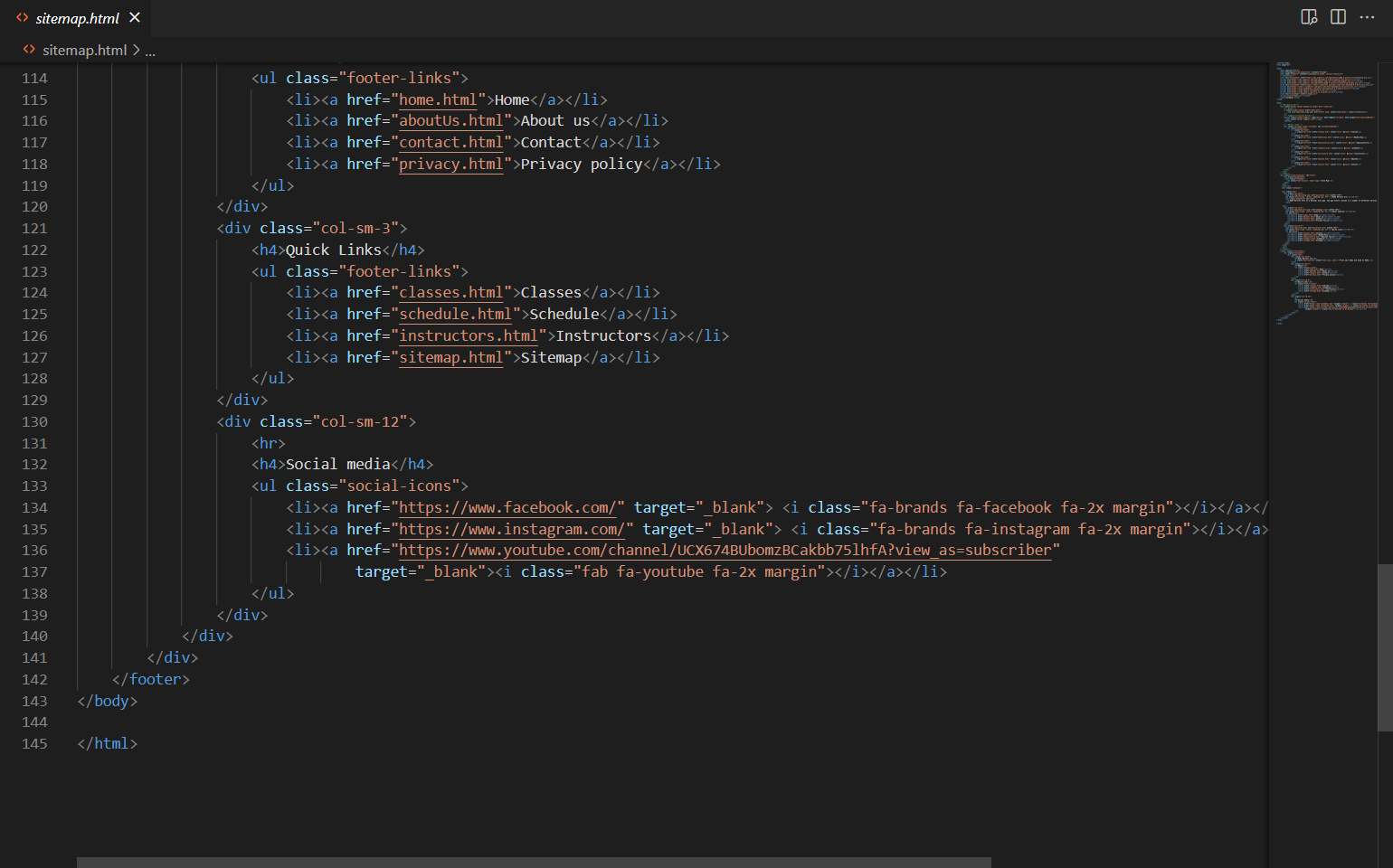

## contact.html

Contact page is built with contact.html and contact.css. contact.html contains navbar, footer, bootstrap jumbotron, form, iframe for google map and other html elements. Contact.css contains css codes for body, nav bar and footer. The following are contact page output and contact.html code.

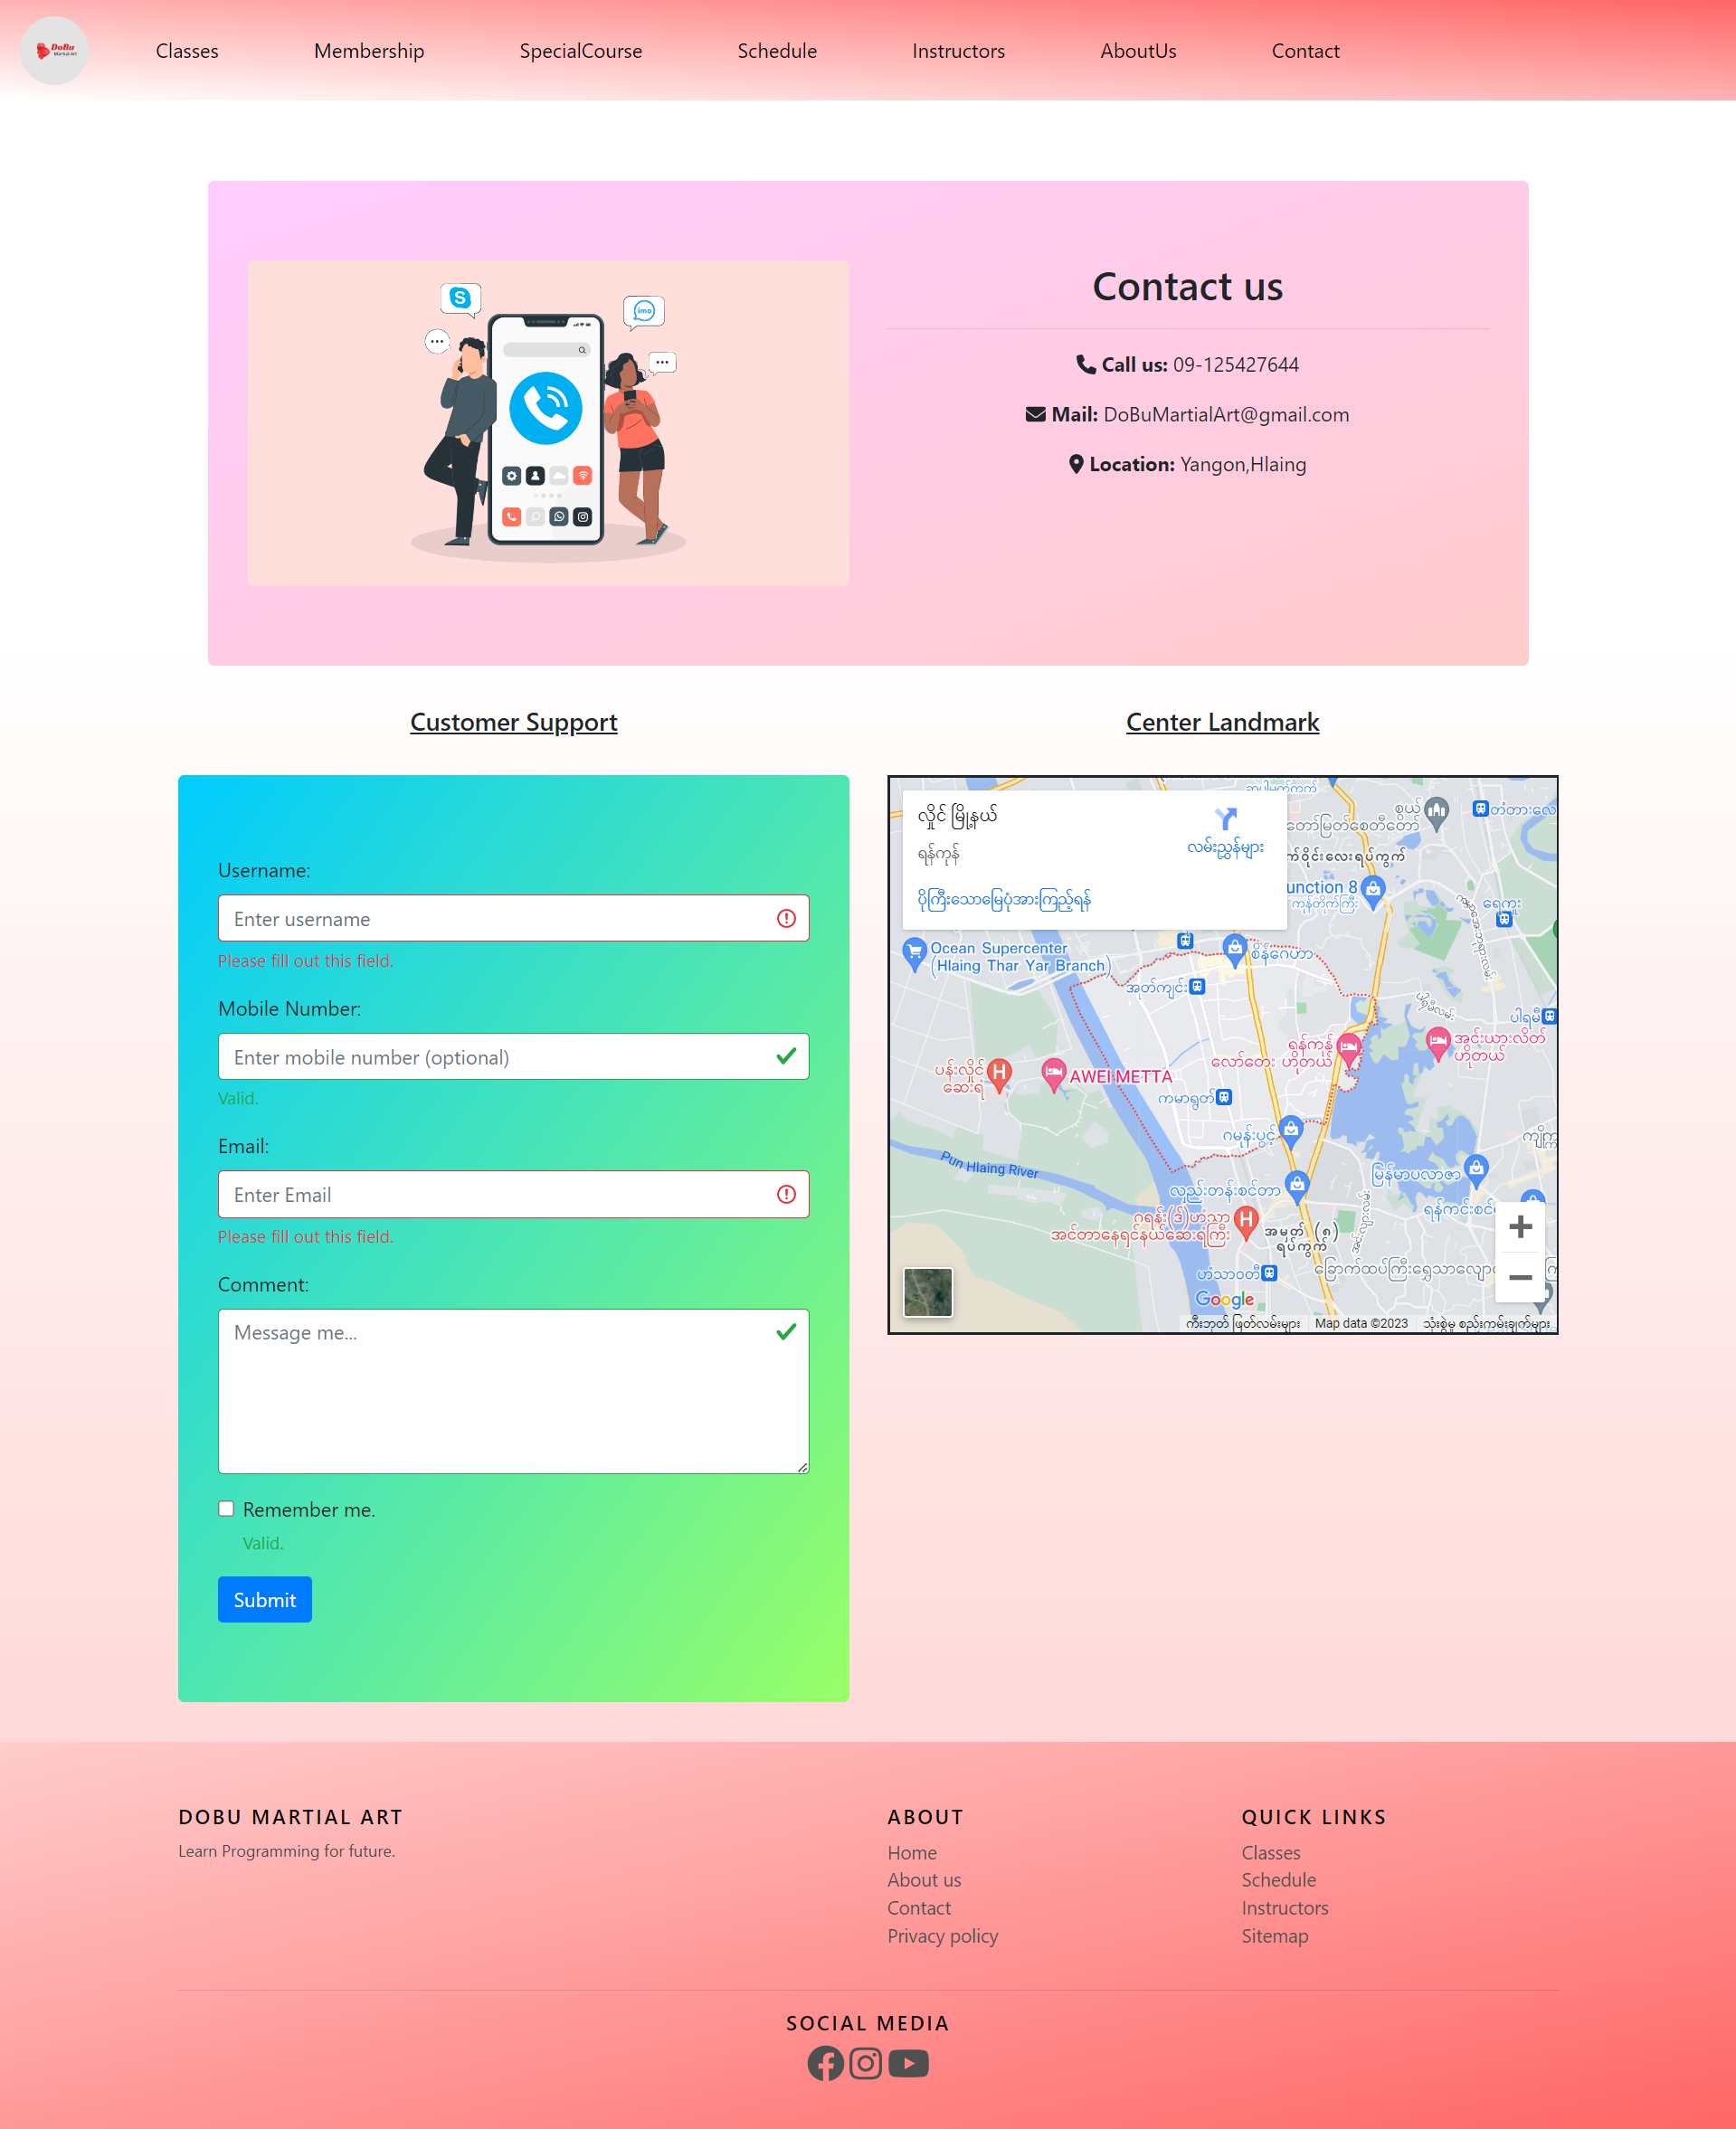 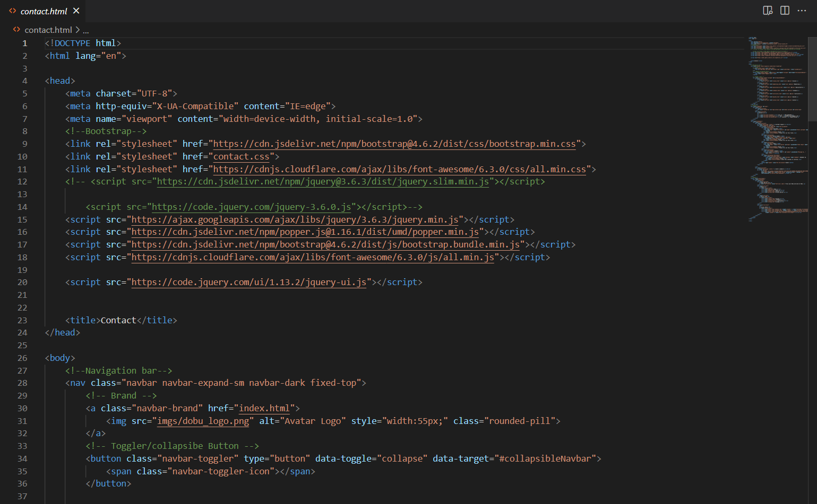 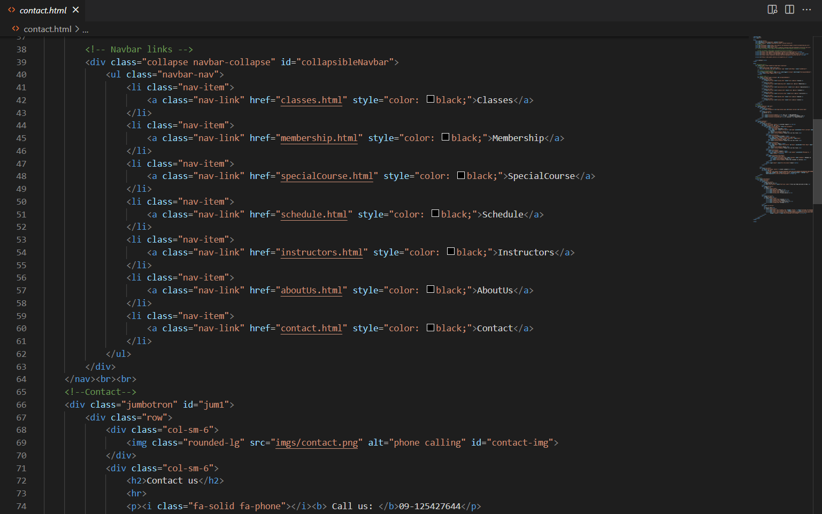 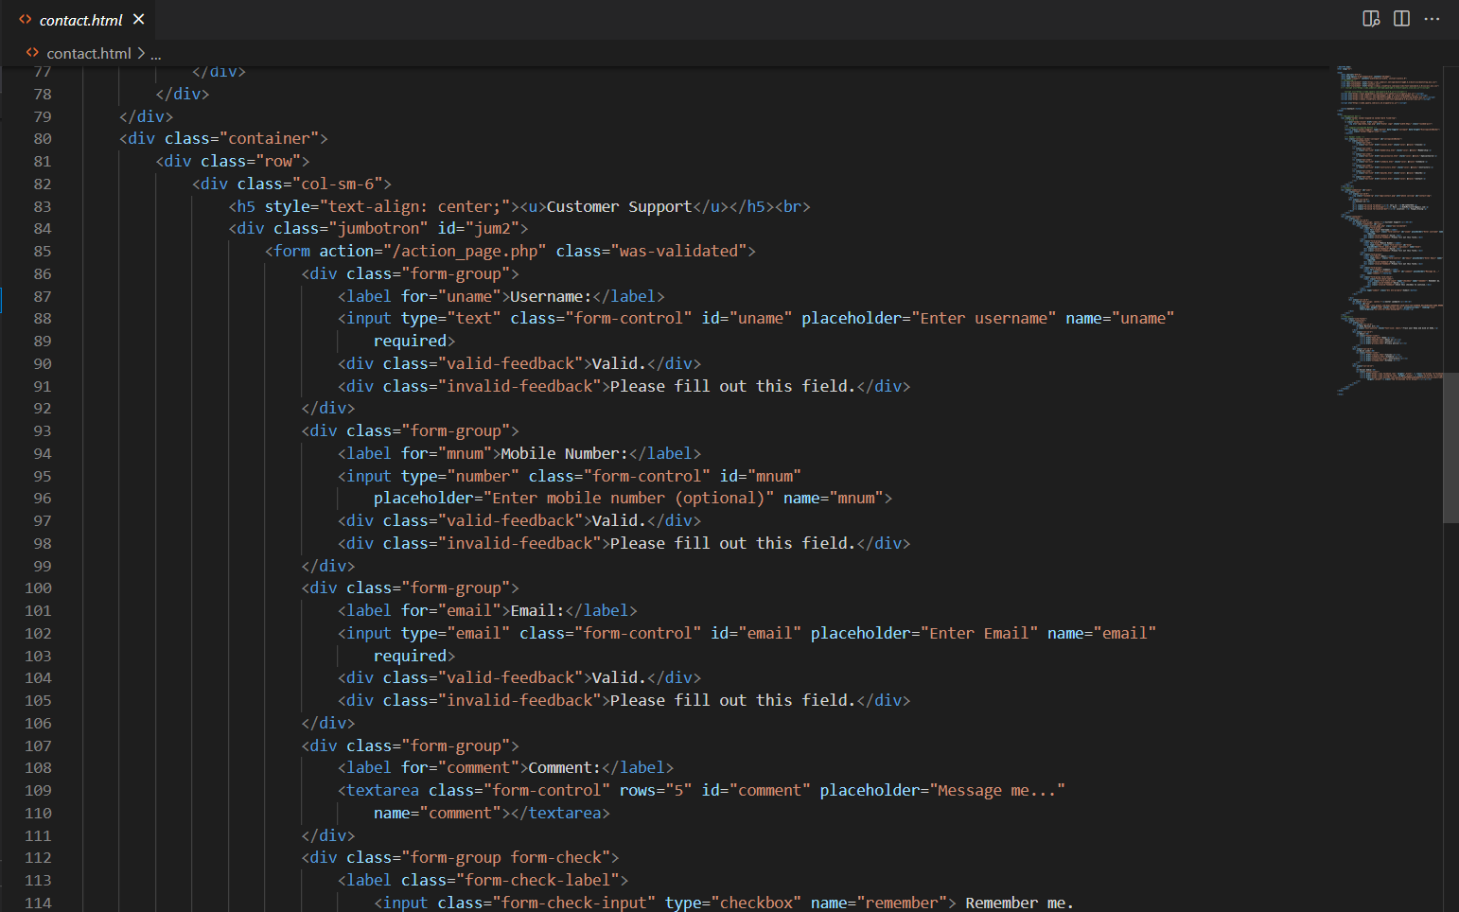 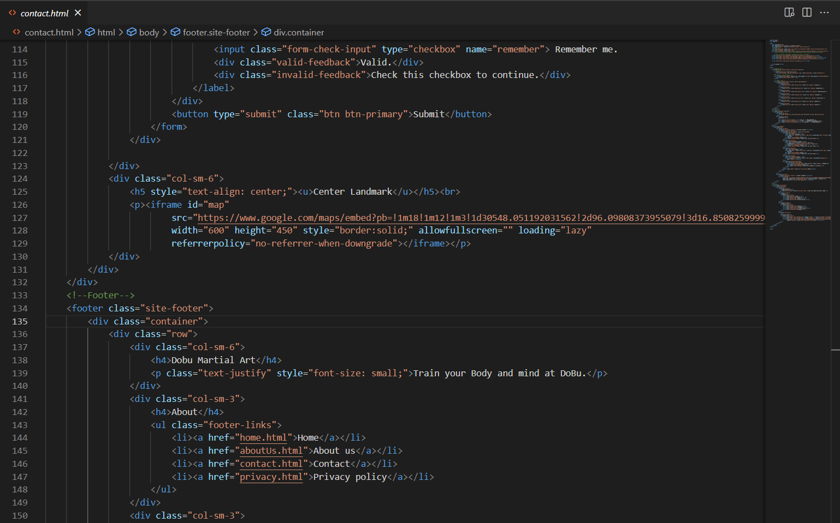 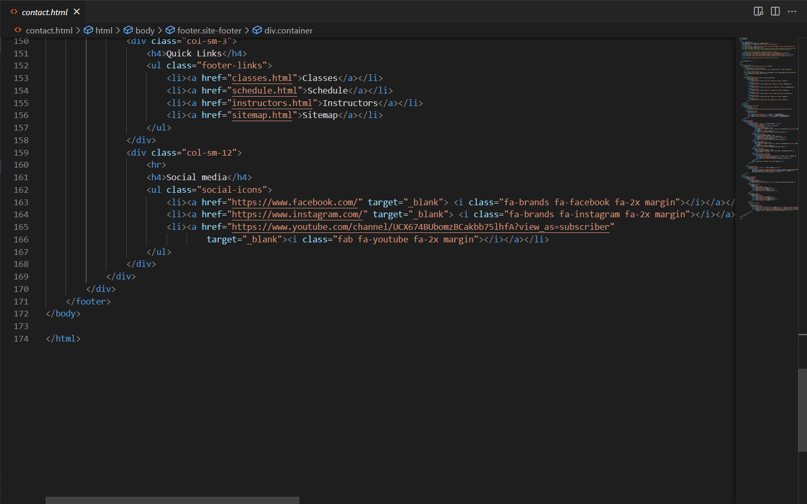

## privacy.html

Privacy page includes privacy.html and privacy.css. Within privacy.html, there are html code for navbar, footer, images and bootstraps grids system. privacy.css contains css codes for navbar, footer, background and trans box. The following are privacy page output and coding for privacy.html.

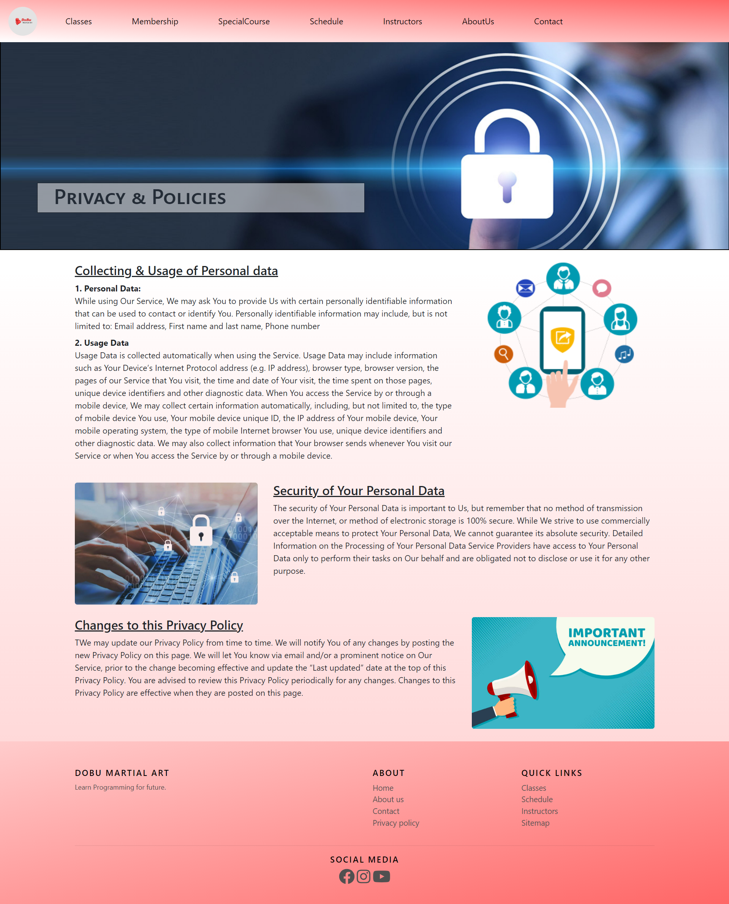

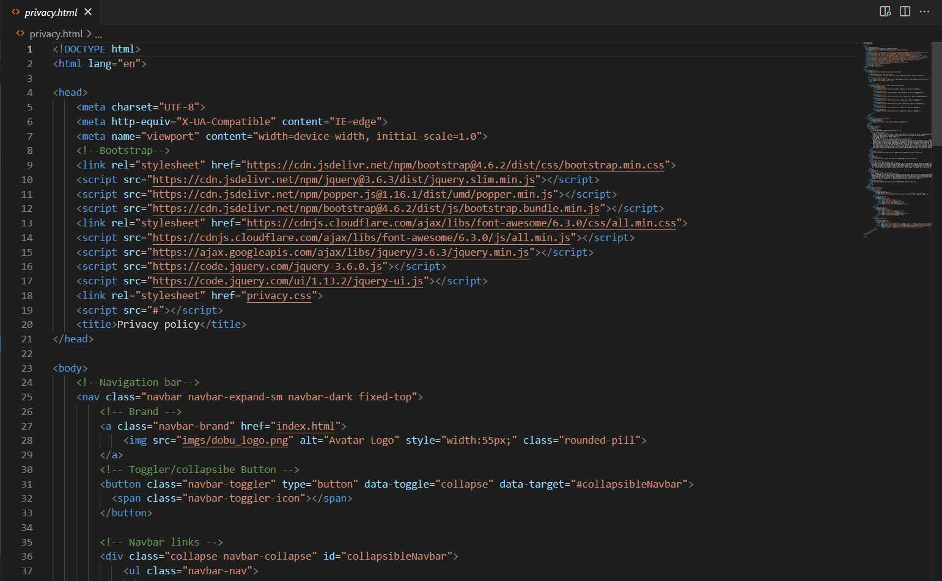 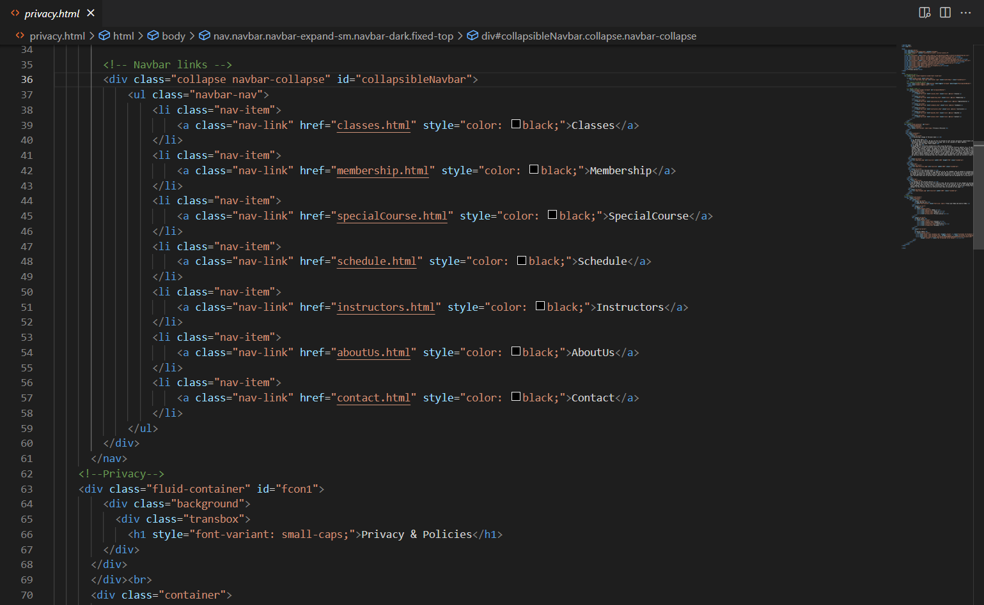 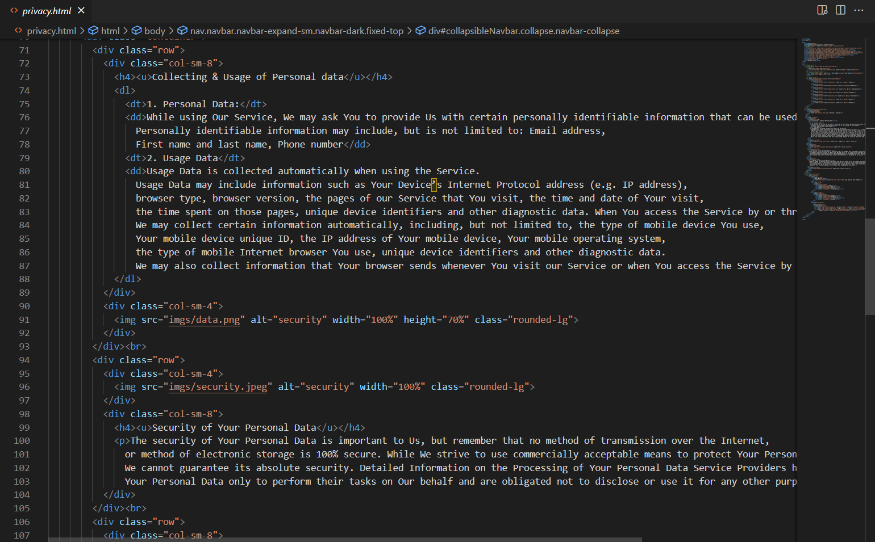 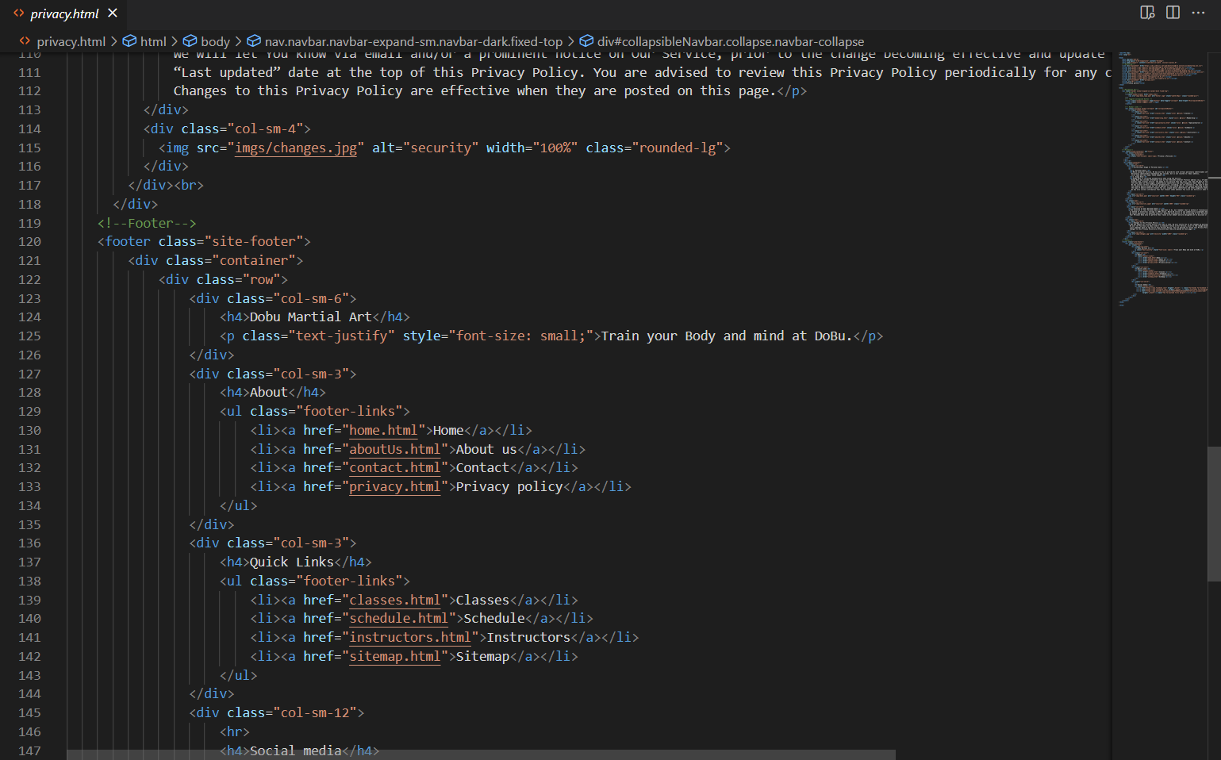 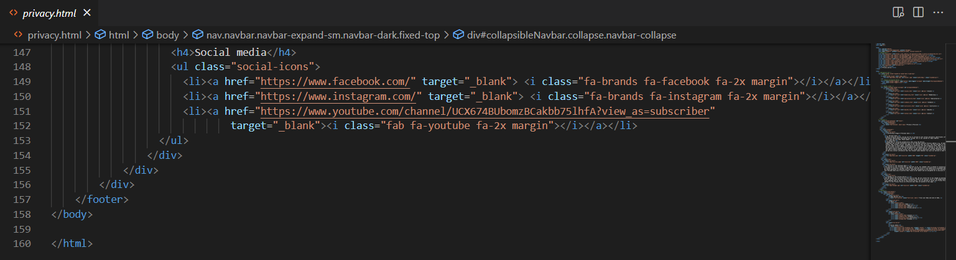

## reguistrationForm.html

Registration form page is built with registrationForm.html and registrationForm.js. registrationForm.html includes bootstrap form and other html elements for user interface. Within registrationForm.js, there are functions formValidation to validate user input, addUserDataToLocalStorage to storage data at Local Storage. The following are registration Form page output and codes for registrationForm.html and registrationForm.js.

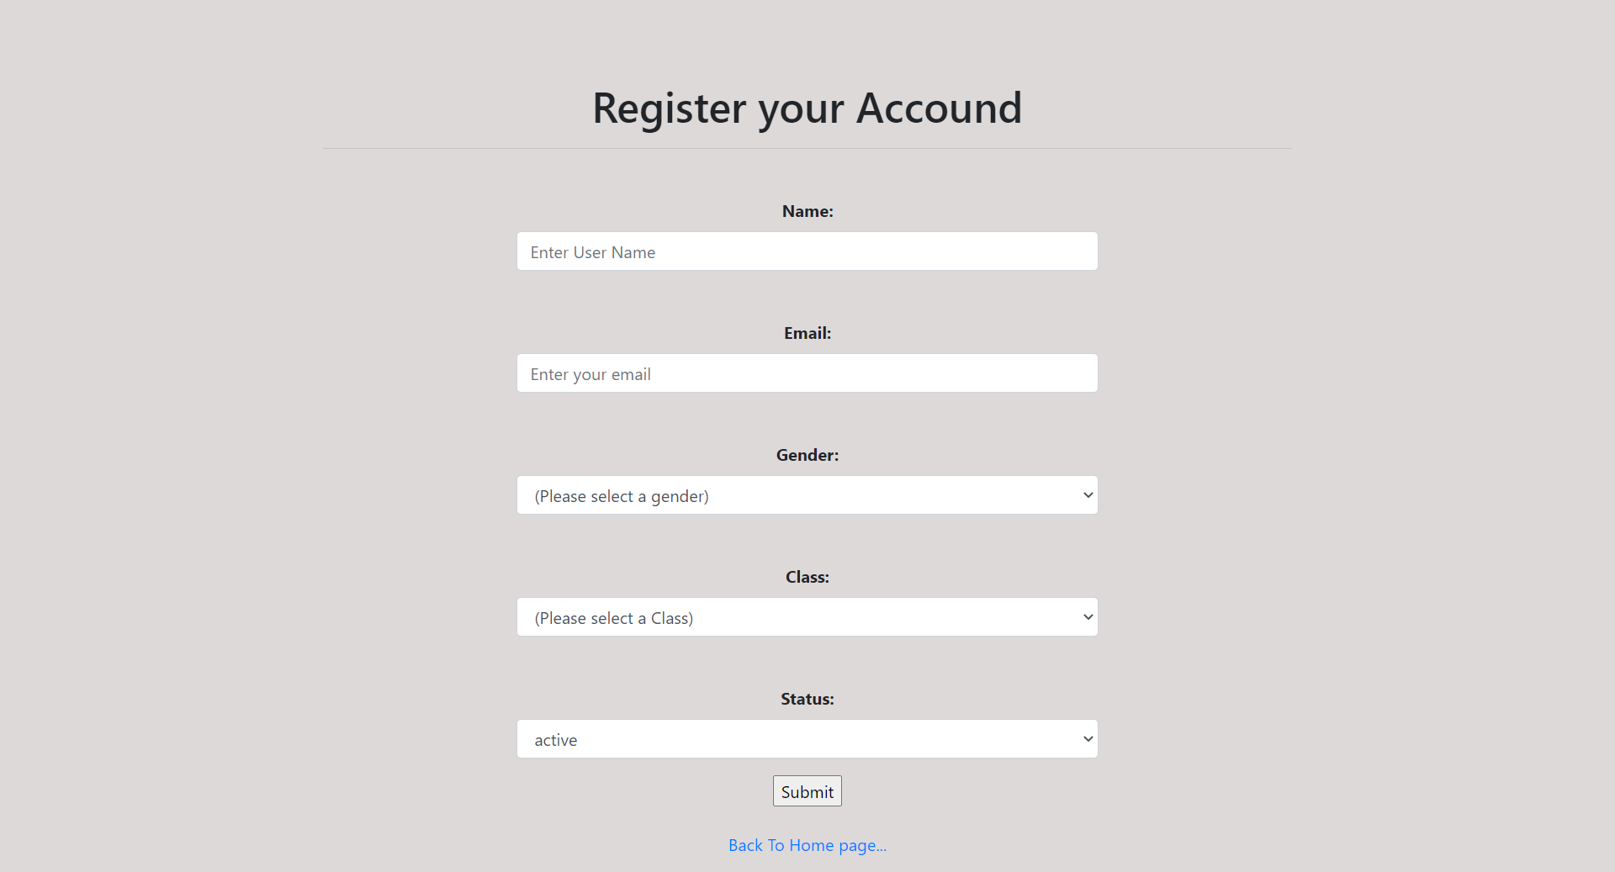

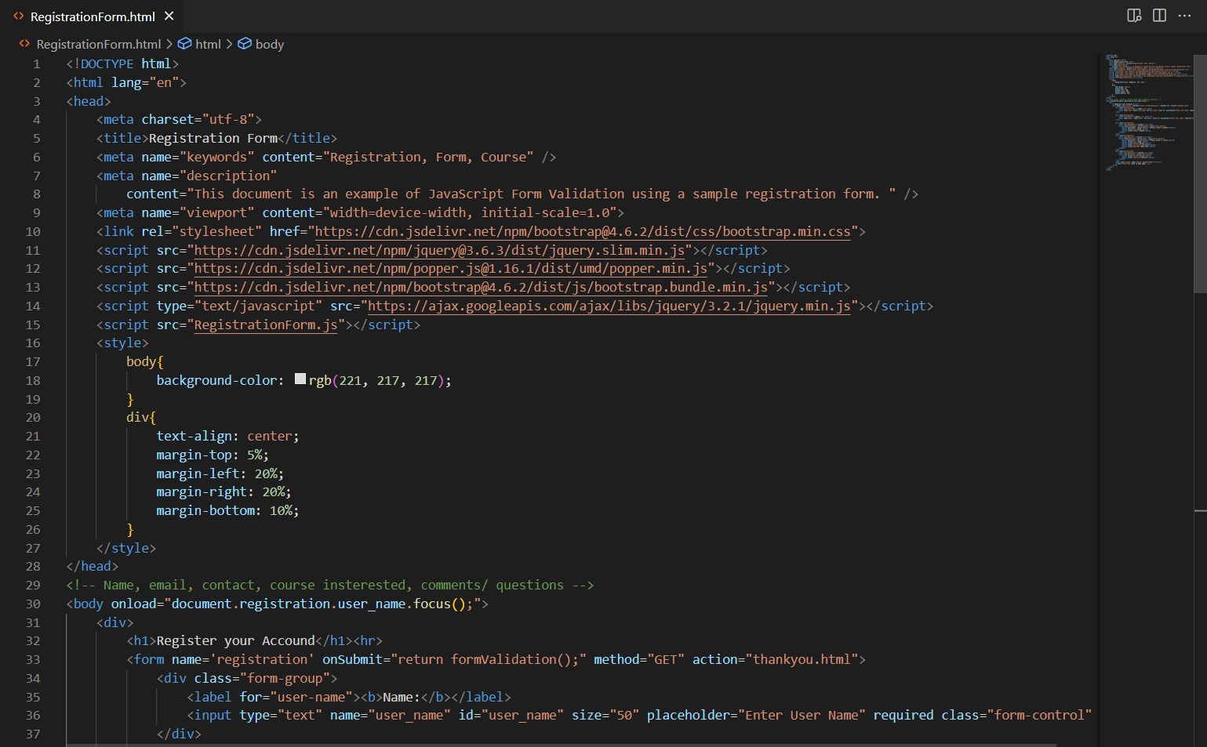 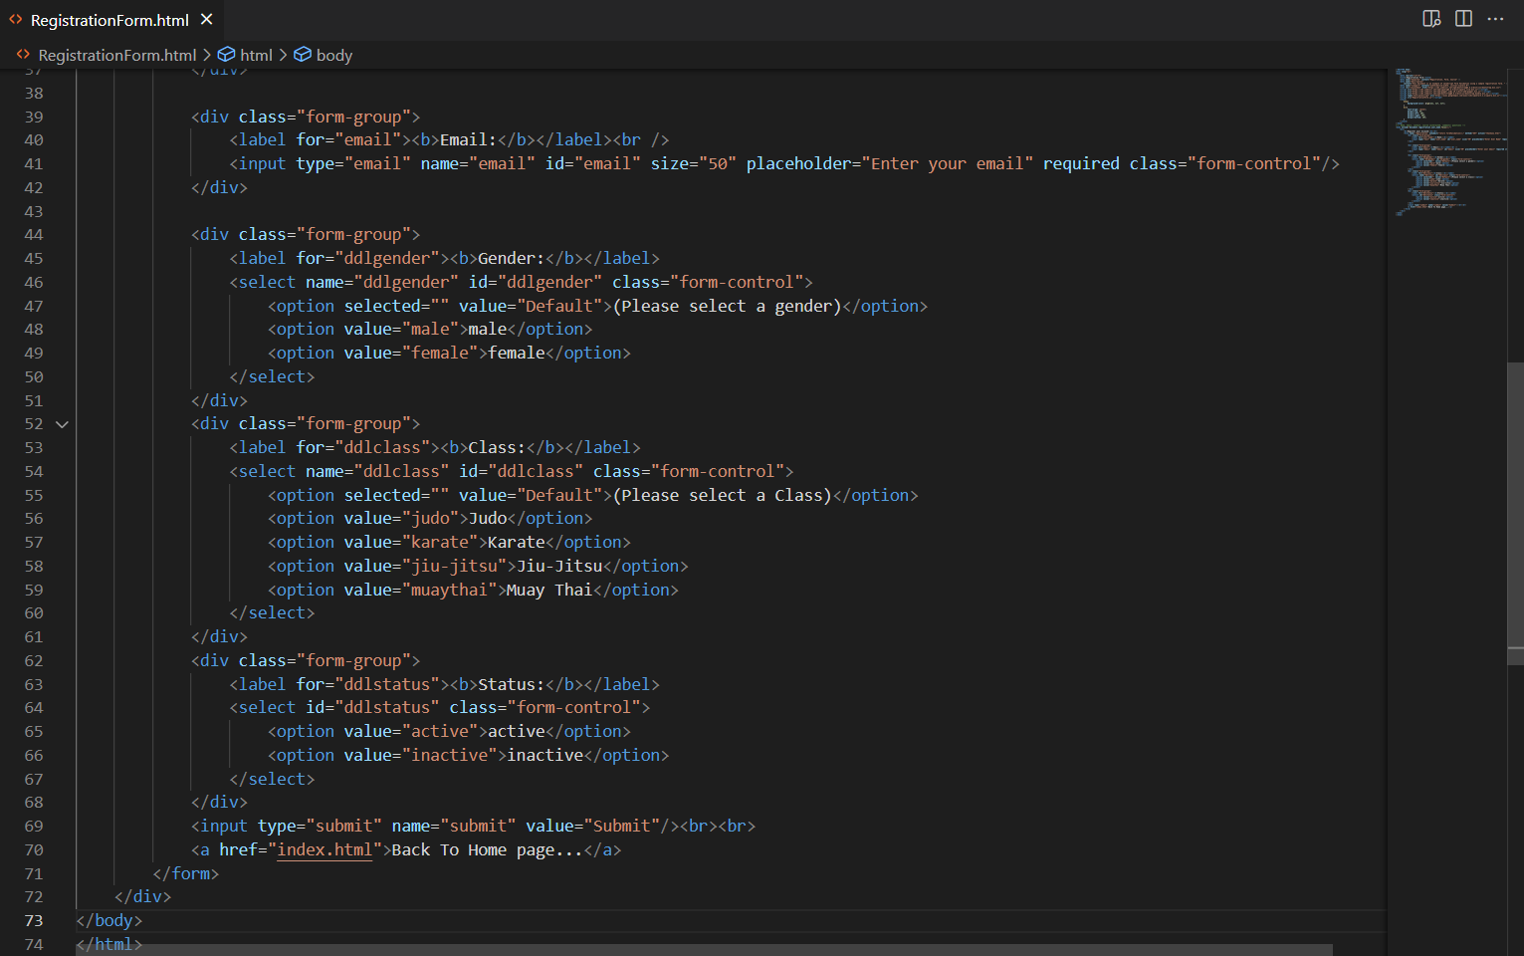

## user.html, admin pages

Admin page is built with user.html that contains bootstrap container, table and other html elements. There are also JavaScript and jQuery functions to edit, delete and add the user account information within user.html. Screen capture and codes for user.html are provided.

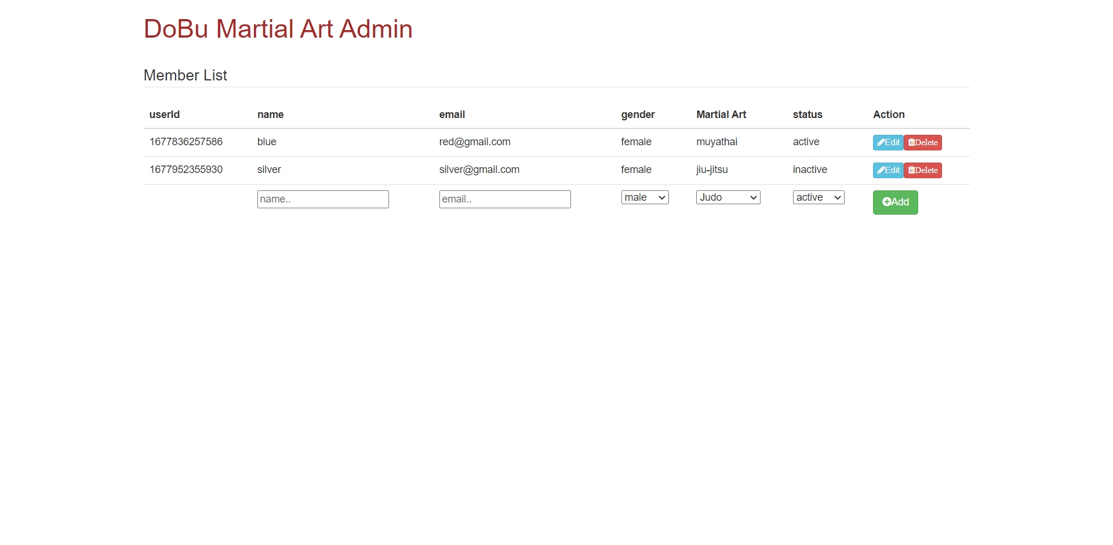 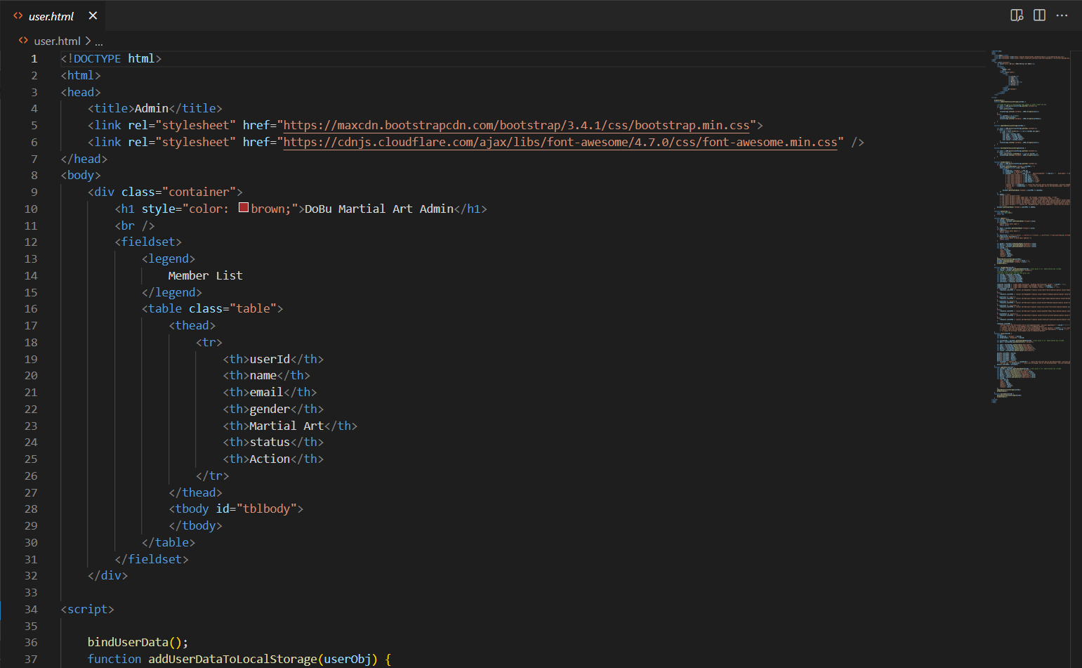 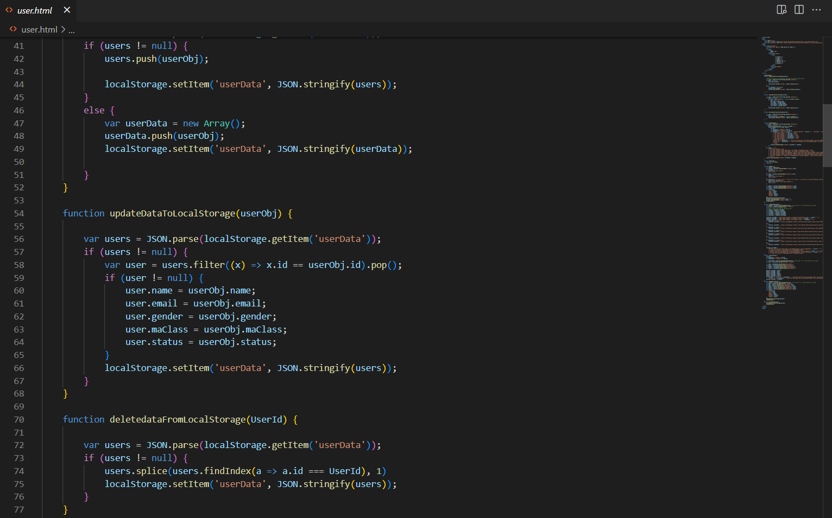 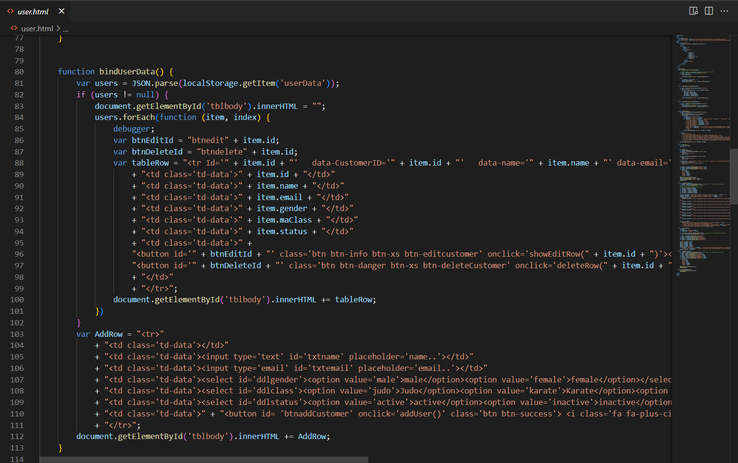 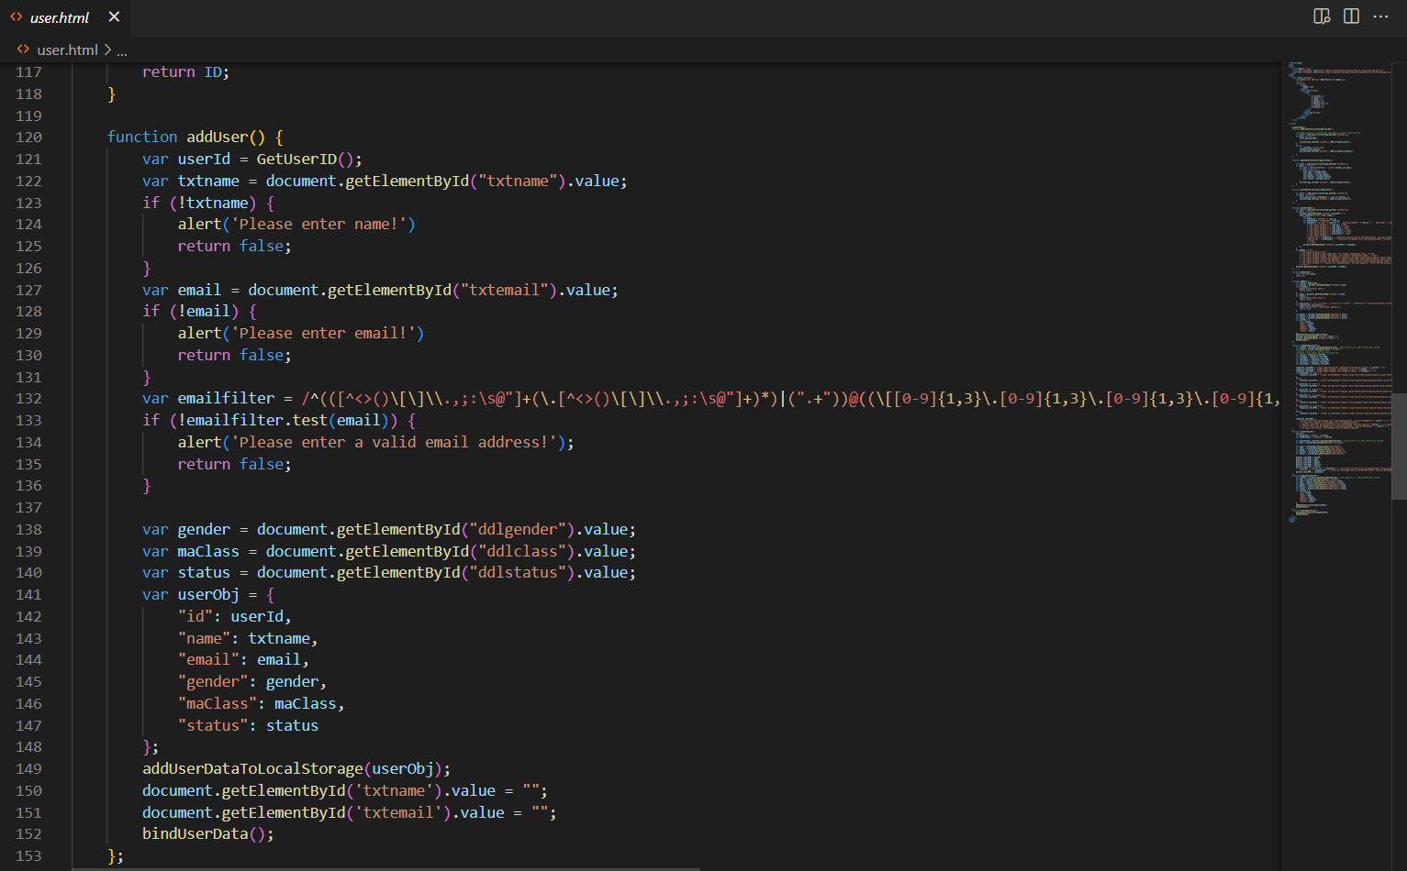 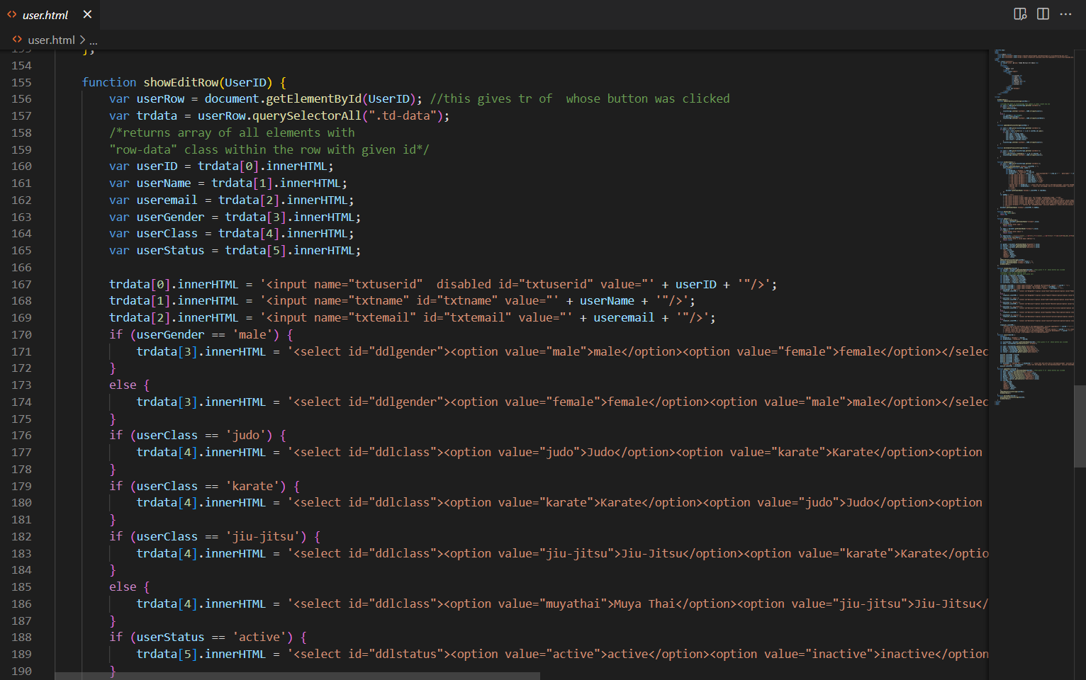 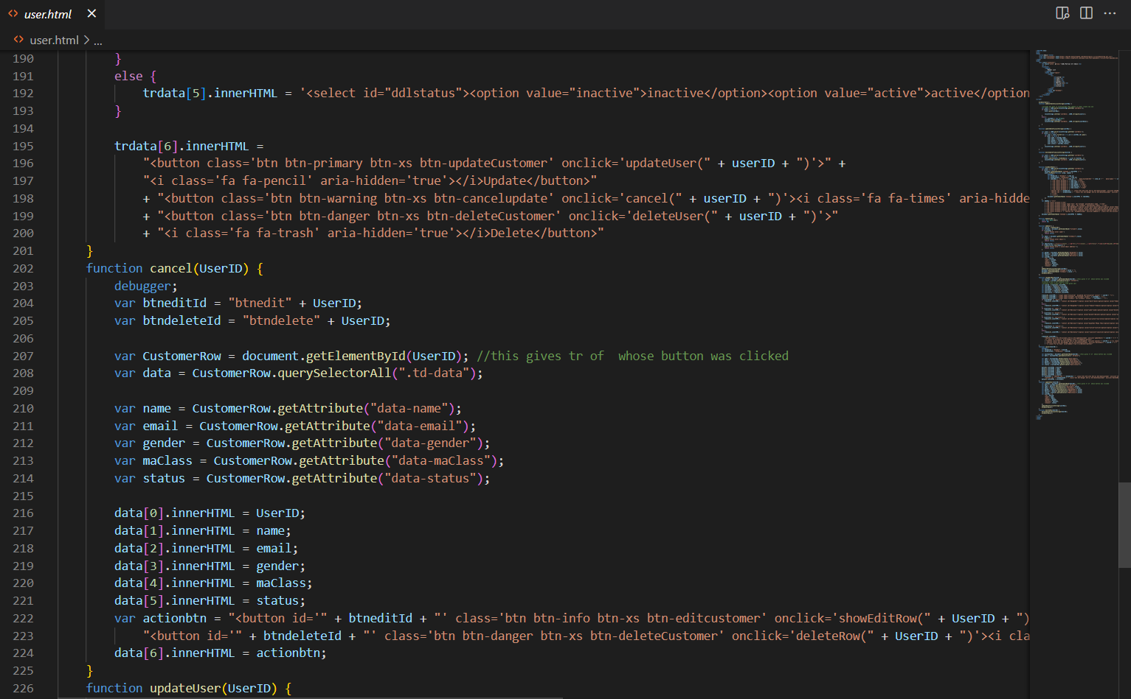 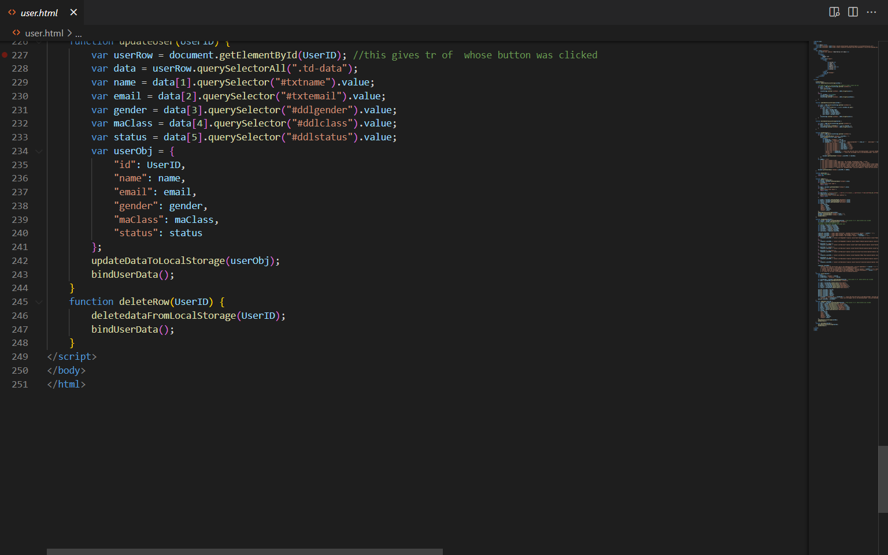

# Testing

After implementation process, testing process comes before the project is delivered to the client. There are five common types of testing. They are

* Usability testing

Usability testing is the process of testing the user friendliness and efficiency of the project for the user. Flow of the project and user understanding about the website can be determined.

* Functional testing

Functional testing is about testing the function and operational behavior of the website so that it meets the requirement and checking generated responses of the website.

* Compatibility testing

Compatibility testing can test the website is works on other particular operation system likes browser, hardware and software

* Performance testing

Performance testing is to determine the performance and stability of the website under different load conditions. This can determine that the developed website can handle the high user level.

* Responsive testing

Responsive testing is to determine the website is responsive to operate at other software or hardware devices like windows, mac or mobile.

## Test plan for DoBu Martial Art

|  |  |  |  |
| --- | --- | --- | --- |
| No | Test Scenario | Test Case | Expected Result |
| 1 | Usability testing | To ensure that content, layout, images and videos works properly | All page Contents contain and work properly |
| 2 | Functional testing | Checking links, button, registration form from validation and errors | All links, button and registration form work properly |
| 3 | Compatibility testing | Checking webpage can handle multi-cross browser | Webpages can be view properly from different browsers |
| 4 | Responsive testing | To ensure that webpages can be viewed properly from different screen sizes and devices | All web pages are responsive at different screen sizes and devices |
| 5 | Performance testing | To test the load speed and used libraries such as Bootstrap and jQuery works properly | Webpage can handle the user load speed and used libraries are working properly |

## Usability test cases for Dobu Martial Art

|  |  |  |  |  |  |  |
| --- | --- | --- | --- | --- | --- | --- |
| No | Test Scenario | Test case | Expected result | Actual result | Status | SC |
| 1 | Web page content | Checking webpage content | There will be 11 web pages home, classes, membership,  special courses, schedule, instructors, about us, contact, register form, sitemap, privacy policy | There are 11 web pages as it was mention at DoBu Martial Art website | Pass |  |
| 2 | Web page layout | Checking web pages content layout | Webpage layout will be according to information architecture, wireframe, story board | Website content layout are according to information architecture, wireframe, story board | Pass |  |
| 3 | Header | Checking navigation bar | Collapsible Navigation bar | Navigation bar is collapsible | Pass | Sc1 |
| 4 | Header | Checking nav bar | Are nav brand and items properly display | Nav brand and items are properly display | Pass | Sc2 |
| 5 | Footer | Checking footer | Four categories –  DoBu martial Art, about, quick links and social media are included | All categories are included within footer | Pass | Sc3 |
| 6 | Footer | Checking footer | Footer title and links, icons display properly | Footer title and links, icons display properly | Pass | Sc3 |
| 7 | Images | Checking inserted images | Images are inserted according to IA and wireframe | Inserted images show properly | Pass | Sc4 |
| 8 | Videos | Checking inserted videos | Inserted videos display properly to the user | They display properly to the user | Pass | Sc5 |

## Functional text case for DoBu Martial Art

|  |  |  |  |  |  |  |
| --- | --- | --- | --- | --- | --- | --- |
| No | Test Scenario | Test case | Expected result | Actual result | Status | SC |
| 1 | Nav bar links | Checking nav bar links | Nav bar links take the user to respective page properly | Nav bar links works properly | Pass |  |
| 2 | Footer links | Checking footer links | Footer links take the user to respective page properly | Footer links works properly | Pass |  |
| 3 | Member registration | Checking register button | When user click register button, register form page will appear | Register button works properly | Pass |  |
| 4 |  | Checking member registration | When user enter name ‘red’, email ‘red@gmail.com’, choose male, judo, active and click register button the data will be stored at local storage | Data is stored at local storage | Pass | Sc6 |
| 5 | Admin | Editing user account from admin | When admin edit user name to ‘blue’ and gender to female and update, user information will change | User account change when admin edit | Pass | Sc7 |
| 6 |  | Deleting user account from admin | When admin delete the user account from respective delete button, user account will be deleted | User account is deleted as expected | Pass | Sc8 |
| 7 |  | Adding new account from admin | Admin can add new account from admin | New account can be added from admin | Pass | Sc9 |
| 8 | Input validation | Does not filling form | Name and email cannot be left behind before submitting, if it was left behind warning message will show | Name and email cannot be left behind as expected | Pass | Sc10 |
| 9 |  | Email valid form | Email has to be failed in valid form, if not show message | It will show warning message when email is in invalid form | Pass | Sc11 |

## Compatibility test case for DoBu martial Art

|  |  |  |  |  |  |  |
| --- | --- | --- | --- | --- | --- | --- |
| No | Test Scenario | Test case | Expected result | Actual result | Status | SC |
| 1 | Cross-browser testing at Microsoft edge | Loading website at Microsoft edge | DoBu martial Art website can be use on Microsoft edge | Website can use on Microsoft edge | Pass | Sc12 |
| 2 |  | Checking webpage content at Microsoft edge | All content categories - home, classes, membership, special course, schedule, instructors, contact, about us, privacy policy, sitemap and register form contain | All categories contain within website | Pass |  |
| 3 |  | Responsive testing | Home page is responsive when it used on another browser | Home page is responsive when it used on another browser | Pass | Sc13 |
| 4 | Cross-browser testing at Fire fox | Loading website at fire fox | DoBu martial Art website can be use on fire fox | Website can use on fire fox | Pass | Sc14 |
| 5 |  | Checking webpage content at Microsoft edge | All content categories - home, classes, membership, special course, schedule, instructors, contact, about us, privacy policy, sitemap and register form contain | All categories contain within website | Pass |  |
| 6 |  | Responsive testing | Home page is responsive when it used on another browser | Home page is responsive when it used on another browser | Pass | Sc15 |

## Responsive test case for DoBu Martial Art

|  |  |  |  |  |  |  |
| --- | --- | --- | --- | --- | --- | --- |
| No | Test Scenario | Test case | Expected result | Actual result | Status | SC |
| 1 | Responsive testing | Home page | Home page is responsive when it was tested | Home page is responsive | Pass | Sc16 |
| 2 |  | Classes page | Classes page is responsive when it was tested | classes page is responsive | Pass | Sc17 |
| 3 |  | Membership page | Membership page is responsive when it was tested | Membership page is responsive | Pass | Sc18 |
| 4 |  | Special course page | Special course is responsive when it was tested | Special course page is responsive | Pass | Sc19 |
| 5 |  | Schedule page | Schedule page is responsive when it was tested | Schedule page is responsive | Pass | Sc20 |
| 6 |  | Instructors page | Instructors page is responsive when it was tested | Instructors page is responsive | Pass | Sc21 |
| 7 |  | About us page | About us page is responsive when it was tested | About us page is responsive | Pass | Sc22 |
| 8 |  | Contact page | Contact page is responsive when it was tested | Contact page is responsive | Pass | Sc23 |
| 9 |  | Sitemap page | Sitemap page is responsive when it was tested | Sitemap page is responsive | Pass | Sc24 |
| 10 |  | Privacy policy page | Privacy page is responsive when it was tested | Privacy page is responsive | Pass | Sc25 |

## Performance test case for DoBu Martial Art

|  |  |  |  |  |  |  |
| --- | --- | --- | --- | --- | --- | --- |
| No | Test Scenario | Test case | Expected result | Actual result | Status | SC |
| 1 | Performance testing | Checking loading speed of DoBu martial Art website using lighthouse | Expected at least 60% load speed for user | Load speed reach the expected result | Pass | Sc26 |
| 2 |  | Bootstrap testing | Bootstrap grids work properly | Bootstrap grids display as expected | Pass | Sc27 |
| 3 |  | Bootstrap testing | Bootstrap jumbotron works properly | Bootstrap jumbotron displays as expected | Pass | Sc28 |
| 4 |  | jQuery tabs testing | jQuery tabs work properly and display intro text, history text and video tab | jQuery work properly | Pass | Sc29 |
| 5 |  | jQuery testing | See title button will displays instructor’s title and see hide title button will hide the title | Buttons show and hide the titles properly | Pass | Sc30 |

Sc1

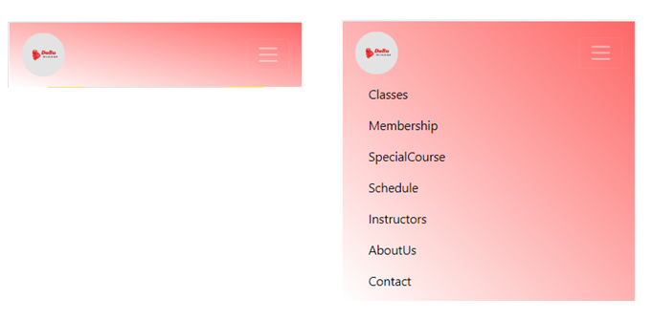

Sc2



Sc3

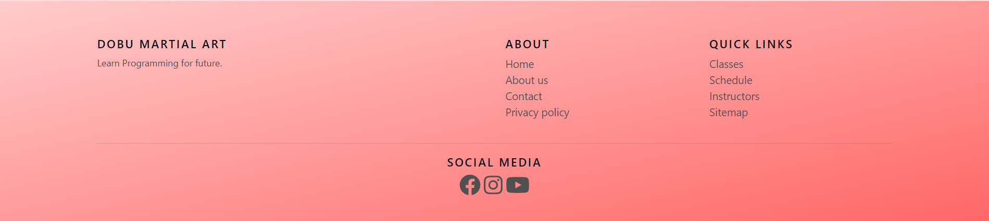

Sc4

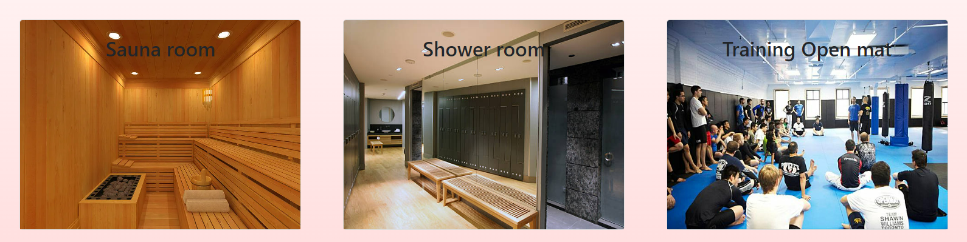

Sc5

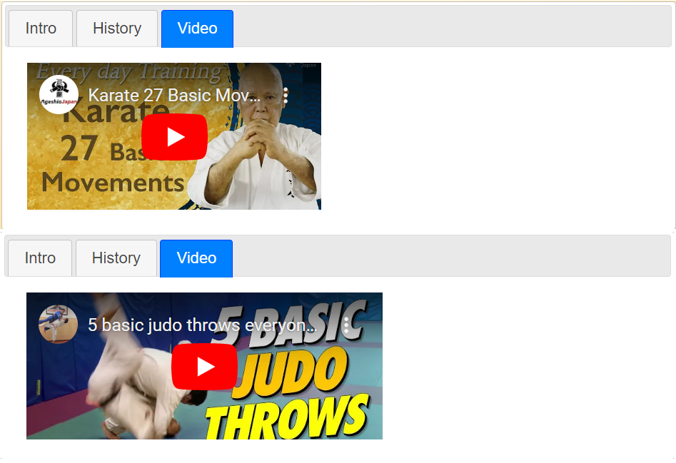

Sc6

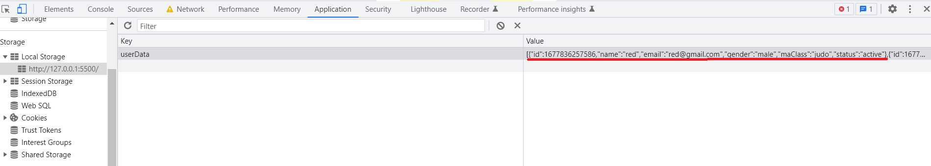

Sc7

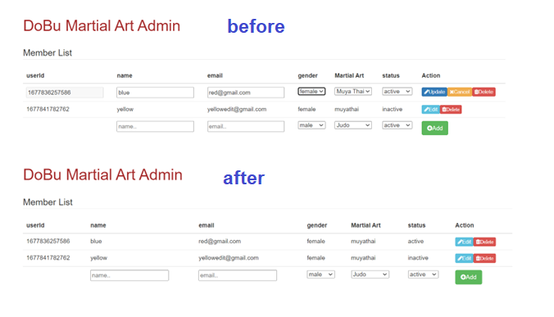

Sc8

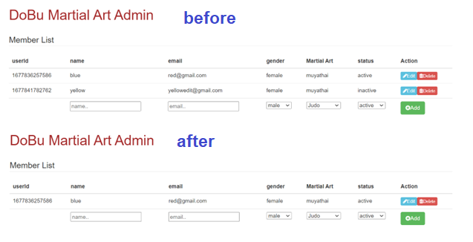

Sc9

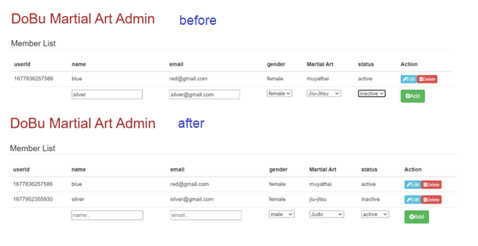

Sc10

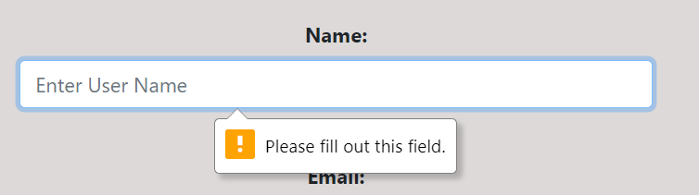

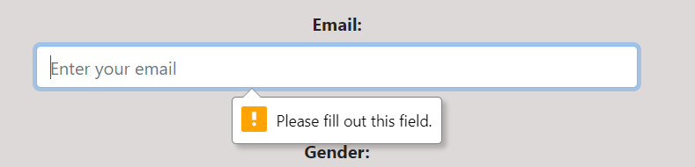

Sc11

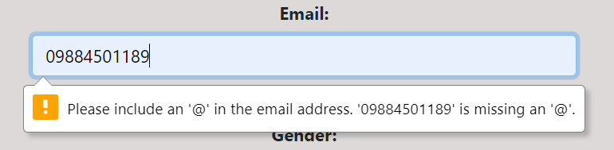

Sc12

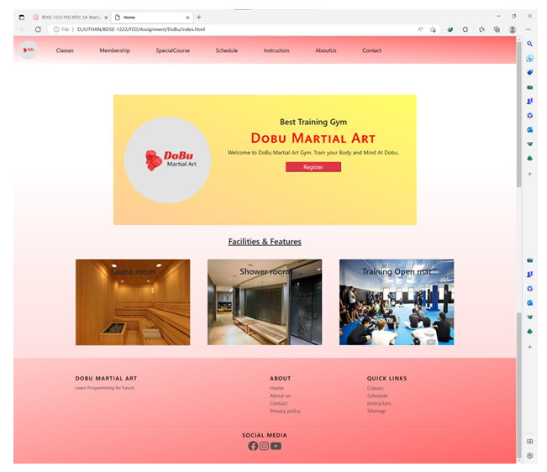

Sc13

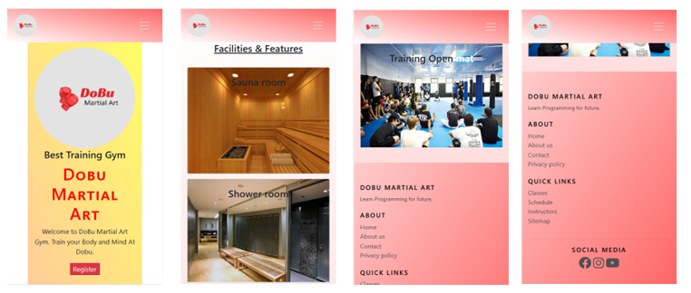

Sc14

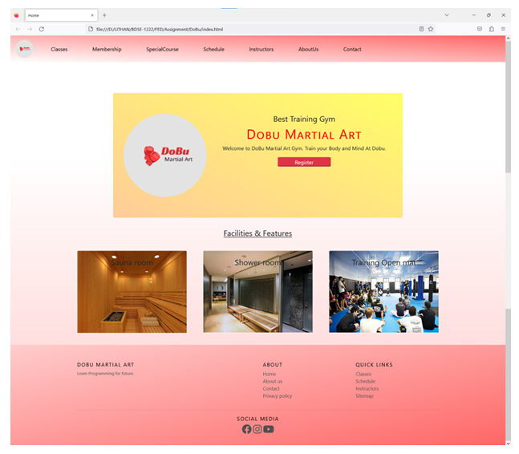

Sc15



Sc16



Sc17

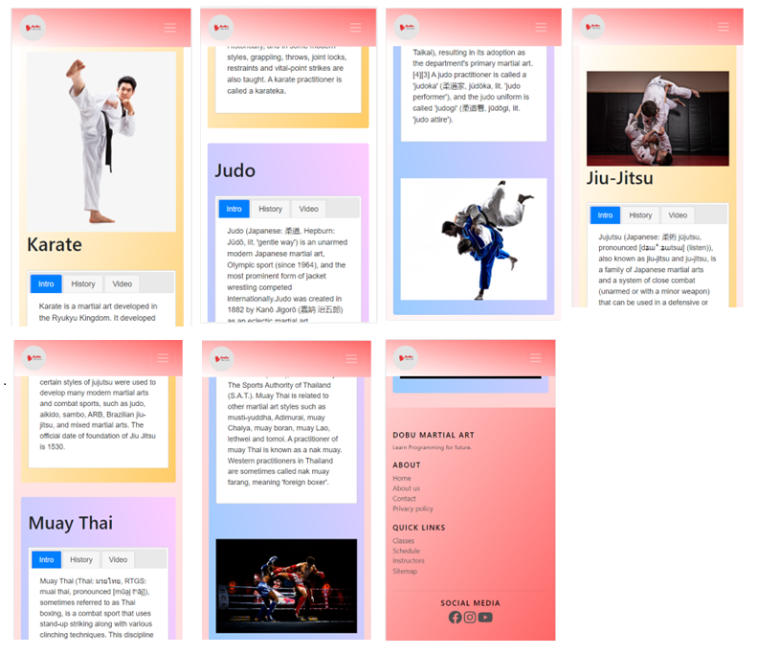

Sc18

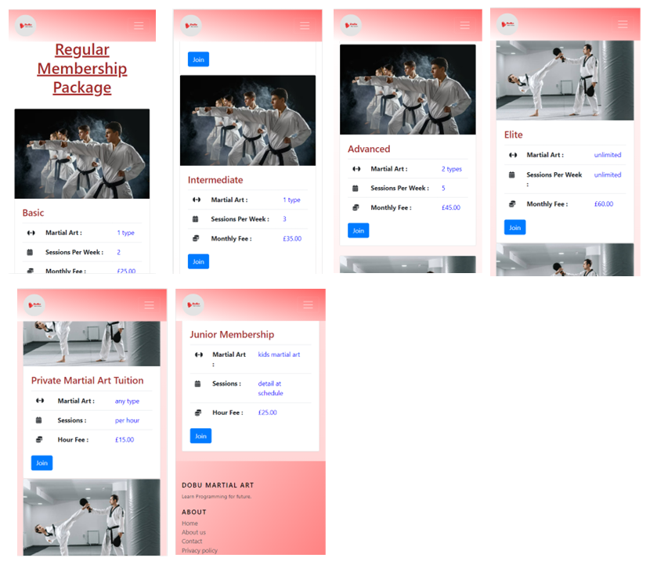

Sc19

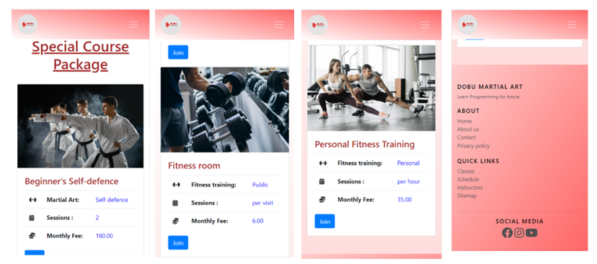

Sc20

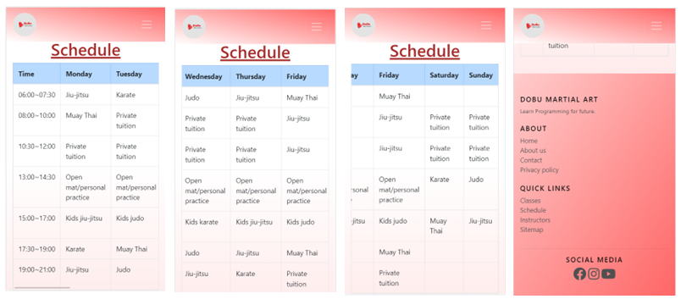

Sc21

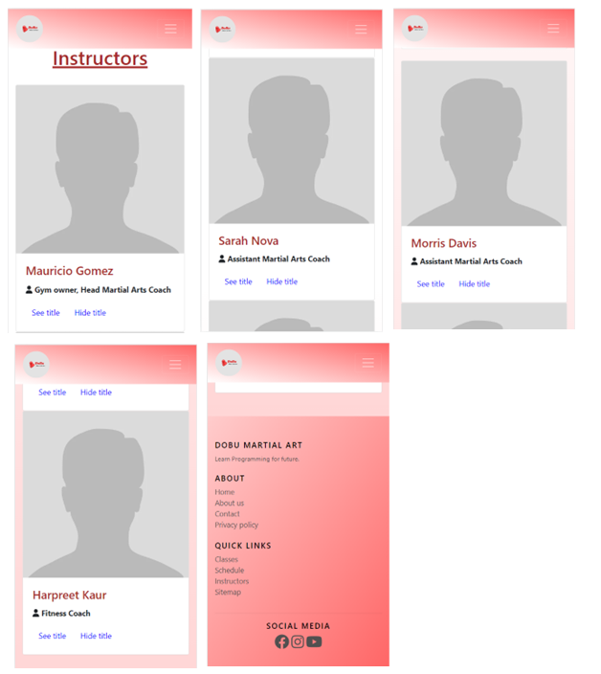

Sc22

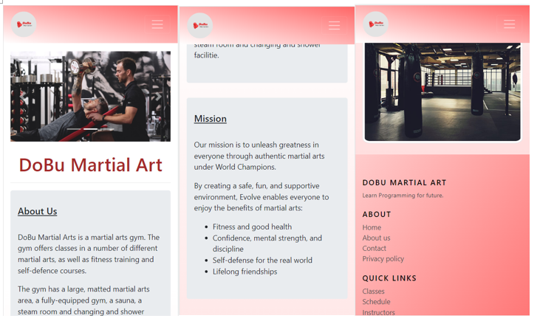

Sc23

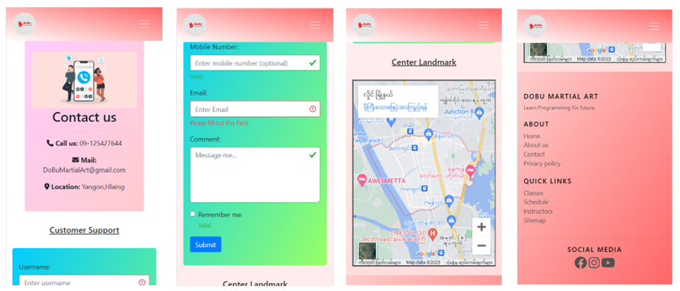

Sc24

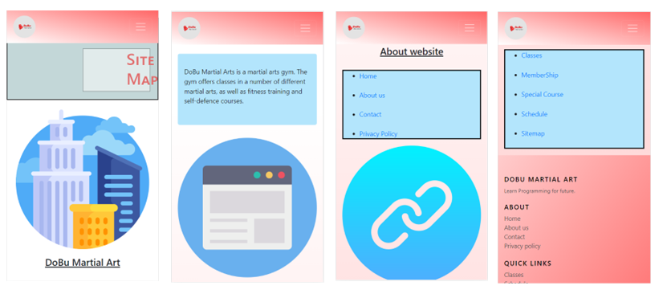

Sc25

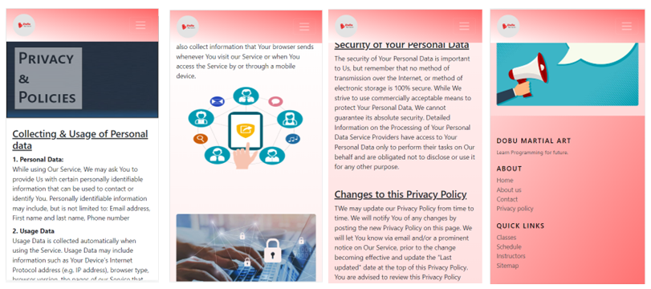

Sc26

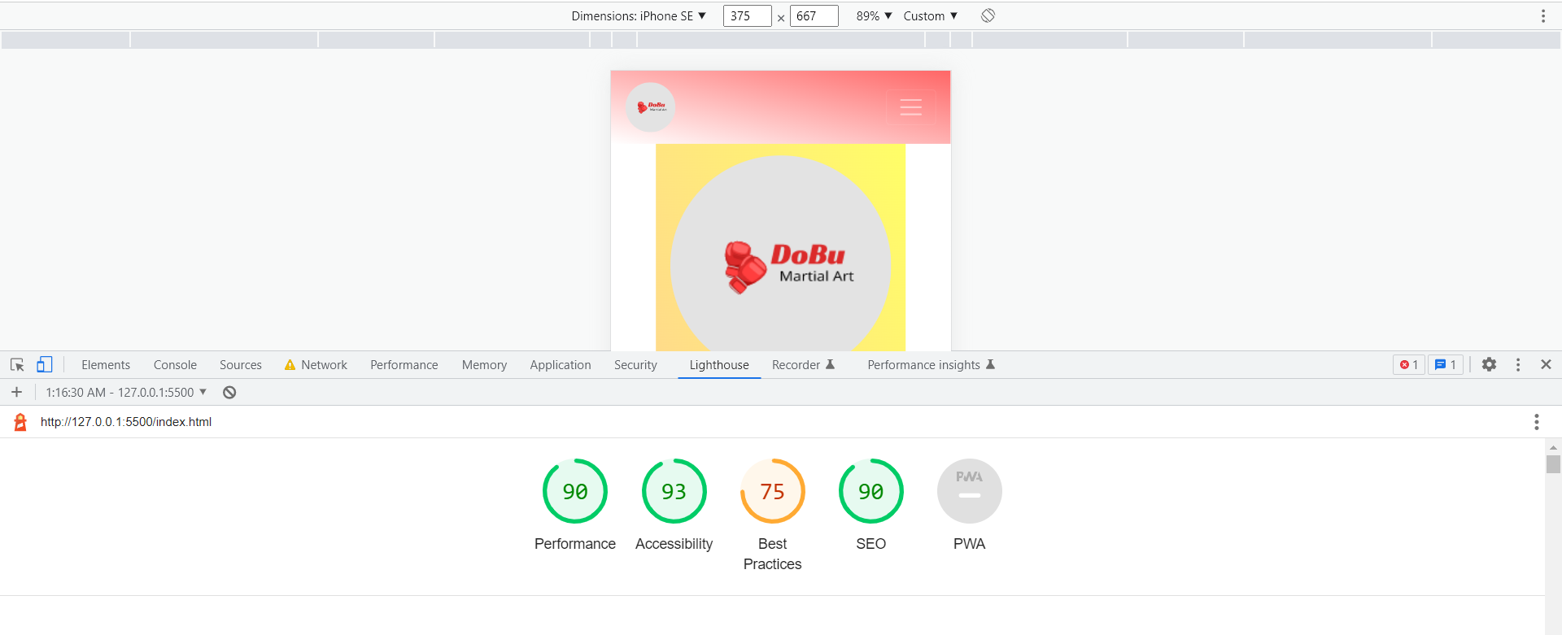

Sc27

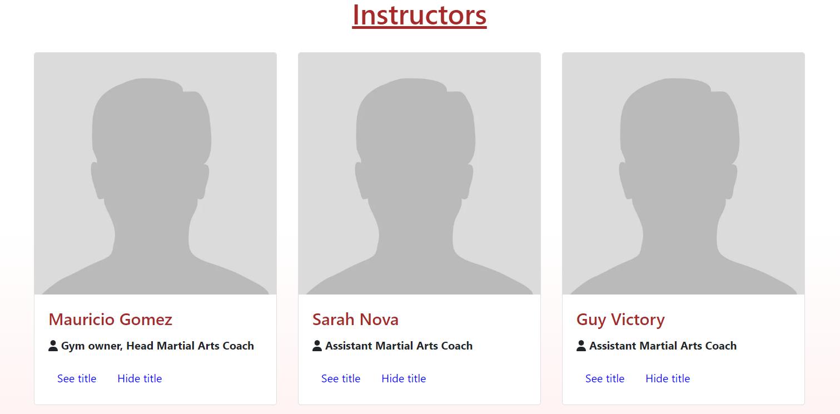

Sc28

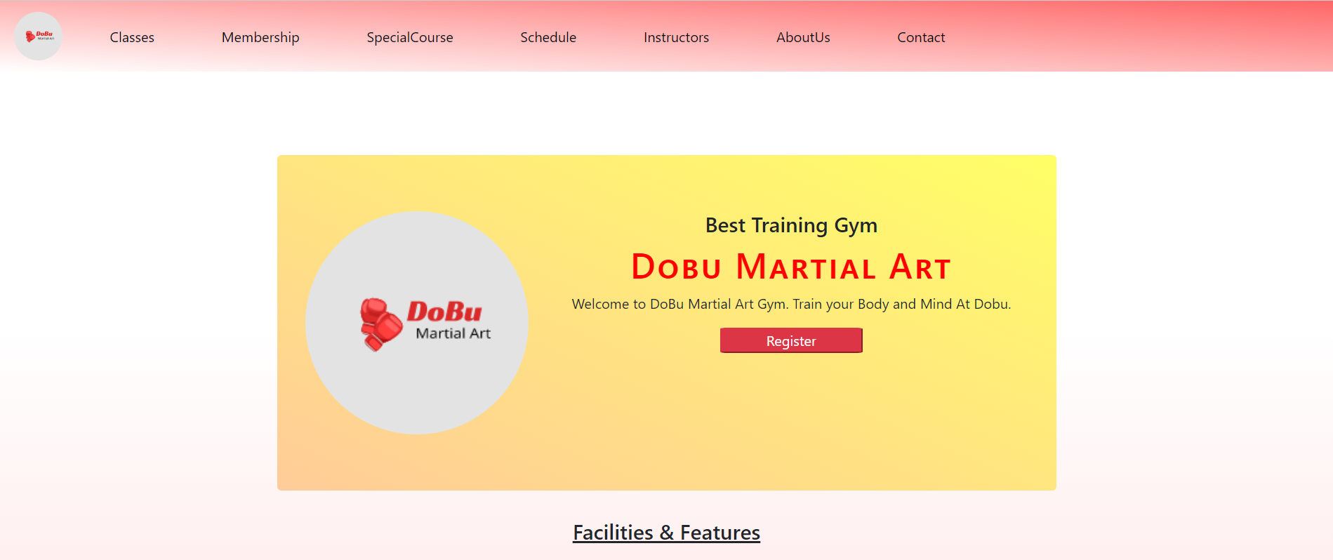

Sc29

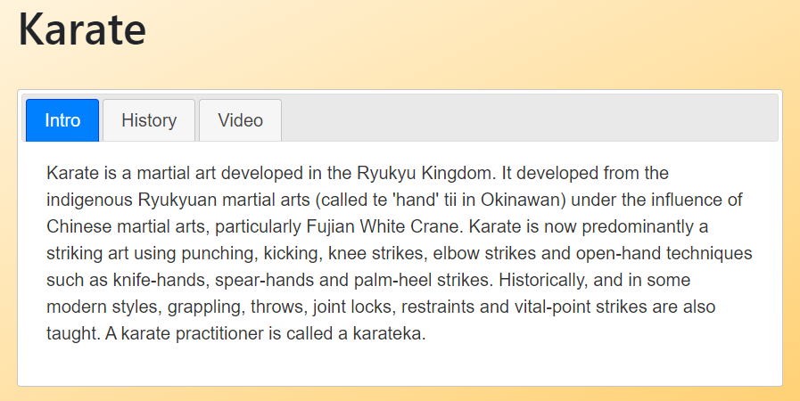

Sc30

